Blindata Release Note 6.6.5 

1 November 2013

Bug Fixes and Enhancements

4395. Order Processing > Quality Control

This form was showing orders that had a status of ‘Invoice Posted’. These have been removed.

4396. Purchase Order Enquiry > Regular PO Amend > Deliver

If a user selected individual detail lines to deliver, and ticked ‘Complete’ but forgot to put in the delivered amount, and then saved this, it was not possible to then change this.

Now a message appears saying ‘You have selected ‘Completed’ but not entered a quantity. Is this correct?’. If yes, then it will continue as before. If no, the focus goes to ‘Amount’.

4398. Works Order – Bespoke 42

There is now more room for the printing of special instructions.

4400. Order Processing > Orders

When entering an order, if you selected a customer that is a proforma, and then changed to another customer that was not a proforma, when a blind detail line was added, a ‘non nullable’ message appeared. This has been fixed.

4401. Import From Excel > Stock Additional Options

Last week we added a blind type column, but it would not allow an import of two records that are the same, except for having different blind types. Fixed.

New Work and Customer Requests

3351. Integration to Mertex Accounting System

We have a new customer that uses a bespoke accounting system called ‘Mertex’. Functionality has been added to integrate to this system in the following way.

- Add/Update Customers from Mertex to Blindata
- Blindata to Mertex outstanding order totals per customer
- Posting sales invoices
- Posting credit notes
- Posting purchase invoices

Therefore there is a new option in Parameters > Accounting Parameters / Invoicing called ‘Mertex’. If this is selected, data locations need to be filled in for:

Customers From Mertex
Order Totals to Mertex
Sales Invoice csv File Location
Credit note csv file location
Purchase Invoice csv file location

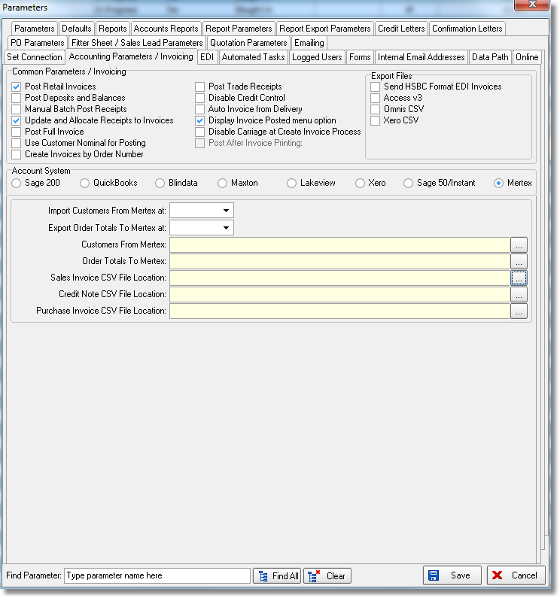
3366. UK Mail / Other Carrier File Layouts

We are being asked to create more csv files for different carriers. Until now there were only a limited number of layouts available. They are selected in Administration > System Tables > Despatch Method.

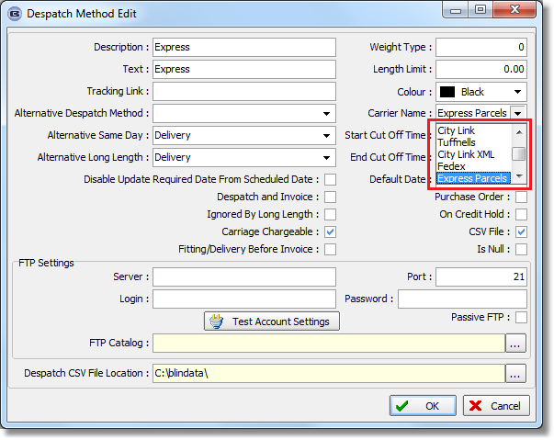
There is now functionality so users can create bespoke csv file layouts. There is a new system table called ‘Carrier File Layouts’. The form for this contains a way to set up the field structure for a file. There is a flag choice to determine file type ie csv, xls, XML.

We then need to determine which fields should be chosen and what position they should inIt is possible to choose from all the fields that are currently used in the different files. There are fields in the table for Field Name, Start Position, End Position. The choice for field name is also one of the fields already used in the hardcoded files along with the option to have a blank.

We have included create records to replace the currently hardcoded choices ie City Link, Tuffnells, City Link XML, Fedex, Express Parcels.

3380. Carriage

There is now a new threshold for wholesale orders – held in ‘Carriage by Area and Total’. This has a ‘Wholesale From Amount’, ‘Wholesale To Amount’ and ‘Wholesale Carriage Amount’.

There is a new parameter in Administration > Parameters called ‘Apply Wholesale Carriage’ which should default to false.

If an order contains only component detail lines and this parameter is set to true, then the carriage amount will be taken according to the new fields in ‘Carriage By Area and Total’.

If there is a mixed order, then the existing ‘Made To Measure’ carriage will apply.

3419. Robertshaw Documents

There are new bespoke layouts for quotations, order acknowledgements, delivery dockets and invoices. These will only be for emailed documents.

The email pdf reports are:

Quotation – Bespoke 20 (based on Quotation – Laser Print, move fields down and up to fit)
Acknowledgement – Bespoke 20 (based on Acknowledgement – Laser print)
Delivery Docket – Bespoke 20 (based on print version of Delivery docket – Bespoke 20)
Invoice – Bespoke 20 (replace existing)

These reports all contain logos. They contain header and footer images that go onto the various reports. Rather than embedding the images they are stored in Company Details > Logos (in logos 2-9).

3421. Purchase Order Enquiry > Regular PO

At the moment there is a column choice for ‘Free Stock’. This is ‘Stock In Hand’ – ‘On Sales Order’ + ‘On Purchase Order’. There is now another column choice called ‘Free Stock Ex PO’. This is ‘Stock In Hand’ – ‘On Sales Order’.

3422. Invoice Settlement Discount

There is a new parameter called ‘Hide Settlement Discount Text’ in Administration > Parameters which defaults to false. If this is set to true then the settlement discount text does not print on an invoice but the VAT is still shown as the VAT after settlement discount has been applied.

3423. Purchases > Suppliers

There is now another PO email address field called ‘PO Email cc’. If this is filled in, when the regular PO is emailed, it is sent to this email address as well.

