Blindata Release Note 6.6.4 

28 October 2013

Bug Fixes and Enhancements

4368. Stock Control > Stock Transaction Entry

If you ticked ‘relocation’ and moved a ‘batch’ with a quantity from the factory to the warehouse, the stock in hand figure goes up by that quantity, but the factory stock did not reduce by the same quantity.
The user is now able to select a batch on the stock transaction form for reallocation from a drop down list. The list will contain of batch records where there are free on stock items and factory stock true or false depending on the reallocation direction. If there is not enough on stock items the reallocation will not be done.

4375. Fitters Sheet / Sales Leads

When you convert a sales lead to an order, you are given the choice of creating the fitting appointment. If this is chosen, the fitting appointment is saved and is visible in the diary and the order. Temporarily, this was not working but is now.

4376. Purchase Order Regular – Bespoke 28

The company name and address was incorrect on the purchase order if ‘Use PO Delivery Address’ was ticked in Administration > Company Details. If this is ticked, the delivery address now prints on the right hand side of the header.

4381. Financials > Invoice Batch Print

Invoice – Bespoke 46a was emailing all invoices for each customer each time. It is now only emailing the invoices that have not yet been sent (unless the ‘Reprint’ is used).

4382. Paid Proforma

The ‘Paid Proforma’ form was showing cancelled quotations and orders that had been proformas. This is no longer the case.

4383. Import From Excel > Stock Additional Options

There is now a column for ‘Blind Type’ in this spreadsheet.

4386. Sales Files > Reports > Statements

When you run statements, there were no records appearing for some customers. Fixed.

4387. Order Processing > Orders > Create Bought In PO

After installed version (6.6.3) when a bought in PO was created, the order status did not change to ‘Work In Progress’ if there was a miscellaneous line on the order (and ‘Change Order Status After PO Create’ was set to true. It now does this properly.

4388. Label Print – Bespoke 33A

The text ‘Valance will be mitred’ now only appears on this report for blind identifier = Wood (and if Valance Width from Order Detail is greater than Maximum Valance Size held against Blind Type record) . It no longer appears for other blind identifiers.

4391. Email Credit Note

The header fields have been tidied up on the right hand side.

4393. Receipt Email

The text was overlapping on the receipt print and the email receipt. We have moved Width, Drop and Quantity more to the right to make space.

4394. Picking List

The picking list quantity was incorrect. It now prints only 2 decimal places.

New Work and Customer Requests

3412. Reports > Sales Analysis > Sales Analysis Profit by Order

There is a new report called ‘Sales Analysis Profit by Order’ that shows individual orders with margins. This shows order number, order date, company name, invoice date, invoice number, order value, order net value, discount %, order cost, profit and % mark up.

3413. Order Processing > Orders

There is a new flag on the order form (in the ‘Totals’ tab) called ‘Important’. This is also a column choice.

3414. Employee Check In / Out

It is now possible to scan when an employee is about to start work and when they finish work. Therefore there is a ‘Check In’ and ‘Check Out’ for each employee, which is done with a scan on the employee barcode. If an employee is already checked in, they cannot check in again, only out. Similarly, if checked out, they cannot check out, only in. There is a new button for this in ‘Order Enquiry’ called ‘Check In/Out’. When this button is selected, a form appears so the user can scan their employee bar code. After the scan is done, a message will appear saying either ‘[Employee description] has checked in’ or ‘[Employee description] has checked out’.

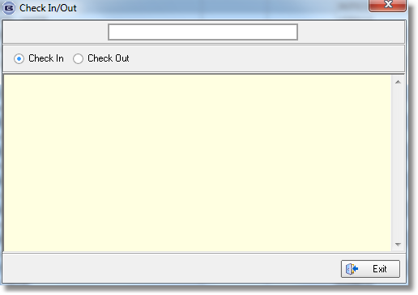

3416. EDI Import

We need to create a new parameter record to take this into account. There is a new parameter in the customer record called ‘Use Customer Email in EDI Import’. If it is set to true, then the customer default email is saved in the order when the EDI order is imported.

3420. Label Print – 3 ½ x 1 Standard

The number of vanes field has been made bigger for blind identifier = Vertical, Headrail Only and Vanes Only.

