Blindata Release Note 6.6.2 

11 October 2013

Bug Fixes and Enhancements

4363. Sales Analysis By Blind Type (Weekly)

If the start date was not a Monday, the days on the report were wrong. This has been fixed.

4364. Pleated Blind Fabric

When a pleated blind is entered (blind identifier = P), the calculator for the fabric will always be drop. The program now looks at the ‘Roll width’ for the fabric and compare it to the width (blind size). If the width > roll width, then a message appears saying ‘This blind is too wide to be made with this fabric’.

4366. Purchase Order Enquiry

If you generate a regular PO but then cancel it, it left records in the stock transaction table. These are now removed.

4369. Stock Valuation Report

The totals have been tidied up – they were different sized fonts.

New Work and Customer Requests

3231. Fabric Optimisation Cutting Sheet

There is a new parameter called ‘Manual Fabric Cut Optimisation’. This is required because when fabric is cut manually, it is cut right across the roll width, and this has an impact on the optimisation routine.
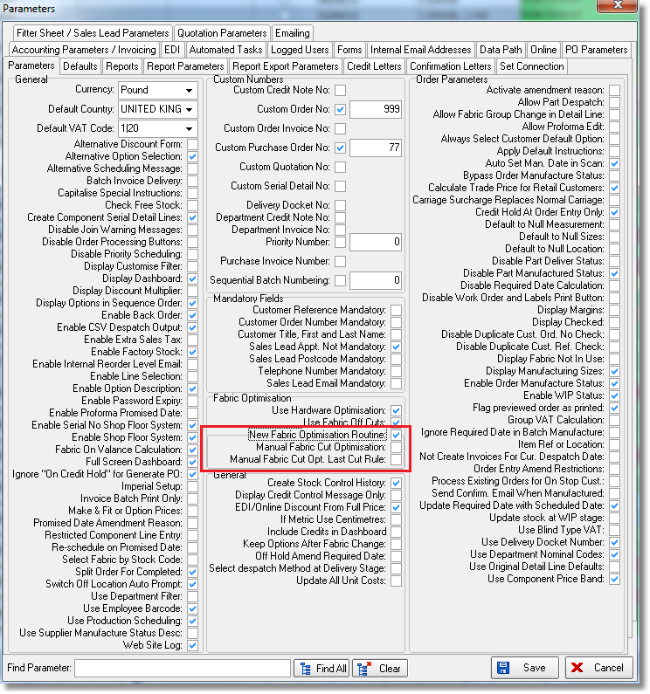

The new Fabric Optimisation routine has been integrated into Blindata but we didn’t implement two additional routines: Splitting of Optimisation by Roll Length and Fabric Off Cuts. These routines are separate for old Fabric Optimisation and will be added after the new Fabric Optimisation routine has been fully tried and tested.

3374. Delivery Reprint Order History

An order history record is now created when a delivery docket is reprinted.

3394. Financials > Create Invoices

At the moment the invoice numbers are allocated by customer then order number. There is a new parameter called ‘Create Invoices by Order Number’ in Administration > Parameters. This defaults to false. If this parameter is set to true, the invoices will be created in order number order.

3396. Sales Files > Customers

There is a new button on this form called ‘Export Transaction Data’. When selected, the user is able to enter a sales order date, then export data to a spreadsheet. The spreadsheet name defaults to the account code and date ie DN9999.130927.xls.

There is a flag for this button in Administration > Users > Buttons Visibility.

The data extracted has one line per order with columns for nominal breakdown.

3398. Order Processing > Orders > Receipts Tab

There is now an option to email a receipt to the email address held in the order. A receipt pdf is sent to the email address held in the order header
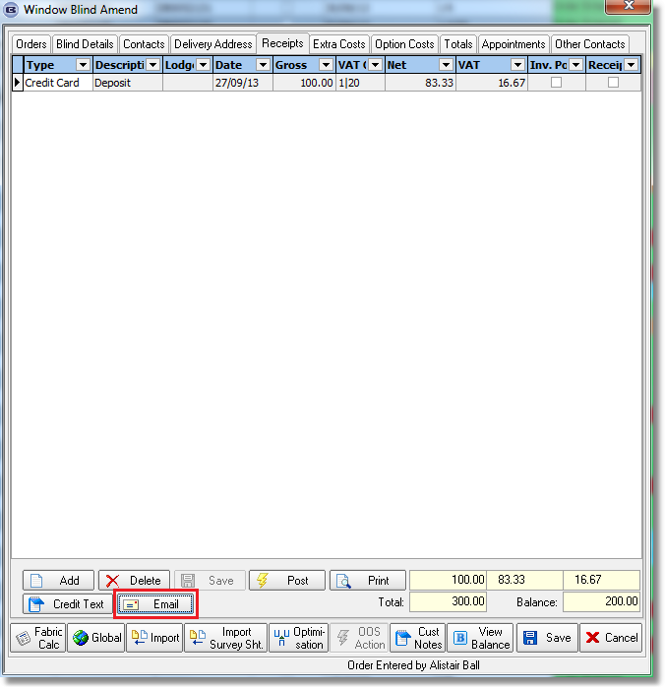

3400. Delivery Docket – Bespoke 46

Increased the font size for Delivery Address

When the delivery address is different to the default delivery address, ‘**Alternative Delivery Address**’ prints out.

The Quantity Of blinds column has been moved to the right hand side of the delivery docket.

‘Total Number Of Blinds’ is now printed under the detail lines section.

3402. Company Details > PO Delivery Address

There are new fields in the ‘Company Details’ tab for PO Address. If these fields are filled in, then they are used in all of the purchase orders (regular and bought in, print and pdf).

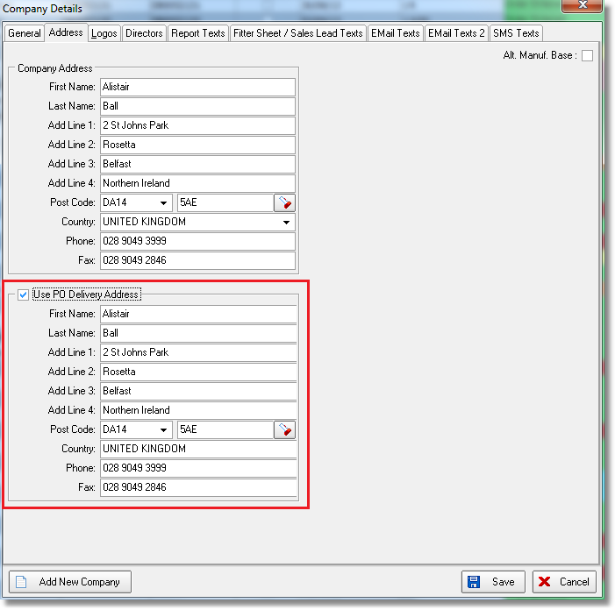

3403. Order Processing > Orders > Context Menu > View Details

‘Number Of Vanes’ is now a column choice in ‘View Details’ (in the context menu).

3405. Delivery Docket – Customer Special

‘There is a new parameter called ‘Print Carriage Detail Line’ in Parameters > Report Parameters > Delivery Docket section. If this is set to true, then the carriage detail line now prints in the detail section and the ‘Carriage Type’ (in the header) does not print at all. This only applies to this report.

3406. Administration > Import From Excel

There is a new option in this form called ‘Supplier Stock Descriptions’. This import includes columns for stock code, supplier and supplier description. It will import records to the table for Stock Items > Supplier Description tab.

3408. Customer Discount Report Email

The email text now says:

Dear Sir/Madam,

Please see attached confirmation of all your product discounts as recently discussed.

Kind regards,
[company Name]

W207. Online System

Width is no longer displayed for vanes only on the online system if ‘Hide Width Entry’ is set to true in the blind type record.

