Blindata Release Note 6.6.3 

21 October 2013

Bug Fixes and Enhancements

4372. Formula

There was a rounding error with the formula that has been corrected.

4374. Order Processing > Orders

The price code used for the INTERNAL.csv file record is now selected from the customer held against the department record in the order, rather than just the ‘Trade’ price table.

New Work and Customer Requests

3399. Acknowledgement – Bespoke 42

There is a new order acknowledgement report called ‘Acknowledgement – Bespoke 42’. It is based on ‘Acknowledgement – Laser Print’. This looks at data held in the department field – logo, company name, address.

We now also hold more fields in the department record:

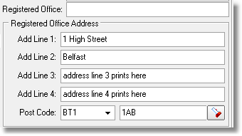

There is also a new acknowledgement Email Text field in the department record.

These new fields are taken from the department record for this new report.

If trade type = ‘Including Tax’, then the customer name and address comes from the delivery name and address.

3404. Purchase Order Reports (Bought In & Regular)

If the required date is for the day after the PO date, the text ‘HIGH PRIORITY’ now prints on the purchase orders.

3410. Administration > Import From Excel

There is a new option to import nominal codes. The spreadsheet has the following fields: ‘Nominal Code’, ‘Description’, ‘Sales Code’ and ‘Currency’.

3411. Suppliers

There is now a default nominal code held against the supplier. This is a lookup field in the form and only allows the choice of a nominal codes where ‘Sales Code’ = false and ‘Bank Code’ = false.

3415. Reports > System Reports > Production Process by Employee

There is a new report that shows the number of process done by employee per hour.

The criteria for this report is start and end date, with a choice of employee or ‘All’.

There are extra criteria for start and end time for the hours that appear. It should default the whole day ie all 24 hours.

There is also an option to select either processes or minutes.

