Blindata Release Note 6.6.1 

7 October 2013

Bug Fixes and Enhancements

4353. Quotations > Create Orders

New indices have been added to speed up the conversion of quotations to orders.

4362. Acknowledgement Laser Print (Letterhead Logo)

The column headings have been tidied up.

New Work and Customer Requests

3384. Sales Files > Customers

At the moment there are two flags that determine whether delivery dockets are printed or not. The first is in Administration > Parameters > Report Parameters (No Delivery Docket Print Preview) and the second is in Sales Files > Customers (No Delivery Docket).

Both these flags are now checked at the same time now. This means that if the first flag is set to false and the second is set to false, a delivery docket will print. If the second is set to true, the the delivery docket will not print for that customer.

3385. Credit Note Laser Print (Letterhead Logo)

This report is now a choice in ‘Report Export Parameters’.

3387. Works Order – Bespoke 50

Special instructions have been extended along the bottom of the large label and the top left and right small labels.

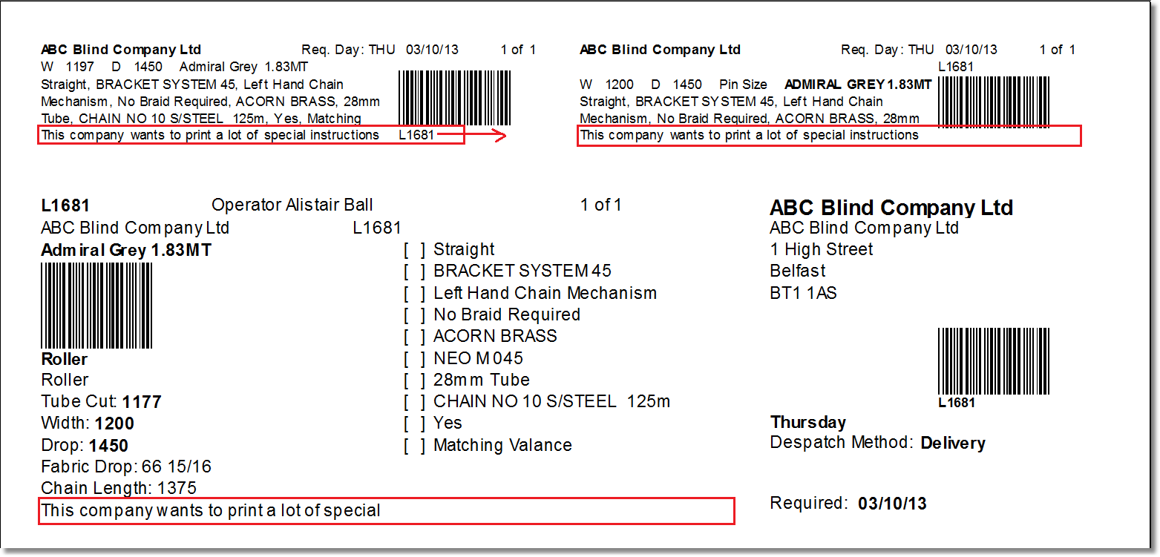

3388. Works Order – Bespoke 46

When you enter a components order, there is a box to enter the number of labels, but only 1 label was printing off for this report. It now prints the number of labels specified in ‘Number Of Labels’.

3389. System Tables > Dimension Codes

There is a new button in ‘Formula’ called Louvres. This can be used for creating a calculator that is dependent on the number of louvres in a blind eg ‘Louvres x 2’.

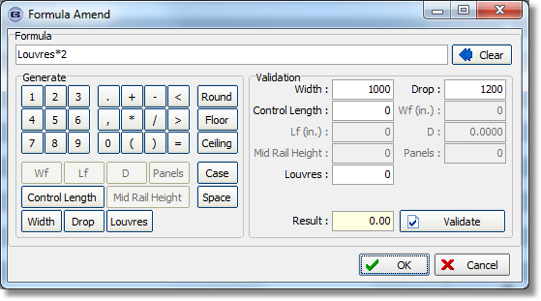

3390. Invoice – Bespoke 46 / Delivery Docket – Bespoke 46

If the blind identifier = ‘Vanes Only’ the number of Louvres is now printed on the invoices/delivery note.

3391. Order Processing > Delivery Docket Batch Print > Delivery Run Report

If the carriage type in the order is not the default one, then ‘Carriage Type’ now prints in a line beneath the order.

If the delivery address is different from the invoice address, the address (Del Add Line 1 and postcode) are now in bold and italics.

3392. Emailing Order Acknowledgements

It is now possible to email Order Acknowledgements when the status is changed to order printed.

The parameters have been amended so the following options are now available:

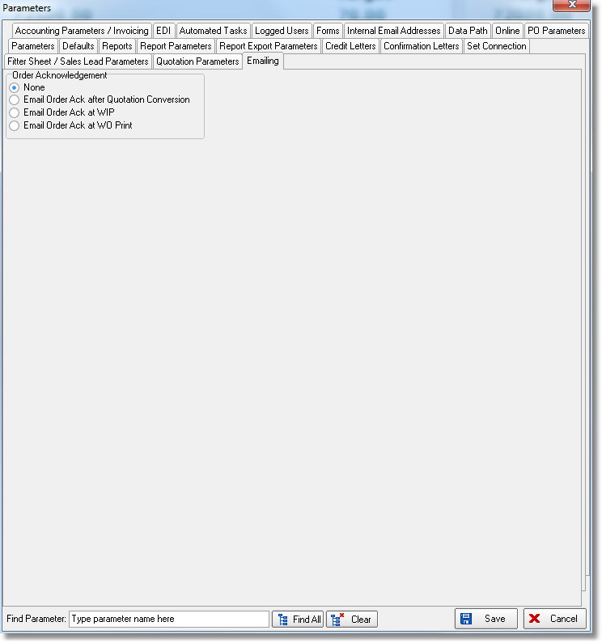

3395. Production List > Roll Out Production List

There is now an option for ‘Only Must Go Orders’.

Also carriage lines are now excluded from this report.

