Blindata Release Note 6.6.0 

27 September 2013

Bug Fixes and Enhancements

4348. Order Processing > Paid Proformas

This form was still showing proforma orders even though they had been paid and despatched and invoiced. These records now disappear after invoices have been posted.

4352. Quotation – Bespoke 46

If there is settlement discount, the VAT now has the settlement discount amount deducted, but the text ‘Amount to pay after 2.5% settlement discount’ has been removed.

4356. Works Order Label Blind Size

The ‘No of Wires’ figure was wrong – it is always showing 1 less than it should be. Fixed.

4357. Works Order – Bespoke 46

For sloping verticals (blind identifier = Vertical and ‘Sloping Headrail’ = true), if the dimensions were input as inches, the small drop was displayed in inches on this works order. Fixed.

4359. Invoice – Bespoke 49 pdf

The two extra totals boxes no longer print on this pdf invoice.

New Work and Customer Requests

3361. Blind Types > Cutting Sizes

We need to record ‘Single Draw Support’ and ‘Split Draw Support’ for verticals. The rule is 0 for up to 1500mm width, 1 up to 2500mm width, 2 above that. It varies by headrail system and bunch.

Therefore we have expanded the formula functionality to include rounding (use INT) and also have a nested IF function.

There can be 3 types of rounding: ROUND, FLOOR and CEIL. First is rounding to INT, second is rounding down to INT value and third is rounding up to INT value.

Here is an example of a nested if statement. If width < 1500, then use 1, else if width >= 1500 use 2.

You can have as many cases as you like, as long as the formula text does not exceed 2000 characters.

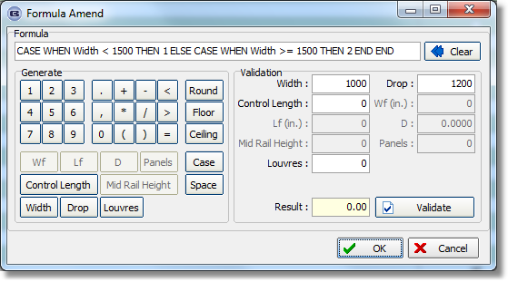

3369. Purchase Order Bought In – Standard / Purchase Order Bought In (Blind Size)

There are now parameters to show ‘Required Date’ and ‘Expected Delivery Date’ in Report Parameters > Purchase Order.

These parameters are called ‘Show Required Date’ and ‘Show Expected Delivery Date’. Also the column headers have been tidied up in ‘Purchase Order Bought In (Blind Size).

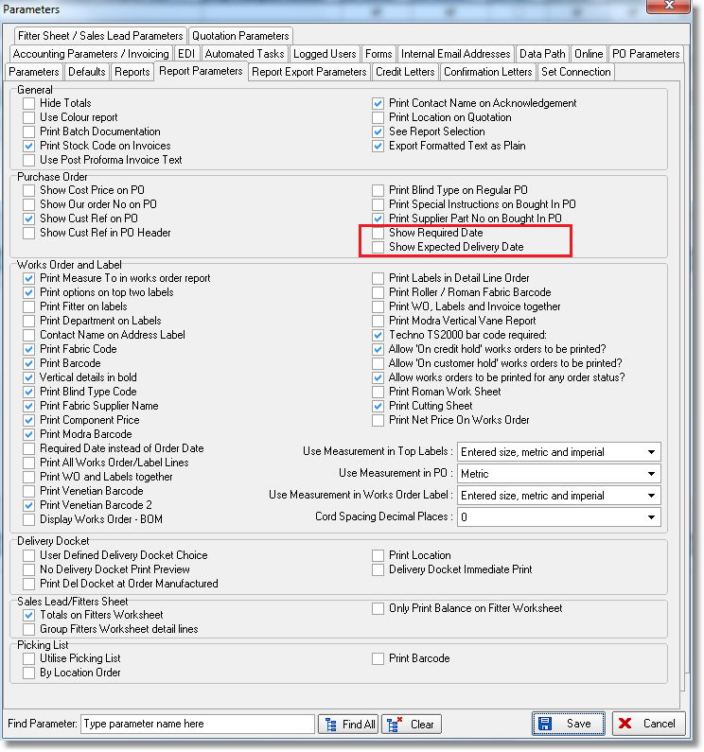

3372. Label Print – 3 ½ x 1 Standard

We have removed the special instructions from the labels on Venetian blinds. This allows the cord spacing on longer blinds to be fully printed.

3373. Delivery Docket – Bespoke 46

Below the ‘Received’ space/line, there is now a ‘Date and space to enter it.

3376. Works Order Portrait

It is now possible to show the net price on Component/Repair detail lines. There is a new parameter called ‘Print Net Price On Works Order’ in Parameters > Report Parameters. The price will print beneath the location on this report.

3378. Archive Enquiry > Context Menu

In the ‘Serial Detail Lines’ form (selected from the context menu), there is now a button so all processes can be seen with when they were done and who did them.

3379. Order Enquiry > Processes

There is now a column for location (from detail line) on this form.

3381. Acknowledgement – Bespoke 34

Only carriage description is printed ie the description from the stock record (if it is ‘Carriage’, not ‘Carriage Surcharge) for a normal carriage line.
Removed quantity and unit of sale from carriage lines.
Carriage surcharge description (ie the description from carriage type) is printed if the carriage line is ‘Carriage Surcharge’
This has also been done in ‘Quotation – Bespoke 34’ and ‘Invoice – Bespoke 34’.

3382. Works Order – Bespoke 34A

There was a request to have 13 options printed on this works order, but there was no space. Instead any extra options are now printed in the same line as the special instructions.

3383. Quotation – Bespoke 34

- Detail line column headings have been centralised vertically and moved in on left hand side by 1mm
- Lined up text on left hand side – move in 1mm – same as heading
- Lines in boxes for details are now the same as the address.
- Option description wraps round at the same point as the blind type description.
- VAT No has replaced registration no.
- Boxes at bottom are attached and uniform.

Also, if blind identifier = Track, the fabric description does not print.

Spec ins do not run off end of the line – they also now wrap round.

3397. Works Order – Bespoke 46

If an order has ‘Quality Required’ ticked, ‘QUALITY CHECK’ now appears as text below cutting sizes but above the bar code.

