Blindata Release Note 6.5.8 

16 September 2013

Bug Fixes and Enhancements

4317. Order Processing > Orders (re-release of 6.5.4)

If ‘Display Checked’ is ticked and an order is entered and saved with a 0 base price, a message nowd says ‘At least one detail line has a 0 base price. Do you still want this order to be flagged as checked?’.

4320. Quotations > Create Order (re-release of 6.5.4)

The functionality to check a quotation and then have the check flag carried across to the order was done in dev item 3272. This has been speeded up.

Also if a quotation has been checked, an order history record is now created.

4321. Blind Details > Blind Types (re-release of 6.5.4)

If the blind identifier = ‘Wood Component’, then the ‘Show Cord Spacing’ flag is now visible.

In ‘Works Order Label 1’, if ‘Show Cord Spacing’ = true for a blind identifier = Wood, then the cord spacing now prints on this report.

4329. Order Processing > Quotations

If a quote was entered with ‘Use Original Detail Line Defaults’ set to true in Parameters, and an option had been changed from a default in the first detail line, the second detail line used the new option choice used in the first line.

However if a text line was entered in between, the next blind detail line reverted to the default options. It now ignores the text line and uses the option from the previous blind detail line (providing it is the same blind type).

4330. Order Processing > Orders > Post Full Invoice

If ‘Post Full Invoice’ is switched on, then the full invoice is posted to Sage 50. But there is a problem with it. The discount % and net GBP figures are correct, but the unit price was incorrect. It is now the net price before discount is taken off ie the base price + option price.

4331. Works Order – 4 Per A4

Rounded up vertical fabric required to next full metre.
Removed ‘Chain Length’ from left hand side of label (even though ‘Chain Length’ is switched on in blind type).
Special instructions have been moved up by 5mm.
Top labels – fabric description is now concatenated after blind type description. Removed word ‘Description’.
Top left label – control type and bunch now print if ‘On Smal Label’ flagged in option setup.
Top right label – number of vanes now printing
Roller blind - removed “Cloth” and sizes beside
Removed “Cloth Width” from LHS small label
New page for each blind identifier
Removed cord spacing for w.vens 25,35 & 50mm sunwood (all bought in wood/venetians)

4332. Acknowledgement – Bespoke 34

There is now enough room in this report to print out the full blind type description. It allows for up to 150 characters to be printed. This is also the case in the pdf version.

4333. Delivery Docket – Bespoke 34

The blind type description now wraps round and does not overwrite other fields. It also prints up to 150 characters.

4334. Invoice – Bespoke 34

There is now enough room in this report to print out the full blind type description. It allows for up to 150 characters to be printed. This is also the case in the pdf version.

4335. EDI Import

When importing a XML file, the ‘Direct Delivery by Supplier’ flag should be set to true in the order, but it isn’t. The XML has the field set to true and the flag is set to true against the customer record. Fixed.

4336. Paul Simon Import

An error message will now appear if the Paul Simon file cannot be imported because of formatting issues.

4337. Invoice – Bespoke 29

A slight change to the layout has been made to move the right header fields 10mm to the right.

New Work and Customer Requests

3354. Fabric Group Setup

There is now an option choice for ‘Special’.

3355. Order Processing > Orders

There is now an option to still show credit control message ie over credit limit, but not have the order put on credit hold. To do this, switch on the new parameter in Administration > Parameters called ‘Display Credit Control Message Only’

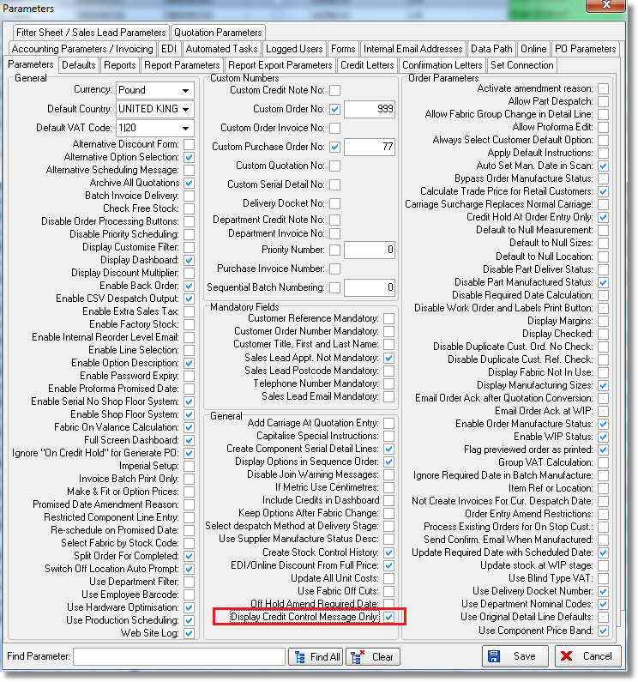

3356. Sales Files > Customers

It is now possible to switch on or off all carriage flags regardless of whether ‘Auto Charge Carriage At Order Entry’ is switched on or not.

3357. Order Processing > Orders > Delivery Docket

It is now possible to select the delivery docket layout at the order entry stage. The user is able to store the delivery docket layout at the order entry stage and amend subsequently.

This can be done if the following new flag is set up in the customer record (which defaults to false). Once this is done, there will be a delivery docket choice in the ‘Totals’ tab of the order.

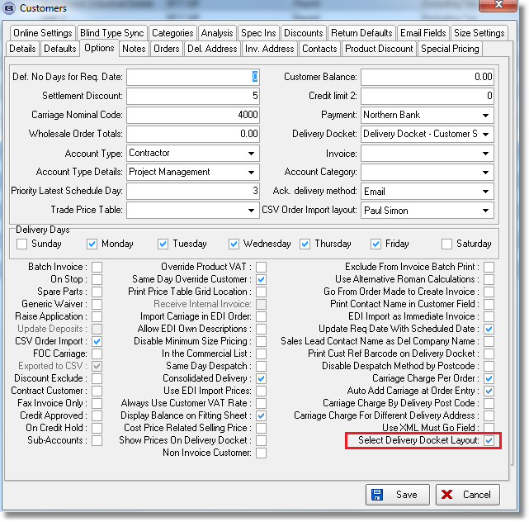

3360. Sales Files > Customers > Non Invoice Customer

There is a new flag on the customer record called ‘Non Invoice Customer’ which defaults to false.

If it is true, then after an order is despatched, it has its status changed to ‘Invoice Posted’. The invoice date is updated with the current date and the invoice number is 0. The despatch can be done in ‘Order Amend Enquiry’ or in ‘Order Enquiry’, either manually or by scanning.

