Blindata Release Note 6.5.7 

9 September 2013

Bug Fixes and Enhancements

4315. Label Print – Bespoke 33A

‘In Colour’ options now print in colour on the two small labels at the top. Previously they only printed in colour on the large label.

4316. Works Order – Bespoke 31

The detail lines now print in order. It makes checking the orders much simpler if they are in the same order as the labels. Previously this report was in fabric order.

4318. Dashboard

If you came out of the order amend enquiry form, the dashboard displayed in full size. Fixed.

4324. Works Order – Label 33A

‘Valance’, ‘Return’ only appears if ticked to show in the blind type record.

4326. Administration > Maintenance

If you ran ‘Update Nominal Codes in Detail Lines’, it did not take into account ‘Department Nominal Codes’. It now looks at these if ‘Use Department Nominal codes’ is switched on in Parameters.

4327. EDI Import

‘Department Nominal Codes’ is now used in the EDI Import if ‘Use Department Nominal Codes’ is switched on.

New Work and Customer Requests

3215. Sales Files > Customers

There is now a flag in the Sales Files > Customers record that allows the customer to change their Despatch Method on an online order. It is called ‘Allow Online Despatch Method Edit’.

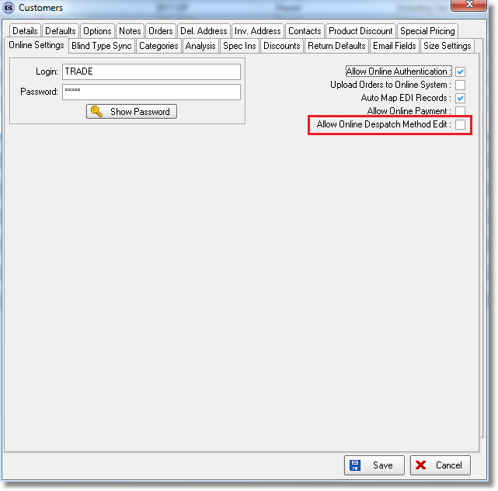

3282. Reports > System Reports > Customer Discount Report

This report now prints the company name (from Company Details) and the name of the report at the top. The company logo (from Company Details) also prints in the top right.
If a specific customer is chosen, a button is now available to email this report to the customer (using the default email address in the customer record).

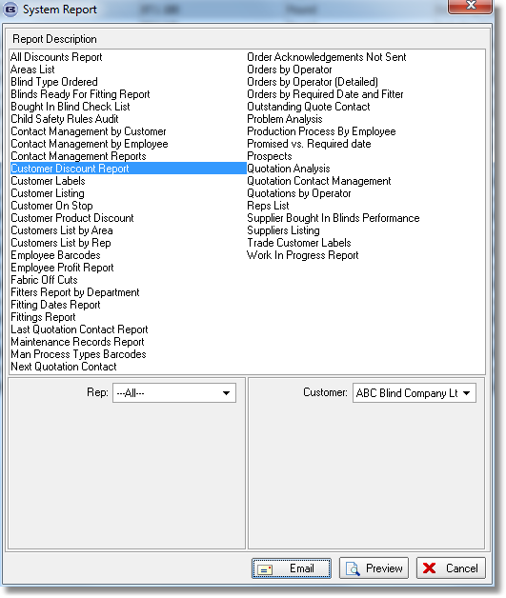

3334. Administration > Parameters

We have a customer that has some of their customers set up as ‘Batch Invoice’ = true. A new invoice layout was developed to handle this but it meant that the invoice layout hd to be changed in Parameters > Report Parameters > Batch Invoice, each time the report was run, which was not convenient.

Historically the problem was actually to do with the word ‘Batch’ as it has two different meanings with regard to invoice printing. It can be used to print a lot of invoices (‘Normal Invoices’ in ‘Invoice Batch Print’) or it can be used for print batch invoices (‘Batch Invoice’ is set to true in the customer record).

Therefore there is now an extra report choice in Parameters > Report Parameters (and Report Export Parameters) called ‘Customer Batch Invoice’. This is used for invoices for customers where ‘Batch Invoice’ = true.

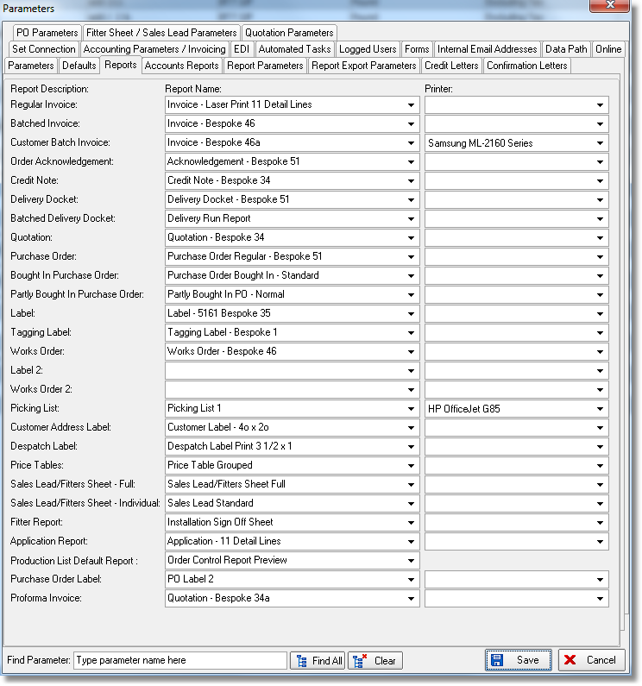

3340. Order Processing > Orders > Number Of Louvres

For vertical blinds, there is now an option to display number of louvres in the order detail line, with the possibility of overriding it.

There is a new parameter in the blind type record (if blind identifier = Vertical) called ‘Display Number Of Louvres’, which defaults to false. If true, the number of louvres shows in the order detail line entry. If the number of louvres is changed, then it is flagged as changed.

3341. Sales Analysis by Blind Type (Weekly)

There is now an option in this report to show either the values or quantities of blinds, or both.

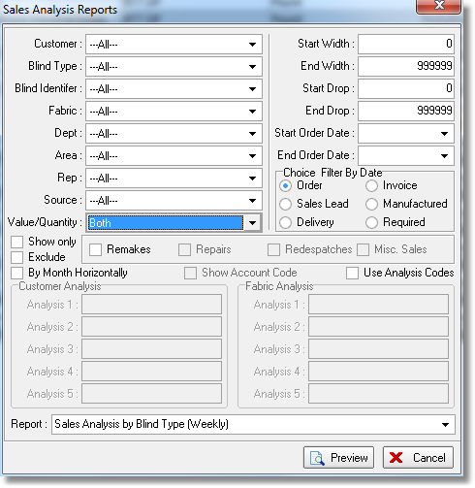
3344. Works Order – 4 Per A4

There is a new works order report that is similar to ‘Works Order Label Blind Size’ report but there are four sets of labels per A4 sheet.

3348. Reports > Cancelled Orders

There is now a new column for invoice number in this report.

3349. Works Order – Bespoke 45

There is another cutting size column, so the first four columns have been a bit narrower.

3350. EDI Import

If ‘EDI Import as Immediate Invoice’ is selected in the customer record, when the order is imported, the status of the order is ‘Invoice Printed’ and not ‘Invoice Created’.

3358. Acknowledgement – Bespoke 34

We made a change to ‘Quotation – Bespoke 34 (dev 3243) so a lot more room was provided for printing the blind type description. There is now the same amount of space on this report for the blind type description.

3359. Invoice – Bespoke 34

We made a change to ‘Quotation – Bespoke 34 (dev 3243) so a lot more room was provided for printing the blind type description. There is now the same amount of space on this report for the blind type description.

W208. Sage Pay

If the Sage Pay payment fails, the screen then showed a ‘Factory Order No’ against the order – now it does not get updated until after the order has been submitted.

W209. Admin Login

There is now a column for ‘Company Name instead of a column for ‘Contact Name’ in this form.

W210. Order Entry > Blind Details

The running total for the blinds was blank. This has been fixed.

