Blindata Release Note 6.5.4 

19 August 2013

Bug Fixes and Enhancements

4298. Order Processing > Orders

If a customer is set as ‘Inactive Customer’, it is not possible to select that company name or account code when adding a new order or quote. Previously it was possible to select it by looking up the ‘Account Code’.

4299. General Diary Appointments

There was a temporary bug where general diary entries could not be added or seen on the diary. Fixed.

4300. Purchase Order Enquiry

When creating regular purchase orders manually, the ‘View Related Sales Orders’ missed out sales orders when orders were ‘On Credit Hold’. This now only happens if ‘Ignore ‘On Credit Hold’ for Generate PO’ is false. If true, then on credit holds sales orders are visible.

4303. Label Print – Bespoke 33

Blinds entered in inches printed chain length incorrectly.

Removed ‘Customer Name:’ and ‘Description:’ from the large label

4305. Invoice – Bespoke 46

If you printed this invoice from ‘Archive Enquiry’ as a pdf, the logo in the archive enquiry invoice in the top left was smaller than the one printed from ‘Order Amend Enquiry’. Fixed.

4306. Posting Sales Invoices to Sage

If you post a sales invoice to Sage that has settlement discount on it, because of rounding errors, a different VAT amount could get posted to Sage. The VAT amount that was posted to Sage was actually correct – the VAT on the invoice was wrong (by 0.01) and has been fixed.

4307. Works Order – Bespoke 42

The contact name is now the contact name from the sales order, not the customer.

New Work and Customer Requests

3187. Optimisation

A significant amount of time has been spent optimising the system. Additional notes can be provided on request but users should notice improvements in speed, in particular to the ‘Order Amend Enquiry’ form and saving orders.

3241. Picking List

There is a new calculator called ‘Quantity Per Blind Type’, which will do the same thing as the ‘Quantity Per Order’ but create the number of BOM records that is the same as the number of blind types in the order.

3242. Works Order – Bespoke 34a

Previously only 8 options showed on this works order. We have increased this by moving the fabric description and customer ref (Location) down a line into the same line as the special instructions. The special instructions now have a slightly smaller font.

This means there is now room for another 4 options.

3280. Sales Analysis by Blind Type by Month (Value/Quantity)

There are now totals at the end for Blinds Per Day (will need to know no. Of working days per month), Total Made Up Turnover, average £ per blind, average made up £ per day, miscellaneous/carriage turnover, credits (entered by month), credit note % (of gross turnover), total turnover (gross – credits), average turnover per day.

The totals appear at the end of the report in the bottom left like this:

Blinds Per Day = 123
Total Made Up Turnover =
Average £ Per Blind =
Average Made Up £ Per Day =
Miscellaneous/Carriage Turnover =
Credits (Entered By Month) =
Credit Note % =
Total Turnover =
Average Turnover Per Day =
credits (entered by month), credit note % (of gross turnover), total turnover (gross – credits), average turnover per day.

Here are the calculations:

Blinds Per Day = Average number of blinds per working day (so exclude weekends and holidays)
Total Made Up Turnover = net total of blinds ie not miscellaneous
Average £ Per Blind = Total Made Up Turnover (excluding misc) / Total number of blinds
Average Made Up £ Per Day = Net total / number of working days
Miscellaneous/Carriage Turnover = miscellaneous total
Credits = credit net total
Total Turnover = net total
Average Turnover Per Day = Net total / total number of working days

3288. Order Processing > Orders > Chain Length

If you select a motor (for example) you will not need a chain length, so we need some way of zeroising the chain length automatically. There is now a new flag on the stock record called ‘Zeroise Chain Length’. If an option is chosen with this flag set to true, then the chain length in the order entry is zeroised.

3315. Sage 50 2014

It is now possible to integrate to the new version of Sage 50 2014 (version 20.0).

3316. Tabular Form Interface

There is now a way of adjusting the tabular form colours in Blindata in Administration > Parameters > Forms. After colour selection and saving parameters, Blindata should be restarted.

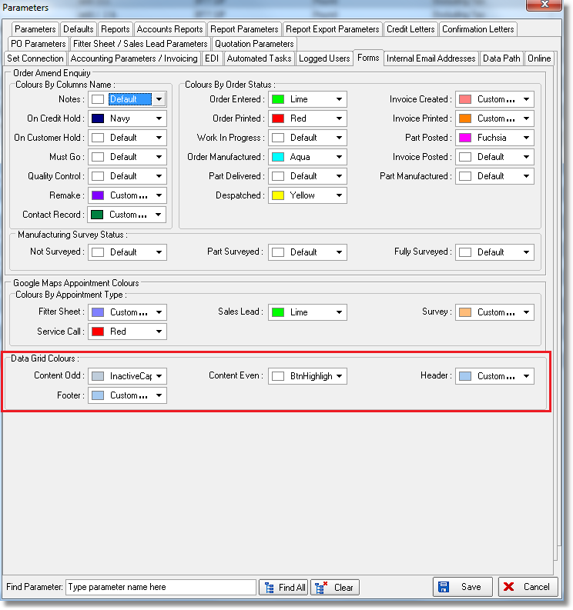

3318. Maxton Purchase Invoice Posting

It is now possible to post purchase invoices into Maxton. The existing location for ‘Maxton Data Location’ has been renamed to ‘Maxton SL Data Location’ and the new one is called ‘Maxton PL Data Location’.

When the purchase invoice is posted to Maxton, it uses the same code as is used for the sales invoice posting. The file layout is the same.

3319. EDI Import

There is a new field in the customer record called ‘Use EDI Import Prices’ which defaults to false. If this is set to true, then the prices in the XML file are put into the net price for the detail line instead of looking up the price tables. The option prices and discount will always be 0.

3320. Sales Files > Customers

There are now column choices for Daily Status Report and Online Order Authentication

3327. Fabric Group Setup

There is now a field choice for ‘Turn If Width > Roll Width’ so it can be updated.

3330. EDI Import XML File

There is a a new field called ‘MustGo_’ in the header of the XML file. When it is imported, it imports to ‘Delivery Notes’.

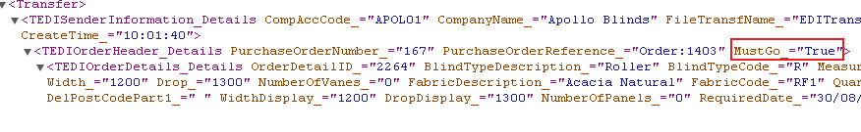

3331. EDI Import Required Date

The ‘Required Date’ that is imported from Direct Blinds XML file to wift Blinds is the date that the end customer should get the blinds. However Swift Blinds define ‘Required Date’ as the date the order has to be despatched by them. We therefore need to calculate the required date as being a working day before this.

There is a new field in the customer record called ‘Import Required Date Days Earlier’. This is an integer field to indicate the number of days to be deducted from the required date in the XMl file to give the required date in the order. It takes into account weekends and holidays.

For example, if the required date is Monday 26 August in the XML file and this field is set to 1, it will be stored as Friday 23 August in the order.

