Blindata Release Note 6.5.3 

14 July 2013

Bug Fixes and Enhancements

4291. Works Order – Bespoke 50

This works order has been tidied up for blind identifier = Miscellaneous.

For the quantity for this blind identifier, the measurement unit as also now shown.

4294. Blindata AT

There was a connection issue with Blindata AT when it was first opened. This has been fixed.

If Gmail is being used for email delivery, then the SMTP server setting should be set up like this.

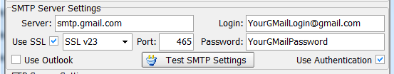

4295. Wholesale EDI File Creation

The quantity was shown to far too many decimal places. It is now held to 1 decimal place.

4296. Order Processing > Orders > Curtain Width Calculation

The ‘Number Of Widths’ calculation now rounds up to the next whole number eg 3.06 rounds up to 4. Previously it was rounding to the nearest whole number. In this example the roll width is 1370, so 2800 * 1.5 / 1370 = 3.0656 which should round up to 4.

The user is also now able to amend the number of widths themselves. For example, in the figures above, 3.0656 is close to 3 and so they may decide to use only 3 widths instead of 4.

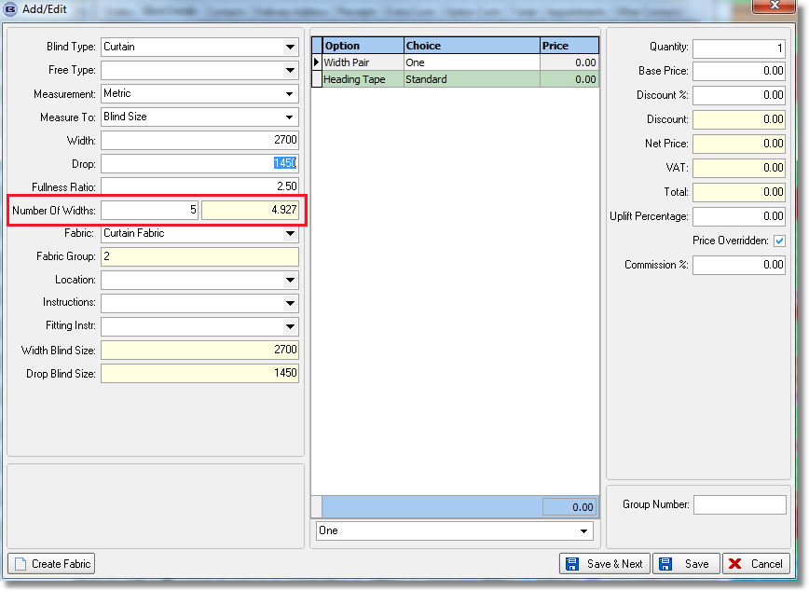

4297. Invoice – Bespoke 46

The totals boxes have been tidied up as the page number was overwriting the company details when there is more than one page on an invoice.

New Work and Customer Requests

3296. Immediate Invoice EDI Import

There is a new parameter in the customer record called ‘EDI Import as Immediate Invoice’, If this is set to true, then when an EDI file import is done, the order will be set to ‘Immediate Invoice’ = true.

Please switch the ‘Allow Immediate Invoice’ parameter on for testing this functionality.

Secondly it is now possible to post these invoices to Sage 200 as a consolidated invoice ie all the orders for that day will have the same invoice number (if imported together) and so will be posted as one invoice (customer will have ‘Batch Invoice’ = true).

This will only be relevant when an EDI import is being done. Therefore the invoice number used will be the same for all of the orders in the import file, because they will all be from the same customer.

3297. Bought In PO Delivery

If a ‘Bought In PO’ is for a sales order that is an ‘Immediate Invoice’ and ‘Direct Delivery by Supplier’ is also true, when the bought in PO is fully delivered, the status of the sales order is changed to ‘Invoice Posted’.

3301. Blind Details > Blind Types

If ‘Curved Headrail’ = true, there is new parameter called ‘Price by Curve’. If this is set to true, it should price as it does now ie based on the length of the headrail (width and depth) and the drop. If it is false, then it is just priced by normal width and drop.

3302. Works Order Label 1

If blind identifier = Wood Component, the option to ‘Show Cord Spacing’ now works for this works order print. If set to true, it prints the cord spacing. If false, it does not.
3303. Order Processing > Orders

There is a new flag called ‘Upgrade’ in the bottom right hand corner of the Window Blind Amend form, below the ‘Audit’ button. It is simply a checkbox with no other functionality or security assigned.

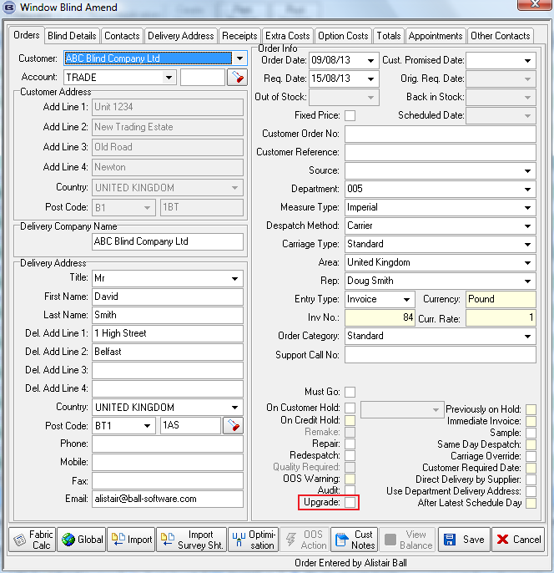

3304. Import From Excel > Option Restrictions

There is now an import routine for option restrictions.

3309. Fitters Sheet / Sales Leads

Previously if a sales lead was created and then an appointment made for it, if that appointment was then deleted (using the delete key), the sales lead iwa completely deleted. Instead of this, the sales lead is now given a status ‘Cancelled’.

Cancelled sales leads are excluded from the Sales Lead Report and Sales Lead Status Report, but they stay on ‘Fitters Sheet/Sales Lead Enquiry’ form so it would be possible to resurrect them.

3310. Financials > Daily Sales Report

The customer’s name for all Retail Sales is now showing on the daily sales report.

In other words, if the customer is Trade type = Including VAT, then the contact name prints instead of the company name ie Retail Sales is replaced by Mrs Smith.

3311. Order Processing > Orders > Order Amend Enquiry

Telephone number has been added as an option into ‘Quick Search’

3312. Reports > Daily Order Control Report

There is now an option to group this report by rep. There is a report choice by Rep (with an ‘All’ option) with group totals by rep and a grand total.

3313. Reps Commission/ Discount Report

We have a customer whose reps are paid following receipt of order rather than after payment of balance. There is now an option in this report for ‘Report on Balance Payment Only’. If yes is answered to this, then the existing report is printed. If no, then all orders are printed.

3314. Sales Lead Status Report

The% conversion calculation on this report is now based on leads less pending leads rather than just on leads.

3317. Blindata AT

There is now a column for the ‘Original Required Date’ on the daily sales report that is sent out.

W198. Square Metre Pricing

Square metre pricing now works in the same way on the online system as it works in the desktop system.

