Blindata Release Note 6.5.2 

6 August 2013

Bug Fixes and Enhancements

4283. Quotation Print

The quotation print routine has been optimised.

4284. Works Order – Bespoke 46

If an order is entered for a curved headrail and the depth is entered as an imperial size, it now prints on the works order as metric (if parameter is set for ‘Metric’ to be printed).

The ‘No of Brackets’ now prints for blind identifier = Venetian if ‘Show Number Of Brackets’ is set to true in the blind type record.

4285. Invoice – Bespoke 46

If the detail lines fill the first page, but there are none on the second page, the totals now print at the bottom of the second page.

4286. System Tables > Area Codes

‘Carriage Amount’ is no longer relevant on this form, and has been removed.

4287. Sales Files > Customers > Add

The adding of customers has been optimised.

4288. Reps Day Sheet

Comments were being cut off. All the comments text that can be entered is now printed.

New Work and Customer Requests

3291. Order Processing > Orders

There is now a new text field for ‘Invoice Text’ that is in the ‘Totals’ tab of the order form.

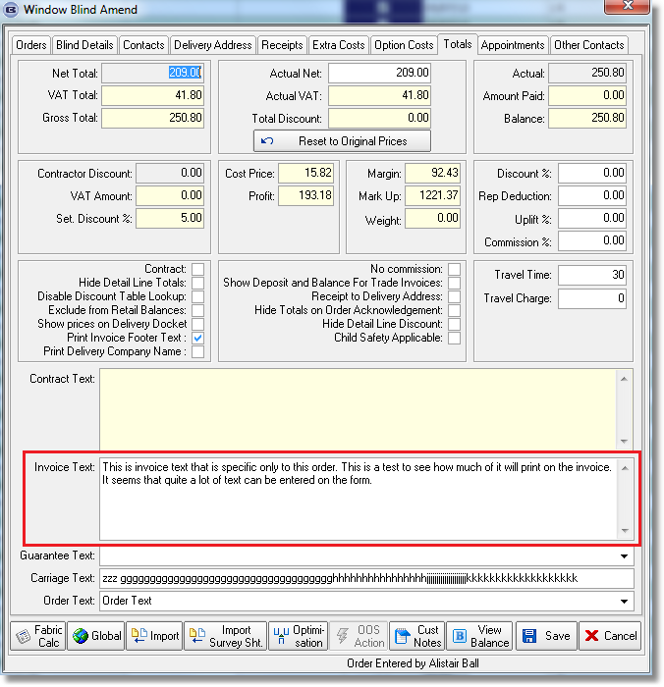
At the moment this only prints on ‘Invoice – Bespoke 42’.

3292. Order Processing > Orders

There is a new parameter called ‘Prompt Customer Email Question’. If this is set to true, then after the customer is entered in order entry, and there is no email address in the customer default address field, a message appears saying ‘There is no email address set for this customer. Please contact them to get this address’. It then allows the user to continue.

3293. Order Processing > Orders On Hold

There are now extra columns in this form for cust ord no, customer reference, account code, along with column choice ability.

3294. Order Processing > Orders

There is a new button on the order entry form called ‘View Balance’. This will display in a small window ‘Sales Ledger Balance’, Blindata Orders’, Credit Limit’, ‘Available Credit’. Available Credit is ‘Sales Ledger Balance’ + Blindata Orders’ – ‘Credit Limit’. This has an advanced permission flag called ‘View Balance’.

3298. Pricing > Discounts

It is now possible to hold discount by blind identifier. There is a new column in ‘Discounts’ called ‘Blind Identifier’. The discount algorithm has been changed to take this new option into account.

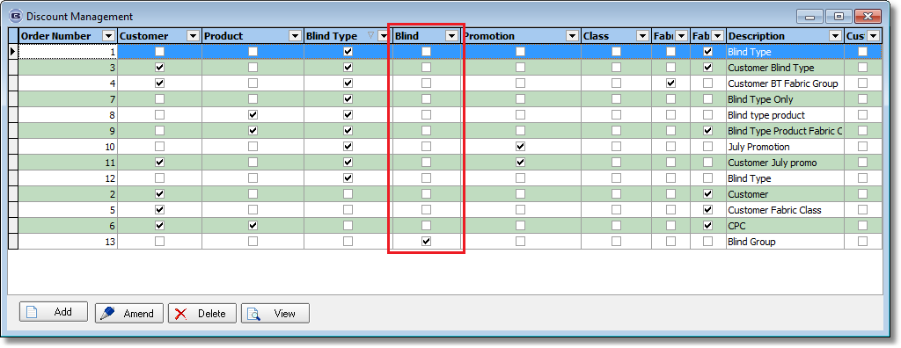

3299. Order Processing > Orders

There is a new parameter called ‘Required Date Prompt’. If set to true, a box will appear to get the user to confirm the required date at order entry after ‘Save’ is clicked (and after the required date has been calculated). It is possible for the user to amend the required date, but only forwards.

This has also been applied to the online system (but only if the flag is set to true).

3306. Works Order – Bespoke 41

Removed ‘Delivery Date’ and changed ‘Despatch By’ to the required date.

W199. Order Entry

If ‘capitalise Cust Ord No / Cust Ref / Notes’ is set to true in the desktop Parameters, then these fields are in capitals on the online system.

