Blindata Release Note 6.5.0 

19 July 2013

Bug Fixes and Enhancements

4263. Invoice – Bespoke 44

On the first page, the line up is ok, on the second and subsequent pages, the detail lines slipped up the page slightly. Fixed. Also checked where totals print on invoices with multiple pages.

Velux code now prints for blind identifier = Velux

Now Print ‘Cust Ord No: 1234 / Ref: cccccc / Order No: 34567’ instead of just 123456 / cccccc.

4264. Works Order Label Blind Size

For a curved headrail, the headrail length now prints out. Also if Impala or Vitesse, it prints the travellers.

4265. Acknowledgement – Laser Print

Velux blinds now print the correct details – Velux Code number and fabric description.

4267. Works Order – Bespoke 51

Aligned customer address so that it appears directly below “Customer” name.

Added black borders around all cells for detail lines.

Changed font/column sizes so that a stock code of 16 characters (ideally) can appear.

4268. Acknowledgement – Bespoke 51

“Total Order Value” - format now shows £
“Price ex. VAT” - format now shows £
“Payment Terms” - dropped this one line down and increased the text field size.
Centre aligned “Blind Type” header
Left Hand aligned all top section editable text.
Made Logo larger – Width = first column

4269. Works Order – Bespoke 50

If the blind identifier = Panel, the ‘No of Panels’ and ‘Panel Size’ now print on the left hand side of the large label.

New Work and Customer Requests

3237. Customer Daily Status Report

It is now possible to send out a report to customers with the status of each live order. This shows:

Cust Ord No, order no, online order no, products, net value, required date, status, on credit hold, on customer hold.

The report is in landscape. Customers without live orders will not receive the report. The report can automated and go out every night, to a specific email address called ‘Status Report Email’.

There is a new flag in the customer record called ‘Send Daily Status Report’ which defaults to false. This field is included as a choice when importing using Import From Excel > Customer Update.

The email is addressed to the contact name in the customer record and the subject is ‘Daily Status Report from [Company Name]’ where [Company Name] is the company name in ‘Company Details’.

The report can be run using a new program called Blindata AT. This will be installed in c:\program files(x86)\ball software\blindata and can be run from there.

When the program is run, the icon will reside in the icon tray in the bottom right of the screen. If you right click on the icon, the following context menu will appear.

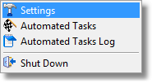
Settings

The following settings need to be entered – you will need to find out emails settings for your system if you are not using Outlook.

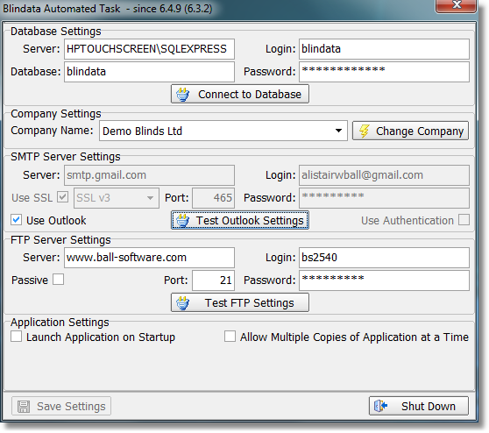
There are two tasks that can be run – Daily Sales report and Delivery Docket Batch XML (see dev 3265 immediately below).

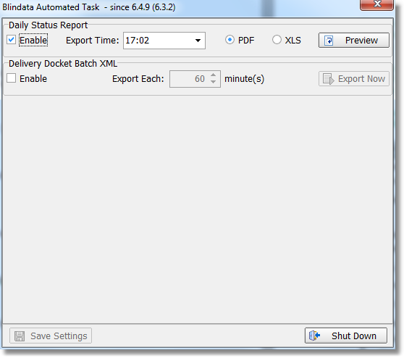
A history of tasks can be viewed here.

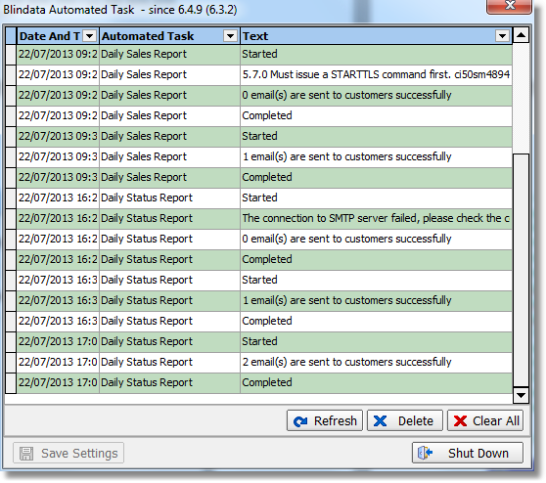

3265. Generate Delivery Docket XML (re-release of 6.3.2)

There is now a function that will batch generate delivery docket XML files for selected customer’s orders.This is run within the Blindata AT program (see dev 3237 above).

It is now possible to do the following:

Have the ability to flag which customers the job will run for – we need a new flag in the customer record called ‘Send Delivery docket Batch XML’. There should then be a new folder name for this called ‘Tracking Folder’.

Flag orders that have had a batch del docket created previously to prevent duplicates
The job should run every hour and for any orders at the ‘Despatched’ status for selected customers and where the ‘ConsignmentNoteNo’ is not blank and where the order has not been previously sent.
For any orders that meet the criteria, an XML delivery docket file will be created in a new FTP folder specified on the customer card called ‘Tracking Folder’ (below Delivery Folder).
The name of the export file is [Blindata Order No]_[Cust. Ref]_[Customer Name].xml
The content of the export file is the same as the existing Delivery Docket XML file, with two additional fields in the <DeliveryDocket> section. These aree called ‘ConsignmentNo’ and ‘TrackingLink’.
ConsignementNo field is equal to the orders ‘ConsignmentNoteNo’ field.
The TrackingLink field contains a URL that is clickable to track the consignment online.
There is a new field on the Despatch Method system table to hold this. Basically, Blindata should append the ConsignmentNo onto the end of the TrackingLink from the orders associated Despatch Method and insert this into the ‘TrackingLink’ XML field. Eg, if a CityLink order is despatched, and the tracking link for City Link is ‘http://www.city-link.co.uk/tracking-id=’ and the consignment no is ‘AIX123’ then the following string is inserted into the XML: ‘http://www.city-link.co.uk/tracking-id=AIX123’.

3266. Order Processing > Repairs

There is now a lookup for the nominal code in the repair order detail entry.

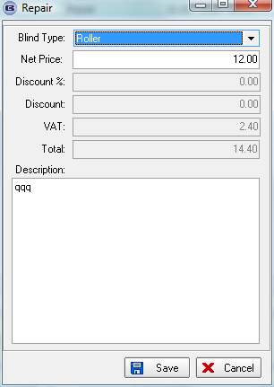

3268. Update Area Codes in Orders

We wrote a script recently so if area codes were changed in customers, they would then be updated in all orders. This has now been included as an option in Administration > Maintenance. The option is called ‘Update Area Codes in Orders’.

3269. Quotations / Order Acknowledgements

If ‘Enter Install Height’ is set to true, then it is printed on all quotations and order acknowledgements.

3284. Stock Control > Reports > Fabric Requirement Report

If ‘All’ is selected for supplier, the report is grouped by supplier.

W202. Child Safety Regulations

The child safety changes are now all applicable to the online system.

