Blindata Release Note 6.5.1 

30 July 2013

Bug Fixes and Enhancements

4273. Blindata AT > Daily Status Report

This report no longer contains records with status ‘Invoice Posted’.

4274. Works Order – Bespoke 42

- This was printing strange characters in the top left – fixed.
- The fabric quantity is now correct if quantity > 1.

4277. Works Order – Bespoke 42

Customer company was running into ‘1 of n’ then off the page – fixed.

Removed ‘Order Line: 1 of 1’.

4278. Production List By Blind Type (Landscape)

Removed slats/vanes column. Fixed quantity – was wrong if quantity > 1.

‘Page 1 of n’ prints instead of just ‘Page 1’.

4279. Pricing > Discounts

Customer column can now be put in order when using the arrow filter.

4281. Order Enquiry > WIP Scan

There is a field on the [Order] table called [date_startmanufacture]. This now records the date that the first blind on an order is set as WIP.

4282. Blindata AT Execution Time

Blindata AT only ran on one day. It now send emails at the scheduled time each day.

New Work and Customer Requests

3270. Order Processing > Bought In Order Tracking

There is now a ‘Net Total’ column choice for this form.

3271. EDI Import

If an order is imported and the value of one of its base prices is zero, and if ‘Display Checked’ is ticked, then the order is not flagged as checked.

3272. Order Processing > Quotations

If ‘Display Checked’ is switched on, then it is possible to set ‘Checked’ = true in a quotation. If it is checked, then when it is converted to an order, the order is also checked. If it is left as unchecked, then it will behave as it currently does.

3275. Order Processing > Global Search

If you printed a works order from Global Search it changed the Order Status and recorded in the Order History. This no longer happens – it doesn’t change the status but it does record it in the history.

3276. System Tables > Despatch Method

This form has been amended so only the despatch method is shown on the grid. The user now has to click on the ‘Amend’ button to edit the form. This form then displays.

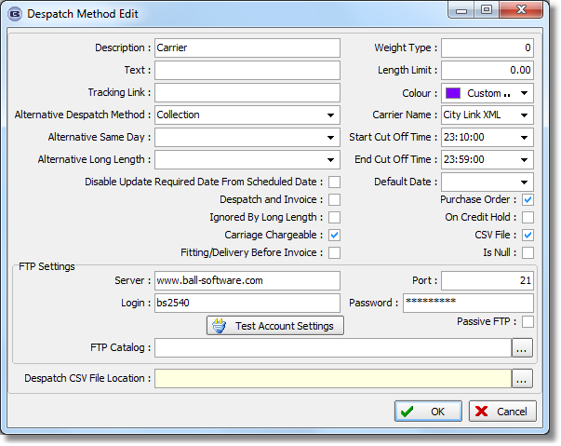
There is a new field in the despatch method form for ‘Despatch CSV File Location’. If this is filled then the location entered will be used, otherwise it will revert to the existing location in the Parameters form.

3277. Order Processing > Global Search

In the Order Enquiry screen there are two buttons located at the bottom called “View Process Transactions” and “View Transactions By Subdivisions”. These buttons are now included in the Global Search screen.
3278. Blind Types > Credit Control Email
There is now an email address held against the blind type called ‘Taken Off Credit Hold Email’ (in the ‘Header, Footer and Works Order Text’ tab. If this is filled, then if an order containing a detail line with this blind type is taken off credit hold, an email is sent to the email address in the blind type record.
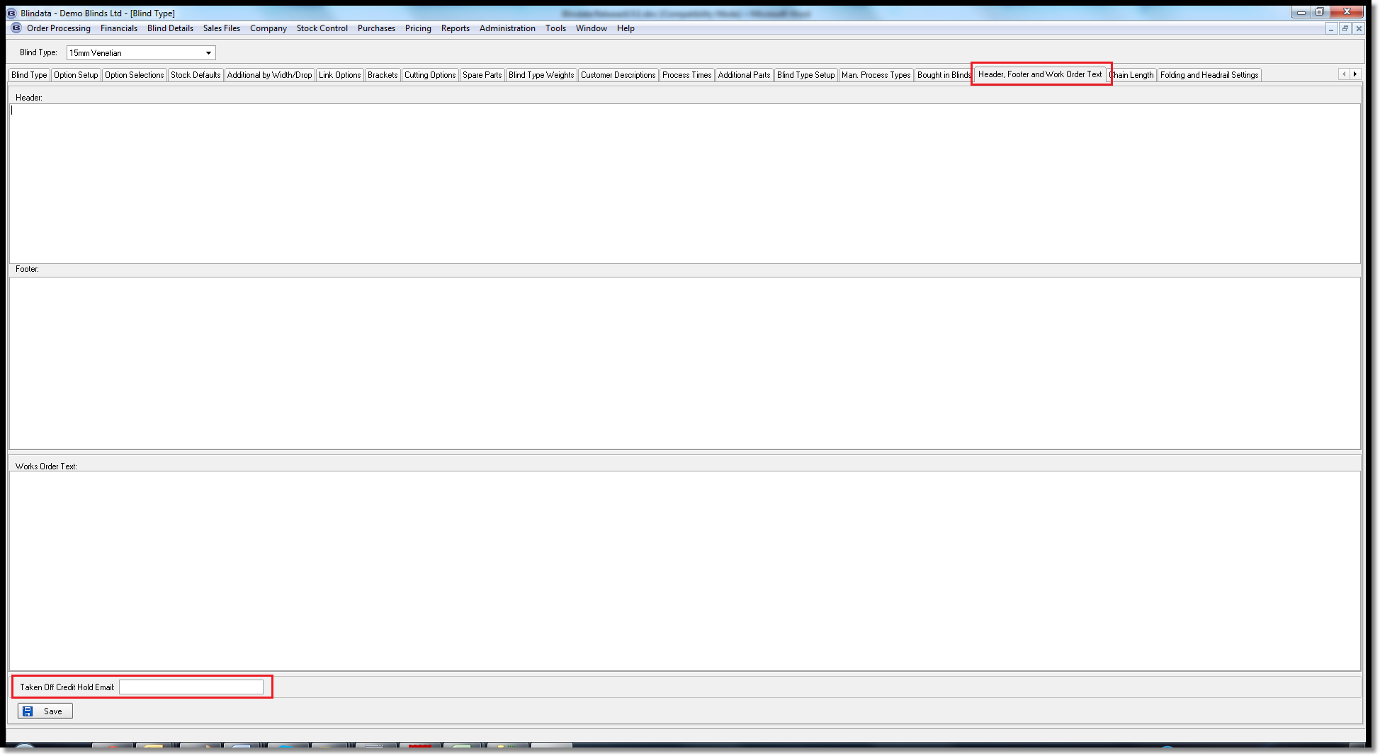
3283. Order Processing > Paid Proformas
The system now records who changed a proforma to paid and when it was done. This is held in the quote / order history.
3286. Works Order – Bespoke 22

For blind identifier = Curtain, the ‘Fullness Ratio’, ‘Widths’ and ‘Number of Cuts’ are now printed on this works order. The number of cuts is the number of pieces of fabric that need to be cut to make the curtain.

3287. Label – Bespoke 22

For blind identifier = Curtain, the ‘Fullness Ratio’, ‘Widths’ and ‘Number of Cuts’ now print on the large label.

3289. Delivery Docket – Bespoke 42

This now prints ‘Customer Signature………..’ in bottom left. Also ‘Date Received……….’ In line below. This is for the customer to sign and date.

3290. Invoice – Bespoke 42

The carriage type description for carriage surcharge is now shown in the invoice detail line – so the description will say, eg, Carriage Surcharge – Pre 10am Delivery’.

If there is a receipt against an order, deposit and balance is now always shown on this invoice.

‘Despatch Method’ now also prints in the header of invoice. Some of the other fields in the header have been made a bit narrower.

