Blindata Release Note 6.4.9 

15 July 2013

Bug Fixes and Enhancements

4258. Works Order Label Blind Size

There was a problem with the Vitesse carrier calculations if the options left or right bunch were selected. Fixed.

4261. Quotation – Bespoke 34

The blind type description now wraps round to the next line if necessary.

4262. Order Processing > Orders

If ‘Create Component Serial Detail Lines’ is switched on, for component entry it only creates one serial detail line per order detail line, regardless of the quantity.

New Work and Customer Requests

3257. Order Processing > Orders / Quotations

If the ‘Group Number’ column is chosen in the ‘Window Blind Amend’ form and ‘Alternative Sizes Change’ = true in the user record, then it is also possible to change the group number here.

3258. Child Safety Regulation

We have made a number of changes to Blindata to comply with anticipated mandatory EU regulations.

The purpose of these changes are twofold. Firstly, it is imperative that companies adhere to the revised standards. We have examined the relevant documentation provided by the BBSA and made changes that should cover the necessary points. Secondly we have introduced an audit trail so companies can keep a record of the changes they have made to their system to make sure they comply with the regulations.

There is a significant amount of set up work required, so customers should be fully aware of what they need to do. The BBSA has already supplied expert guidance to members. For non members, our advice would be to give serious consideration to joining the BBSA.

Administration > Parameters

There is a new field in the Parameters table called ‘Enable Child Safety Rule’. This has three choices – ‘Enabled’, ‘Not Applicable’, and ‘Not Yet Answered’. After the upgrade is done, it will default to ‘Not Yet Answered’. When Blindata is opened, if the parameter says ‘Not Yet Answered’, the user is prompted to fill in the parameter with ‘Enabled’ or ‘Not Applicable’. It records the user and the time this is filled in, in a new table called ‘Child Safety Log’. It is not be possible to enter a quotation or order if ‘Not Yet Answered’ remains in the parameter.

Blind Details > Blind Types

There is a new field for the installation height of the blind. This works in both metric and imperial. If 0 is entered, then it will be classed as ‘Not Known’. This is required in both the desktop system and the online ordering system. There is a new flag on the blind type record called ‘Enter Install Height’.

System Tables > Child Safety Rules / Blind Types > Child Safety Rules

We also need to identify the option that relates to the chain/control length. There is a new table in System Tables called ‘Child Safety Rules’. This contains blind type, stock code, operating method, install height, distance from floor, drop greater than, drop less than, cord length %, cord length max, cord length logic, message.

When records are entered or amended in this table, the changes are recorded in the ‘Child Safety Log’ file automatically.

If stock code is left blank in this table, then the record will apply regardless of options selected.

The operating method will either be ‘Operating Loop – Breakaway System’, ‘Operating Loop – Fixed Tensioning System’, ‘Pull Cord’ or ‘Exempt’.

The specific logic that will be applied is held in spreadsheet ‘Child Safety Rules.xlsx’. Fields in yellow are mandatory. Fields in mauve must have one of these entered per record. The messages have not yet been filled in.

Administration > Import From Excel

There is a new option to import records to the ‘Child Safety Rules’ table in ‘Import From Excel’. This also updates the ‘Child Safety Log’. The option in the ‘Import From Excel’ is called ‘Child Safety Rules’.

The spreadsheet contains fields for blind type, stock code, operating method, install height, distance from floor, drop greater than, drop less than, cord length %, cord length max, cord length logic.

Order Processing > Order Entry

There is a new flag in the order header form called ‘Child Safety Applicable’. If ‘Enable Child Safety Rule’ = Enabled in Parameters, then this defaults to true. If ‘Enable Child Safety Rule’ = ‘Not Applicable’ in Parameters, then ‘Child Safety Applicable’ defaults to false.

If ‘Enable Child Safety Rule’ is enabled, when a detail line is entered for an order, the program will first check the ‘Child Safety Rules’ table to ensure there are records set up here. If none exist, then a message will appear saying ‘Please set up child safety rules for this blind type before proceeding’. If a blind type does not require any child safety checking, a record should still be set up in ‘Child Safety Rules’ for ‘Exempt’.

If ‘Enter Install Height’ has been switched on for the blind type, then the user will have to enter this. It will default to 0. If this is left as 0, then it will be assumed that the ‘Install Height’ is not known. The ‘Install Height’ will appear below the ‘Drop’.

If child safety rules have been applied, then when options are entered/updated, this table will be checked to see if any rules apply and the necessary calculations will be made. The child safety rule will also be checked if the ‘Chain Length’ has been amended in order entry. If there is none compliance, then the appropriate message will appear and the chain length will be adjusted automatically.

If the chain length is altered manually, then it will have to be validated by looking at the options and applying the relevant child safety rule.

EDI Import

We have included a field for ‘Install Height’ in the XML file that is imported to Blindata. The import routine will then have to validate the chain length.

3259. Quotation – Laser Print (Letterhead)

Settlement discount now appears on this quotation in exactly the same text as appears on invoices. This is only applicable if settlement discount > 0 for the customer.

3260. Works Order Label Blind Size

If ‘Print Fabric Supplier Name’ = true in Parameters > Report Parameters, the suppler code is printed in brackets eg (LOUV01) after fabric description

3261. EDI Import

Previously when an order was imported from Blindata Online, it printed the following in the ‘Customer Order No’ field (if there was nothing entered in this field in the online system.

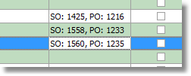

This information did not make a lot of sense, so instead it now prints ‘WEB:’ followed by either the online order number (not the id) if the ‘Cust Ord No’ field was left empty or the cust ord no that was entered by the online user.

3262. Parameters > Online Tab

In the ‘Buttons Visibility’ there is now a flag for ‘Privacy Policy’ as well as ‘Refund Policy’. If it is set to false, then the ‘Privacy’ tab does not appear in the online system. This new flag defaults to true.

There is also a button so the ‘Log In As Admin’ choice is visible as well. This is held in the same section.

3263. Import From Excel > Mapping Records

We now have a mapping import routine so all of the mapped records can be set up by importing them from a spreadsheet. This means a user will not have to start mapping records in ‘EDI Import’ as they will already be mapped.

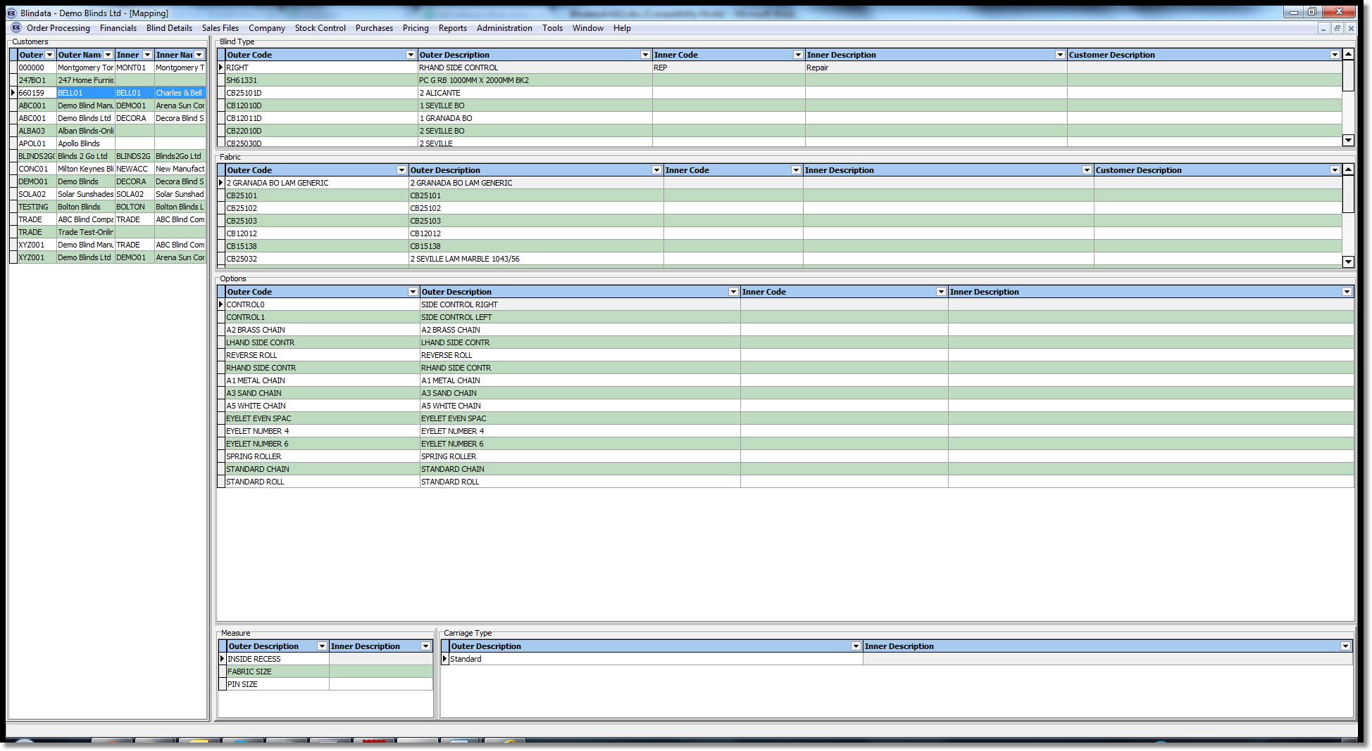

There is a new option in ‘Import From Excel’ called ‘Mapping Records’. The spreadsheet has four columns.

Record Type: this will be ‘Blind Type’, ‘Fabric’, ‘Options’, ‘Measure To’, Carriage Type’
Customer: customer account code
Outer Code
Inner Code

3264. Appointments

It is now possible to stop appointments being created for sales leads / fittings before the current date. There is a new flag in Parameters > Fitters Sheet / Sales Lead Parameters called ‘Block Appointments Before Current Date’. If this is true and a user tries to create any appointment before the current date, a message appears saying ‘You cannot create an appointment before today’.

3267. Reports > System Reports > Child Safety Rules Audit

There is now a report that prints out Date/Time, Operator and Text.

