Blindata Release Note 6.4.7 

27 June 2013

Bug Fixes and Enhancements

4243. Post Invoices

If invoices are being posted to Sage and ‘Post Full Invoice’ is switched on, the correct figures were not going into Sage.

ISSUE 1
Discount information is now being posted to Sage.

ISSUE 2
Mutliple blinds entered under a single detail line price correctly in Blindata. However when posted to Sage the total price was then multiplied again by the blind quantity. This has been fixed.

ISSUE 3
Order delivery addresses are now posted to Sage.

4246. Google Maps

The API for Google Maps is now working again. The following message was appearing.

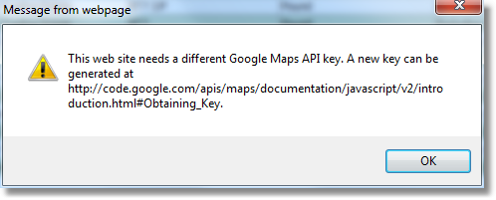

4247. Order Processing > Orders

When the ‘Blind Made Scan’ was done in Order Enquiry, it did not work temporarily. Fixed.

New Work and Customer Requests

3217. Sales Analysis by Blind Type by Month (Value/Quantity)

The records are now also grouped and totalled by Blind Identifier. This is similar to the grouping in Sales Analysis by Blind Type (Weekly).

3218. Order Processing > Orders > On Credit Hold

We now have the new credit on hold function (dev 3173). If the balance for a customer is > zero for invoices order than the payment days, then the order should go on credit hold. We now also look at the last day of the next month to decide whether the order goes to credit hold or not. This means that if ‘Pay By Day Of Month’ > 0, the order goes on credit hold if there is a balance that is overdue according to this rule. This is only applicable for Blindata accounting.

3221. Works Order - Label 7

If ‘Enable Serial No Shop Floor System’ is switched on, the barcode now prints the serial number id.

3250. Invoice – Batch Print Bespoke 46

There is a new invoice batch print called ‘Invoice – Batch print Bespoke 46’. There is settlement discount on these invoices so the calculation has been adjusted for the batch invoice routine.

3252. Delivery Docket – Bespoke 42

A new delivery docket report has been created called ‘Delivery Docket – Bespoke 42’, based on ‘Delivery Docket – Laser Print’.

We have removed order date, order tel no and rep from the header. The other fields have been moved up. Carriage Type has been made a lot bigger and is in bold. ‘Carriage Type’ is on one line with the entered text in the line below to make it stand out more.

