Blindata Release Note 6.4.0 

10 May 2013

Bug Fixes and Enhancements

4182. Blind Types > Cutting Sizes

Formula is now working for /. It was temporarily not working after the ‘Control Length’ button was added.

4183. Order Processing > Orders > BOM

The pocket calculation for a reef blind is now working properly.

4186. Quotation – Bespoke 22

This was printing the discount on the first line of the second page, when it was set to not print discount. Fixed.

4187. Aeronaut File

The file layout now looks like this:

START## HOLLAND BLIND
ORDER NUMBER 1037
LINE NUMBER 1-50 3/4 x 50 3/4
QUANTITY 2
MEASURED WIDTH 49.3750
MEASURED DROP 62.7500
CONTROL TYPE No Deductions
FABRIC TYPE Carnival
FABRIC COLOUR White
TRIM TYPE Very Plain Rectangle

4188. Works Order – Bespoke 42

For blind identifier = Curtain, the ‘Number Of Widths’ and ‘Fullness Ratio’ now print in the bottom third of this page.

4193. Post Invoices

If ‘Sage 200’ accounting is switched on, the ‘Invoice Date’ (and not the current date) now goes into the ‘TransactionDate’ field in the DCSSalesTransactions table,

New Work and Customer Requests

3160. Sales Files > Customers

There is now a default ‘Order Category’ field in the customer record. This is now picked up in the order entry program.

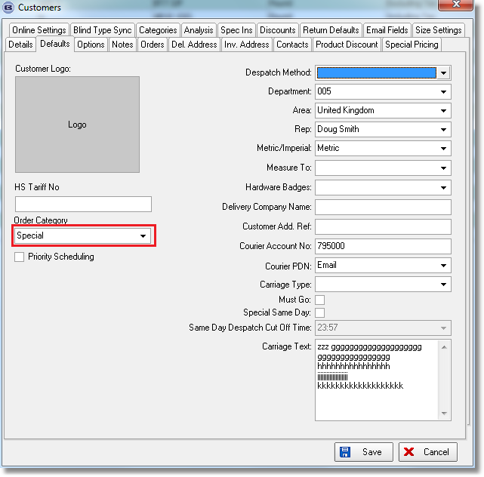

3161. Order Processing > Orders

There is a new parameter to get special instructions to default to CAPS, called ‘Capitalise Special Instructions’. This is held in Administration > Parameters.

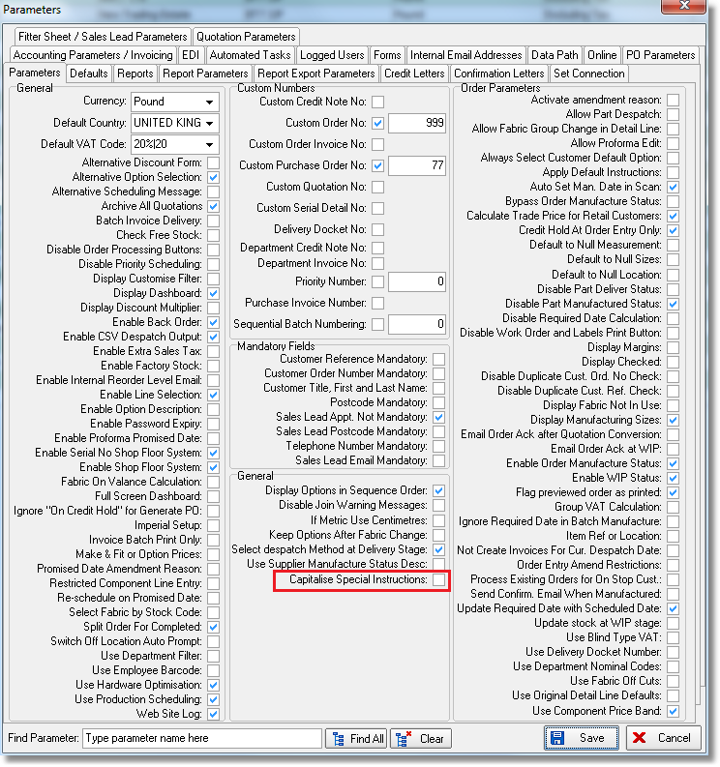

3163. Works Order – Bespoke 46

There is a new works order layout based on ‘Works Order Label Blind Size’, called ‘Works Order – Bespoke 46’.

3164. Order Enquiry > Order Manufactured

It is now possible to print out the delivery docket when order status is changed to ‘Order Manufactured’ instead of at the ‘Deliver’ stage. There is a new parameter called ‘Print Del Docket at Order Manufactured’. If this is set to true, then the delivery docket will print when ‘Order Made’ is done in either ‘Order Amend Enquiry’ or ‘Order Enquiry’ forms. The delivery docket will then not get printed at the ‘Deliver’ stage.

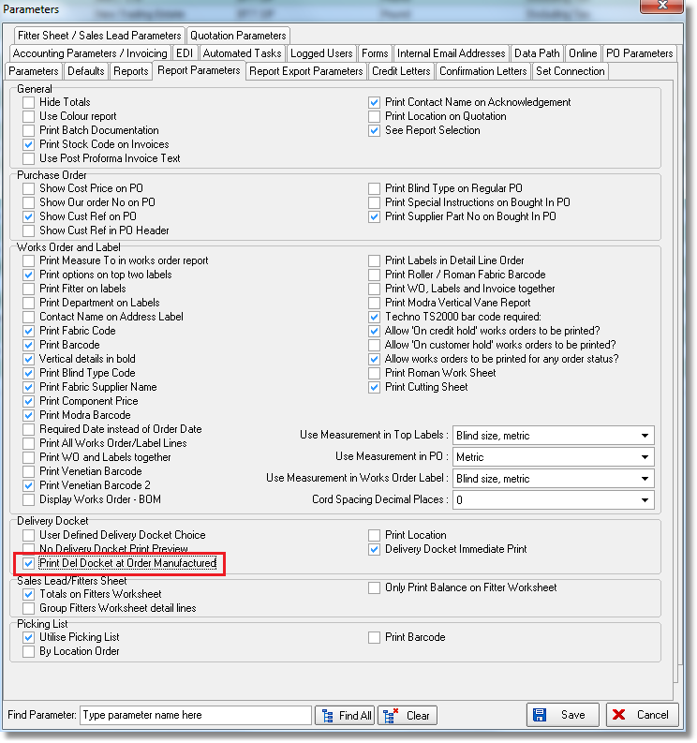

3165. Despatch Docket – Bespoke 46

A new report has been created, based on ‘Delivery Docket - Bespoke 26’ but it is in portrait.

3166. Invoice – Bespoke 46

A new invoice layout has been created, based on ‘Invoice – Laser print (Letterhead Logo).

3170. Order Processing > Production Lists > Order Control Report

The contact name on this report is now shown in brackets if the customer trade type = ‘Including VAT’.

3171. Works Order – Label 7

- Despatch method now prints on top left label to right of cust ord no, on right hand bottom label as well
- For verticals, the barcode now prints on top right label on rhs. We have moved fields left to make room.

3176. Administration > Company Details > Logos

It is now possible to hold six extra logos to be stored here. They are called ‘Logo5’ through to ‘Logo10’.

3177. Quotation – Bespoke 22a

There is a new report called ‘Quotation – Bespoke 22a’. This should be based on ‘Quotation – Bespoke 8 but with the following changes made:

- Have ‘plus VAT’ on the quote for trade type = ‘Excluding VAT’, ‘inc VAT’ for for trade type = ‘Including VAT’.
- Put website address in header – remove from footer.
- Remove address, add customer reference
- Remove ‘Dear’ line
- Put ‘Quote Number’ and ‘Job Reference’ below date.
- ‘Qty 2’ instead of ‘2’, move Location to left,
- Have unit price as (unit price 45.56) after width and drop
- Remove company details from bottom of page and have company name, quote order no, page number in it’s place.
- Print logos 2-8 on the last page of the quote.

W192. Order Entry

If an option is flagged as a ‘Non Discount Item’, then the discount on this option will always be zero i.e. the same functionality as the desktop system.

