Blindata Release Note 6.3.7 

15 April 2013

Bug Fixes and Enhancements

4168. Picking List 1

If this was printed after the works orders in Order Processing > Production Documentation, the pages were not being grouped by order number. Fixed.

4169. Order Processing > Orders

The ‘Order Category’ in order entry was not being saved – it was amended after the blind type is entered. This now only happens if there is a category set up in the blind type record.

4171. Order Processing > Quotations > Create Orders

When a quotation is converted to an order, the ‘On Sales Order’ amount in the stock record was not being updated, even though there is a BOM for a detail line. Fixed.

4172. Works Order – Bespoke 42

If the blind identifier = Panel, the ‘Number Of Panels’ now appears in the bottom part of the works order, below ‘Panel Size’.

4173. Label Print – 3 ½ x 1 Standard

The barcode has been changed to protocol 128, ratio 4.

New Work and Customer Requests

2652. Curtain Pricing

It is now possible to enter ‘Number of Widths’ for a curtain and price according to the number of widths and drop.

These prices are held in the ‘Vanes Price’ table form, as the pricing structure is similar to vanes only pricing. It is now possible to enter a blind type here if blind identifier = Curtain.

There is a new field in the blind type record (only if blind identifier = Curtain) called ‘Pricing by Widths’.

In the order detail line entry if ‘Pricing By Widths’ is switched on, then the base price is taken from the ‘Vanes Price Table’.

For option pricing, it is now possible to hold option price per width in the ‘Number Of Vanes Pricing’ in the Pricing menu. It is therefore possible to enter a curtain blind type here as well as a vanes only one.

2660. Stock Setup > Stock Items > Cost Price Uplift

It is possible to globally uplift unit costs by supplier. At the moment there is an ‘Uplift Prices’ button on the stock enquiry form. This will uplift all records that have been selected. In other words, records can be filtered and only those records filtered will have the cost uplift % applied.

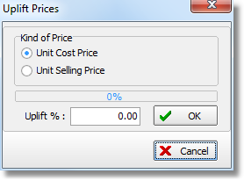
If ‘Unit Cost Price’ is chosen, then the prices in the ‘Unit Costs’ tab are uplifted as well.

3109. Works Order A4 Individual

It is now possible to print the Vitesse spacer information if relevant (as it is currently done in ‘Works Order Label Blind Size).

3110. Vitesse Headrail

Previously it was possible to print out the traveller/spacer information correctly for an Impala headrail, but only do it partially for a Vitesse headrail. It is now possible to do this fully for Vitesse.

The Vitesse system is a similar idea to the Impala headrail system – the main difference is that the spacers (3A, 8C etc) are calculated differently.

The following steps should be followed.

- Import “VitesseVane89.xls” and “VitesseVane127.xls” files using the relevant routines in administration > Import from Excel form.
- Add records into System Tables > Headrail Slat Table to determine the Headrail System which should be used.
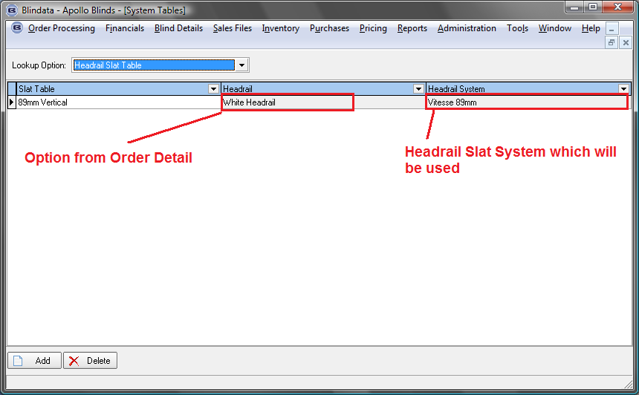

- Modify existing records or add new in the “System Tables > VitesseDefaults” table. There are two default records in the release with empty fabric records in them. One is for 89mm and one is for 127mm. If you want to set up Vitesse Defaults more flexibly then you could add records and fill “Fabric” (Option). This record will have a higher priority than with an empty fabric, if this Fabric exists in the Order Detail > Options and the Headrail System corresponds.

In this form, as an example, you could select the left or right or split bunch.

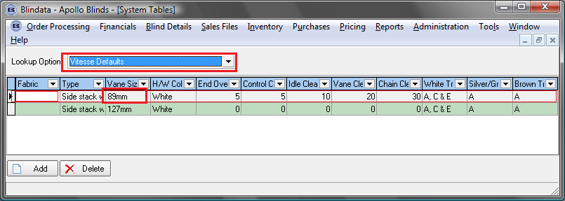

- Enter a detail line with an option for a Vitesse Headrail System.
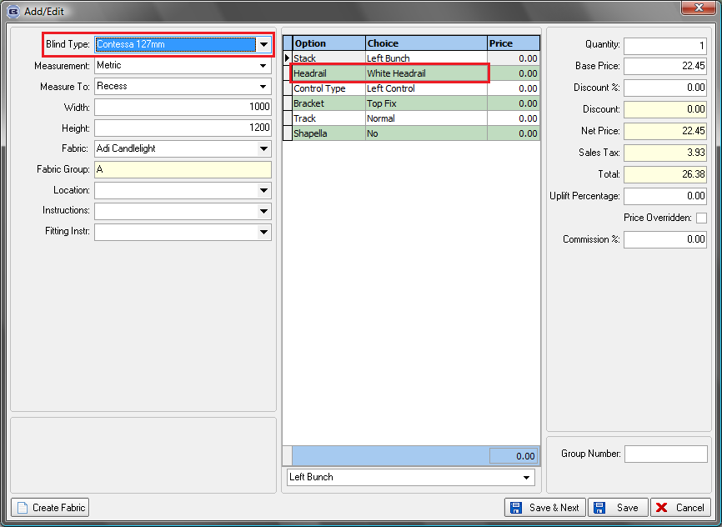

- Print relevant works order.

- Compare result with spreadsheet.
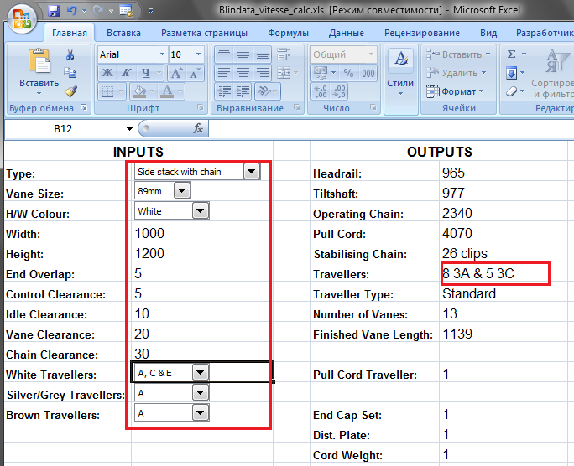

3052. Curtains

Blindata will now handle the entry of curtains properly.
There is some new terminology that has been applied, namely ‘Widths’, ‘Fullness Ratio’ and ‘Pattern Repeat’. We have already dealt with two of these: ‘Widths’ because we use that for calculating the BOM quantity if a calculator = ‘Pattern Repeat’.

The order entry now takes into account the ‘Fullness Ratio’. This actually means how much the fabric gets bunched up by the way it is attached to a track. The heading selected can affect the ‘fullness ratio’, which in turn determines the actual total width of fabric required. For example, if the width entered was 1800m, and the fullness ratio was 2.5, then 4500mm width would be required.

Work Done

Stock Items

There is already an option code for ‘Fullness Ratio in ‘Option Names’. There is also an option to enter the ‘fullness ratio’ for an option in ‘Option Calculations’. These both need to be set up before curtain order entry is done.

Order Processing > Orders

If the order detail line is for a blind identifier = Curtain and ‘Stock Control’ = true, the ‘Fullness Ratio’ and ‘Number Of Widths’ are displayed here (beneath ‘Drop’).

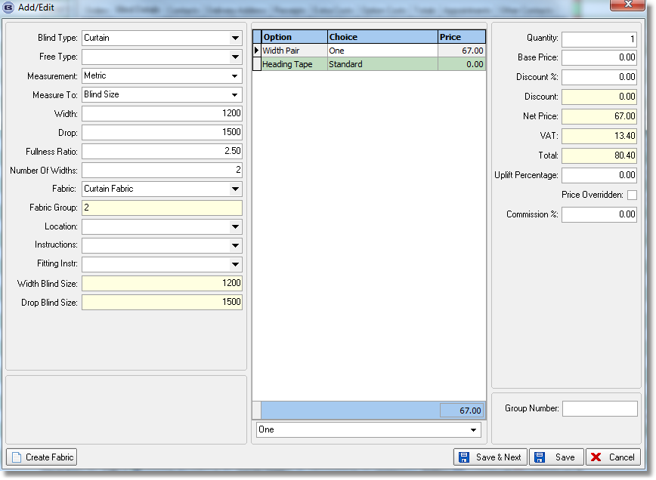
It is still possible to enter the fullness ratio, even though it may already be filled from the options that are selected (provided one of them has an option code = Fullness Ratio).

The ‘Number Of Widths’ is calculated by multiplying the width * fullness ratio (eg 2.5), dividing by fabric width, then rounding to a whole number. The same rule applies to single/pair as does to single/split bunch in verticals ie if it is a split, then an even number of widths must be used. This means rounding up to an even number if necessary.

If ‘Create Fabric’ is switched on in Advanced Permissions, and the blind identifier = Curtain, the user is also be able to enter fabric width, pattern repeat and supplier for the new fabric.

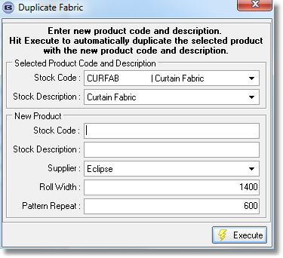
3125. Order Enquiry

There are now column choices for ‘Entered Width’, ‘Entered Drop’, ‘Man Width’, ‘Man Drop’.

3126. Import From Excel > Stock Update

It is now possible to import ‘Discount Class’.

3128. Cutting Sizes

‘Panels’ and ‘Mid Rail Height’ are now button choices in the formula. ‘Panels’ relates to both blind identifier = Panel and blind identifier = Shutter. Therefore it is now possible to do cutting size calculations using these fields.

3130. Order Confirmation XML

‘Required Date’ has been included in XML order confirmation ie if ‘Send EDI Order Ack’ is set to true in Sales Files > Customers.

3131. Stock Setup > Stock Items > Unit Cost Prices

Previously there was an anomaly in the system where two cost prices could be held independently for the same item. Here is an example:

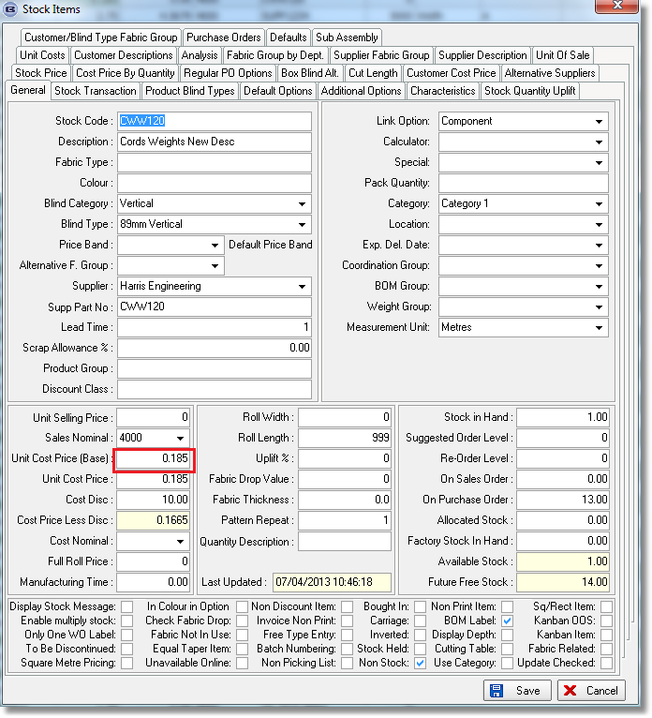
We can also hold the cost price in the ‘Unit Costs’ tab. This has caused confusion as it is not clear what the proper cost price is and we need this when the bill of materials is being calculated.

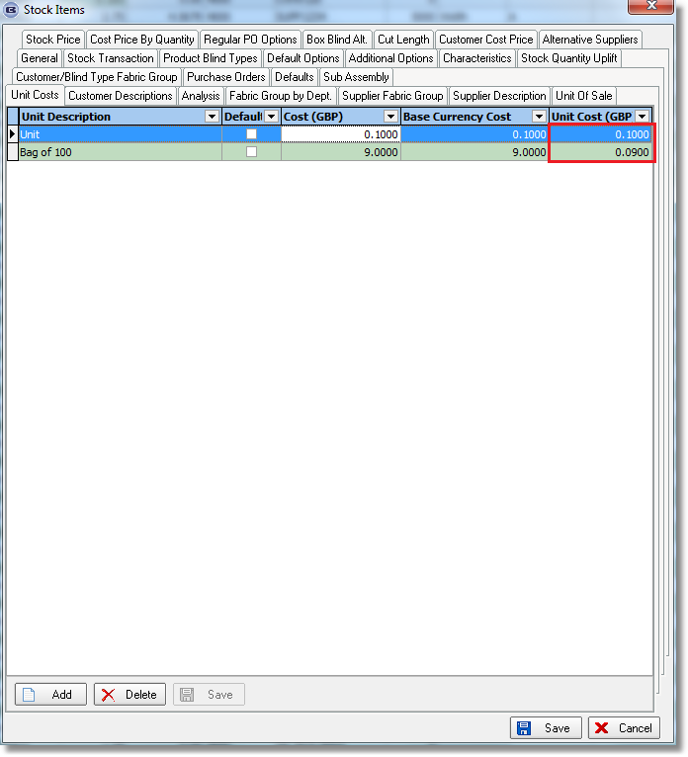
Therefore the following changes have been made.

When the Cost (GBP) or Unit Cost (GBP) is being updated in the ‘Unit Cost’ tab, it updates the ‘Unit Cost Price (and base) in the ‘General’ tab. This could involve several possibilities.
- There is only a unit record in the ‘Unit Cost’ tab (unit of sale quantity = 1 in System Tables > Unit Of Sale), so the cost price in the ‘General’ tab will get updated with the ‘Unit Cost (GBP) amount.
- There is only one record in the ‘Unit Cost’ tab (unit of sale quantity > 1) so the cost price in the ‘General’ tab will get updated with the ‘Unit Cost (GBP) amount.
- There are multiple records in the ‘Unit Cost’ tab, so the cost price in the ‘General’ tab will get updated with the ‘Unit Cost (GBP) amount if unit of sale quantity = 1. If there are no records where the unit of sale quantity = 1, then the record with the lowest unit of sale quantity is chosen.

When the cost price is updated in the ‘General’ tab, it also updates the Cost(GBP) or Unit Cost(GBP) in the ‘Unit Cost’ tab, but only if the unit of sale quantity for that record = 1.

When unit cost prices are being imported in Administration > Import From Excel > Unit Of Sale / Unit Cost Stock Prices / Cost Price By Quantity, the cost price in the ‘General’ tab is also updated if the unit of sale quantity = 1.

3132. Reorganise Stock Reports

Over the years we have been adding stock reports to the system, but in an unstructured way. To remedy this, there is a new ‘Reports’ option in the ‘Stock Setup’ menu. Also the menu option ‘Stock Setup’ is now called ‘Stock Control’, but if the country = USA or Canada, it is called ‘Inventory’.

The new menu option for ‘Reports’ has the following options:

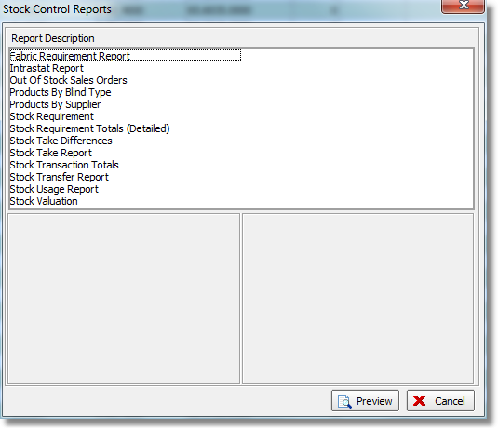

These reports have been moved from the ‘Reports’ menu.

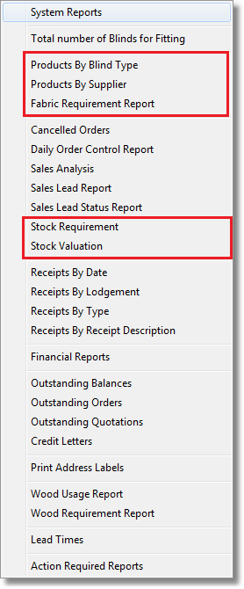

These reports have been moved from the ‘System Report’ form.

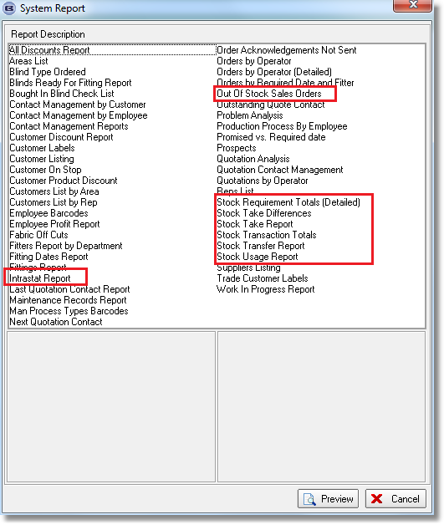

3133. Purchases > Purchase Order Enquiry > Shutter CSV

It is now possible to generate a generic ‘Shutter’ csv file for a bought in order. There is a new flag held against the supplier called ‘Shutter CSV’. If this flag is switched on, then in ‘Bought In Order Tracking’ when ‘Export Batch CSV’ or ‘Export Single CSV’ is used, the shutter CSV file is created and saved in the Docuware file location for the time being.

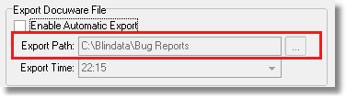
The filename should be Shutter Export.yymmdd.csv. There should be up to 25 options, which will match the sequence number in Blind Types > Option Setup. It has the following fields – there should be one record per detail line.

Order Number
Order Date
Cust Ord No
Cust Ref
Customer Company Name
Delivery Address 1
Delivery Address 2
Delivery Address 3
Delivery Address 4
Postcode / ZIP
Contact Name
Shutter Blind Type Code
Measure To
Width
Drop/Height
Mid Rail Height
Panels
Fabric Description
Option 1
Option 2
Option 3
Option etc

3134. Order Processing > Orders

If the Commission % in totals is updated, then the commission % in all the detail lines is also updated to the same amount.

3135. Acknowledgement – Bespoke 37

The option list has been moved to the second line and an extra 3 options have been added to the first line.

3139. Works Order – Bespoke 41

There is now a second row of options (with headers). This is required because there are too many options for some blind types. If all the options fit on one line, then it does not show a second line of options.

3145. Post Invoices to Sage 200

The nominal cost centre is now taken from the ‘Order Category’ field in the order.

