Blindata Release Note 6.3.6 

8 April 2013

Bug Fixes and Enhancements

4165. EDI Import

If an EDI order is for a customer that has ‘Quality Check’ = true, when the order is imported, it is flagged as ‘Quality Required’.

4166. EDI Import

If an online order is for a customer that is set to import the orders automatically, it was not sending out an order acknowledgement and updating the order history. Fixed.

4167. Works Order Print

A customer has reported an order that had the order detail status set to ‘Works Order Printed’ but the order header was still ‘Order Entered’. This happened because this order was flagged as 'customer hold' during works order printed. The program changes the order details status to 'Work Order Printed' but did not change the order status if order flagged as 'customer hold'. This no longer happens.

New Work and Customer Requests

3087. Xero Integration

The accounting parameters have been rearranged to include integration to Xero Accounting.

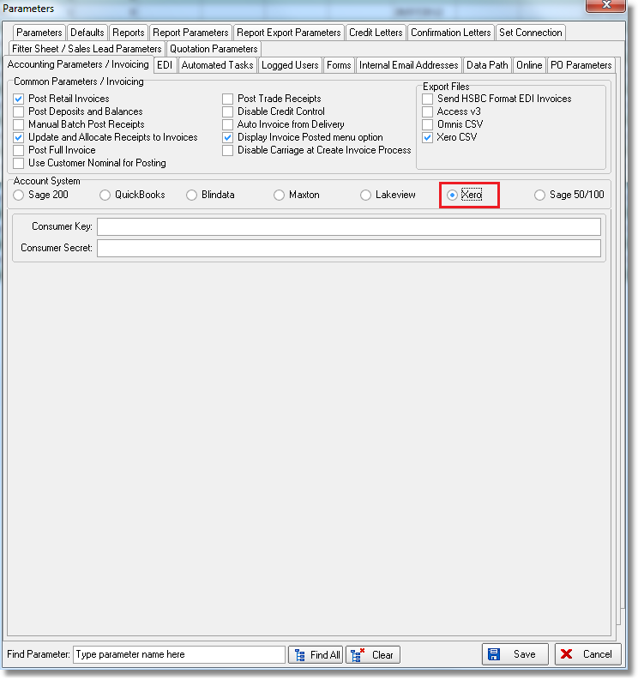

If this is selected, then invoices will be posted to Xero.

3101. Invoice – Bespoke 30a

There is a new individual pdf invoice called ‘Invoice – Bespoke 30a’.

3111. Sales Files > Customers > Activity

There is a new button to print preview an invoice from here, called ‘Print Invoice’. This is only available to Blindata Accounts users.

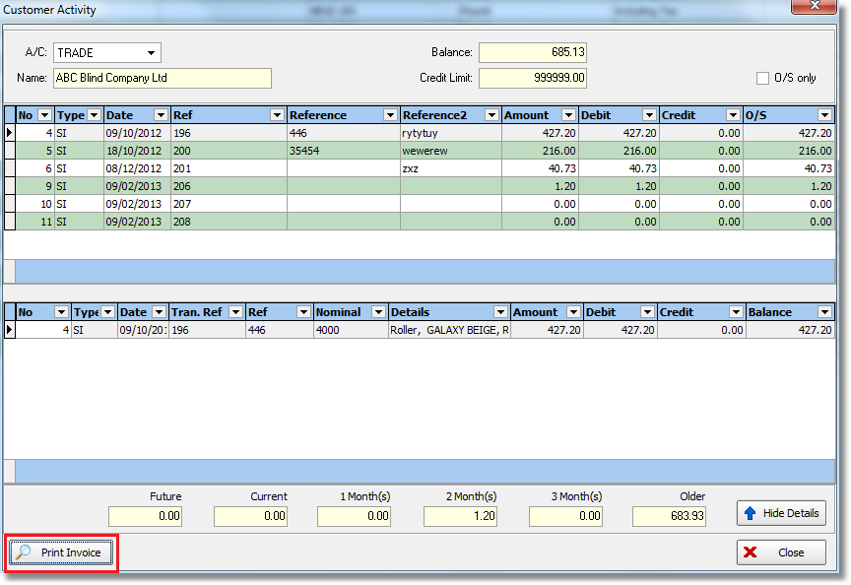

3112. Order Enquiry > Processes

‘Required Date’ has been added as a column and the records now default to required date = today and before today. It is possible to undo the filter so all relevant records are shown.

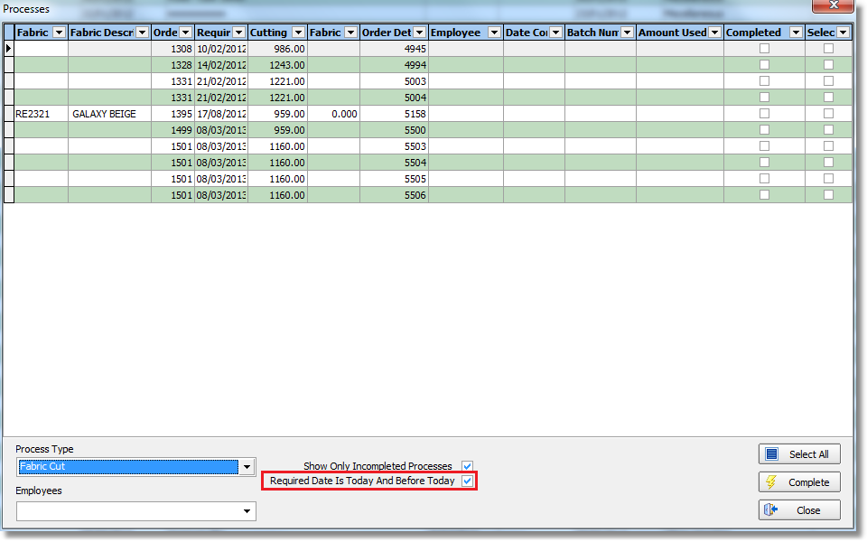

3113. Works Order – Bespoke 34A

Checking sheet information has been added to the bottom of the report instead of the hardcoded text. This can be set up by blind type, with an image being imported to the blind type record. There is a new tab called ‘Images’ where this can be stored.

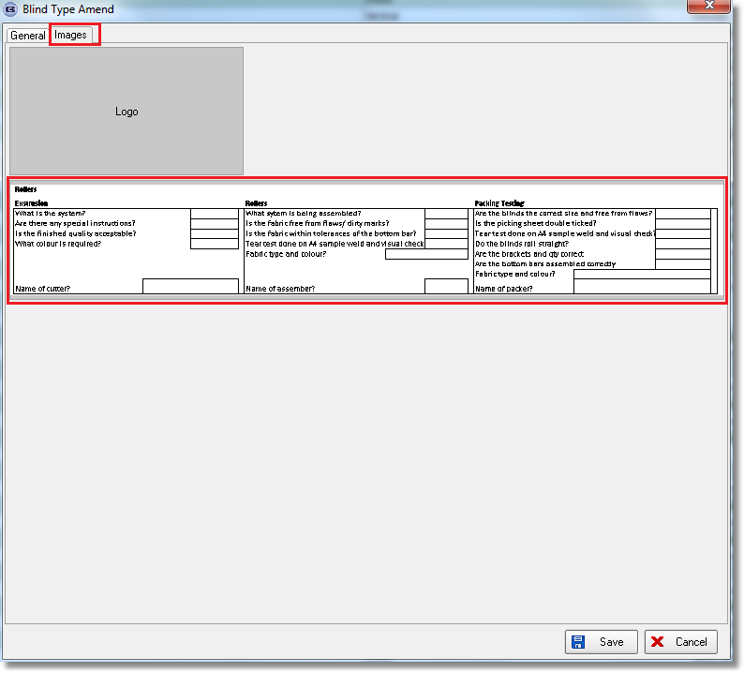

3114. Picking List 1

If an image is held against the miscellaneous blind type record, then it will appear on the picking list.

3115. System Tables > Departments

There is now a VAT number field in the department form.

3117. Credit Note Email

Credit notes now have their own credit note email text field in ‘Company Details’. This is then used when a credit note is emailed.

3118. Invoice Terms and Conditions

There is a new field in this table called ‘Pay By Day Of Month’. If 20 is held in there, for example, then when the invoice is created, the payment date is calculated as being the 20th day of the next month. The text could say ‘Payment for this invoice is due by’ or something like this.

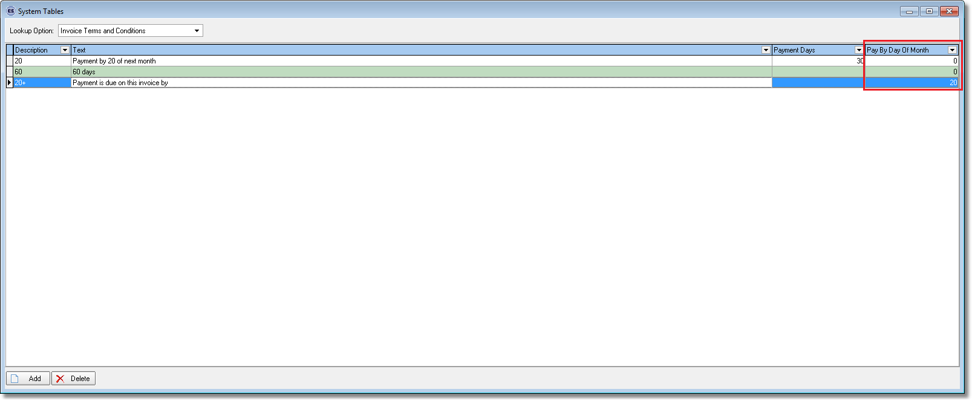

3119. Financials > Post Invoices to Sage > Xero Export File

An export file has been created for invoices that are going to be posted to Xero. There is a new flag in Parameters called ‘Xero CSV’. If this is switched on, then when the ‘Line 50 Export File’ button is selected, the Xero csv file should be created. Also, if this flag is switched on, the button now says ‘Xero Export File’.

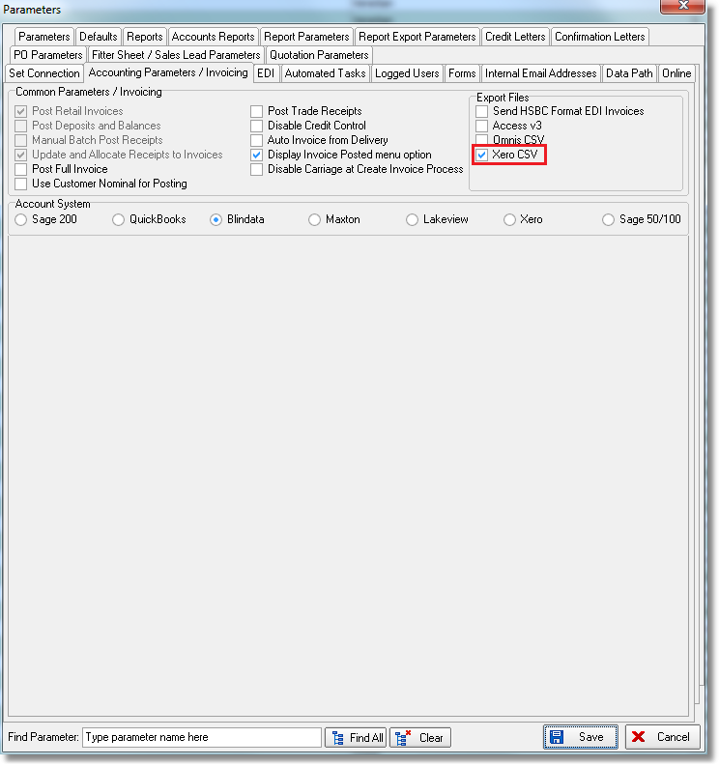

The following fields are included in the csv file.

Contact name – this is the customer company name
Invoice number – Blindata invoice number
Reference – customer order number from invoice
Invoice Date – invoice date
Due Date – due date
Description – hard coded as ‘Blinds’
Quantity – always 1
Unit Amount – actual net total
Discount – always 0
Account Code – sales nominal code from customer record
Tax Type – VAT Code from customer record
Tax Amount – Actual VAT from invoice

There is one interesting thing to note about Xero – it does not hold account codes against customer/supplier records – which they call ‘Contacts’. So the records are matched by customer company name.

3120. Blaze CSV File

The ‘No of Panels’ field now goes into in column 20. This is for all blind types

The existing file had address in 6 columns: 6,7,8,9,10,11. This has been changed to have the address in 5 columns only 6,7,8,9,10.
Column 11 is now used for Pelmet information. This only applies to the Roman blind type. For blind without pelmet, and all other products, please leave blank.
3121. Order Processing > Bought In Order Tracking
Calculated Lead Time Fields – Dev (3074,3075). – The ‘Diagram Check Date’ field has been changed so that it only includes working days (ie excludes weekends and holidays).

A ‘View Consignment Note No’ button has been added to the bottom of the Global Search.

3122. Wholesale EDI File

A unit of measure field has been added to the Wholesale EDI file. This is taken from the ‘Measurement Unit’ field in Stock Items. If the measurement unit = Metres, then it is represented as MTS in the XML file, and if Quantity, it is PCS.

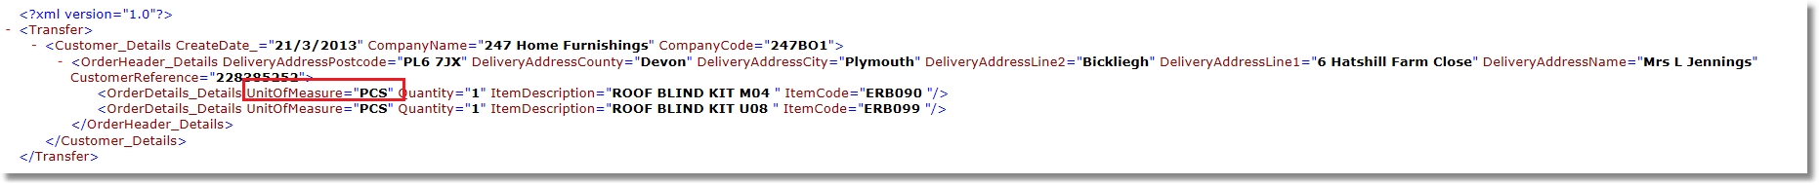

3123. Order Processing > Orders

There is a new user permission called ‘Allow Bought In Split Order’.

3124. Order Processing > Bought In Order Tracking

There is now a ‘Status Change’ button in the Bought In Tracking form, similar to the one on the main Order Amend Enquiry list form. The same user permissions control this and it is only possible to set status from order entered to despatched. Invoice statuses are not available.

3127. Works Order – Bespoke 42

- If the control drop has been overridden, it now prints in bold ie Control Finished Drop 1200. Also it only prints whole number for the control drop ie no decimal places.

- If the order is a repair and detail line has been entered, the repair text prints in the middle section where options normally go.

