Blindata Release Note 6.3.5 

2 April 2013

Bug Fixes and Enhancements

4152. Works Order – Bespoke 42

If a detail line was entered as imperial, but the works order was set up to print in metric, the ‘Control Drop’ was still printing in imperial. It now prints in metric.

4153. Label Print– A4 88mm x 14mm

There is now a page break between blind types.
Misc/component lines have been changed so no labels print – ‘1 of n’ style numbering has been changed so it does not take into account the misc items.

4154. Quotations

When a quote is converted to an order, sometimes the unit of sale was being lost. Fixed.

4155. Acknowledgement – Bespoke 34

For vanes only, ‘Location’ was being overwritten by ‘Number Of Vanes’. Blind types quantities have been added to the top of the page.

4156. Invoice – Bespoke 34

Invoice detail lines now print to the bottom of the page if there is more than one page on the invoice.

4157. Credit Note Email

The email subject field contained the wrong credit note number. Fixed.

4158. Invoice – Bespoke 34

Location now print after sizes in brackets eg (Kitchen)

If there is no discount on the invoice, the discount line no longer appears in the footer.

4159. Works Order – Bespoke 42

This report is now showing all options and cutting sizes.

New Work and Customer Requests

3091. Valance / Return Sizes

If ‘Enter Valance Size’ is switched on in the blind type record, both the Valance size add on and Return size add on are now held against the ‘Measure to’ fields in Blind Type Setup.

If they are left blank in the ‘Measure To’ fields in Blind Types > Blind Type Setup tab, then the existing values from the blind type record are used.

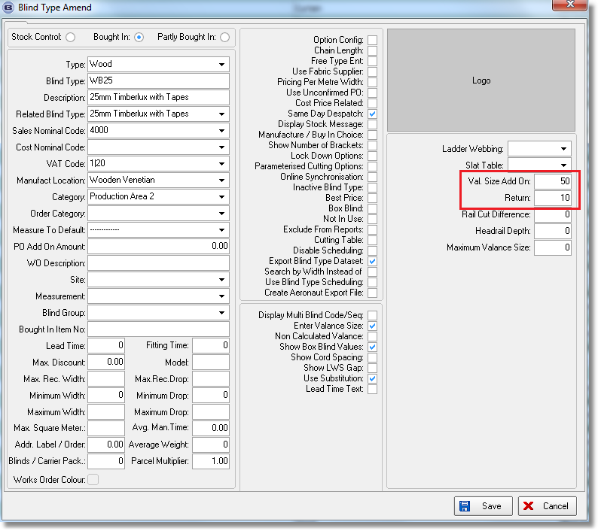

3104. Calculator For Reef Blinds

There is a new calculator called ‘Reef Fabric’. If a fabric is set up with this calculator, and the blind type has ‘Pocket Calculation’ = true, then the bill of materials calculates the amount of fabric used as the (blind size drop + end pocket size + ((pocket size * 2) * number of pockets)).

3105. Customer Despatch Method Days

There is a new system table called ‘Customer Despatch Method Days’. This contains customer, delivery day, despatch method.

The order entry program will look at this to determine the despatch method. If there are no records for this customer in the new system table, then the despatch method from the customer will be used.

3106. Import From Excel

There is now an import facility for Vanes only prices. There is a new option in the ‘Import From Excel’ form called ‘Vanes Only Price Table. The spreadsheet has column headers called ‘Blind Type’, ‘Fabric Group’, ‘Price Table’, ‘Drop’ and ‘Price’.

3107. Pricing > Price Table Preview Report

There is a new print layout for price tables. This can be set up in Administration > Parameters > Reports. The new style looks something like this.

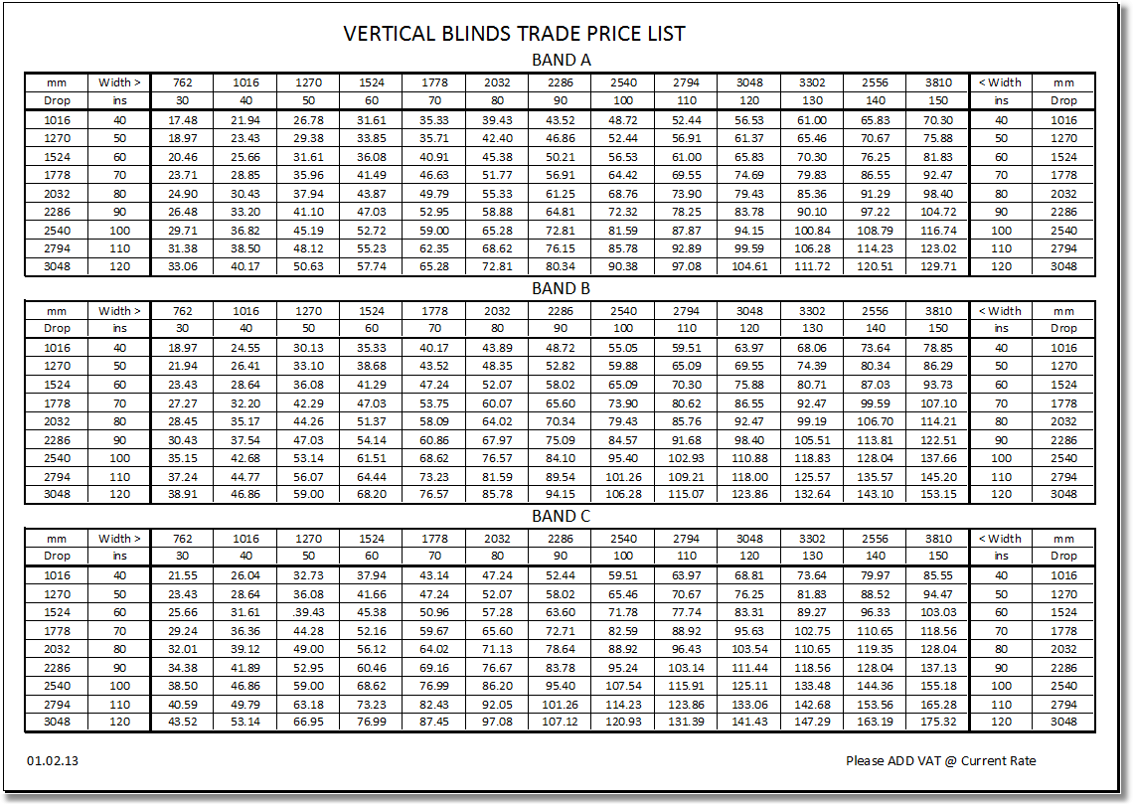

3108. Stock Setup > Fabric Group Setup

There is now a ‘Copy to Clipboard’ option on this form.

