Blindata Release Note 6.3.4 

25 March 2013

Bug Fixes and Enhancements

4142. Works Order – Bespoke 42

For blind identifier = Panel Blind the panel size now prints in the manufacturing section (bottom section)

Control drop (chain length) now prints in the bottom section

Cutting sizes now print out for all blind types.

In top section, Order/No in red now prints the cust ord no beside it instead of works order no.

If blind identifier = Roller, ‘Blind Width’ in the middle section now says ‘Cloth Width’.

If ‘Print Barcode’ is switched on in Parameters, the barcode now prints in the bottom right of the page.

4143. Purchase Order Enquiry > Generate Regular PO

If a stock item is flagged as ‘Fabric Not In Use’, then it no longer appears when the ‘Generate’ button is used.

4145. Bill Of Material Calculation

Width Variable is now calculating up to the size – not over. For example, if the following is set in the ‘Width Variable’ table for A, then if a blind has a width of 1200, then the quantity used is 2, not 3. Previously the rule was to ‘less than’, which is not consistent with other lookups like this.

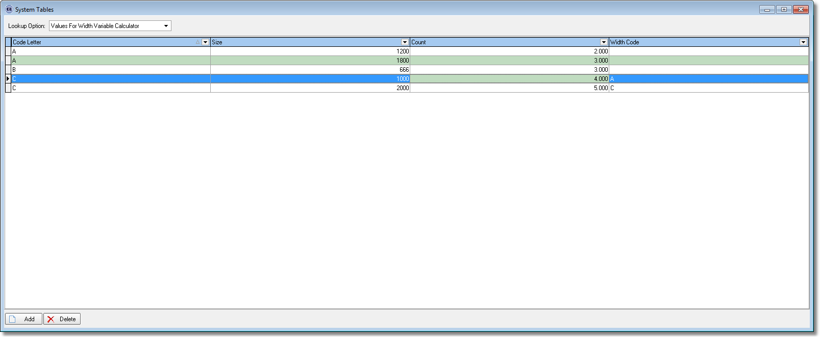

4146. Blind Details > Blind Types > Option Setup Tab

‘Field Name’ now says ‘Option’.

4148. Stock Items > Characteristics

‘Antimicrobial’ is now spelt properly.

4149. Stock Setup > Stock Transaction Entry

This form is now wider so the ‘Stock Code’ and ‘Stock Description’ fields can be seen properly.

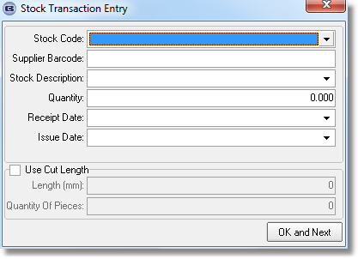

4150. Invoice – Bespoke 42

Deposit and balances are now shown if ‘Show Deposit and Balances for Trade Invoices’ = true.

4151. Works Order – Bespoke 34a

The detail lines were sometimes printing out in the wrong order. Fixed.

New Work and Customer Requests

3092. Stock Setup > Stock Items

‘Batch Numbering’ is now a column choice in the stock enquiry form.

3093. Stock Setup > Stock Items

We now hold supplier barcode for products. This is an alphanumeric field called ‘Supplier Barcode’ which is held in the ‘Characteristics’ tab.

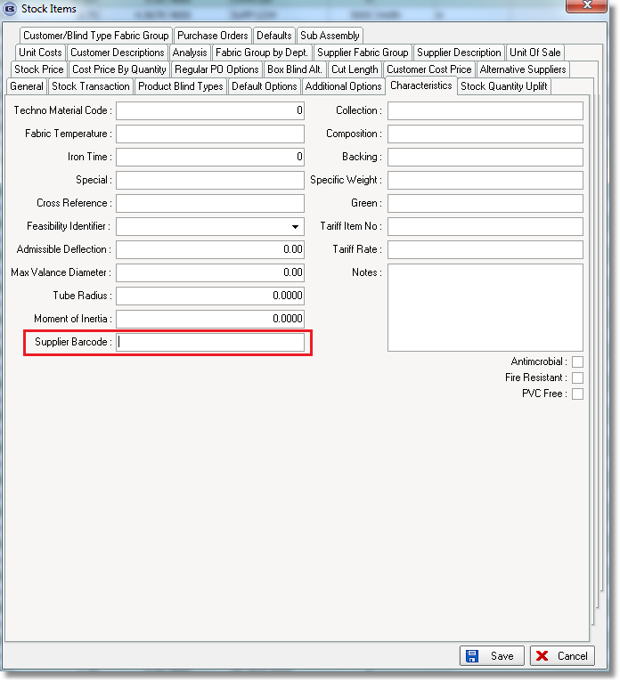

It is also possible to import this field in Import From Excel > Stock Update.

3094. Stock Setup > Stock Transaction Entry

It is now possible to transfer a product by supplier barcode. There is a new option of scanning a barcode here, as well as looking up the stock code by typing it in.

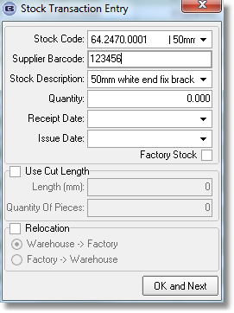

3095. Reports > System Reports > Stock Transfer Report

There is a new report to show all stock transfers from a start date to an end date ie relocations from Warehouse > Factory and Factory > Warehouse.

The report shows:

Stock code, stock description, operator, transaction time, stock transaction amount. It is grouped by ‘Warehouse > Factory’, then ‘Factory > Warehouse’.

3096. Stock Setup > Stock Items

‘Unit Of Sale Minimum Quantity’ can now be entered as a unit description amount ie be able to hold ‘100m Roll’ for example. After the ‘Unit Of sale’ or this field are amended, the ‘Minimum Order Quantity’ will be updated.

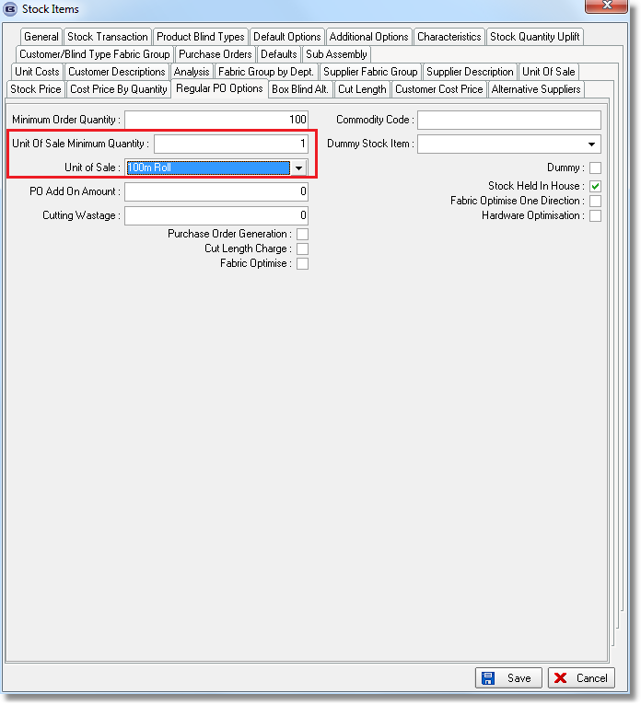

3102. EDI Import

There is a new field in the Order table called OnlineOrderDate. When the EDI import is done, this field is populated with the CreateDate from the XML file.

This new field is now in column choice in ‘Order Amend Enquiry’.

3103. Delivery Docket – Laser Print

Delivery notes now appear in the bottom left (text entered from ‘Delivery Notes’ button in order amend enquiry).

Despatch method prints in the top right.

Carriage Type also prints in the top right.

