Blindata Release Note 6.3.2 

11 March 2013

Bug Fixes and Enhancements

4129. Works Order – Label Blind Size

Location on top right label was being cut off (roller blinds). Fixed.

4130. Fitters Sheet / Sales Lead

In the ‘General Diary Entry’ form, the employee lookup now displays all employees where ‘Appear in Diary’ = true. Previously it only showed fitters.

4131. Works Order – Bespoke 37

Column headers are now displaying properly. Also in option list characters after _ no longer display (same as we did in ‘Acknowledgement – Bespoke 37’).

Also removed cost price.

4132. Aeronaut File

The sizes are now in imperial. Also the fabric colour was wrong – it is now taken from the fabric colour field.
Trim Type is now always ‘Very Plain Rectangle’.
Control Type is now always ‘No Deductions’.

4133. Order Enquiry > Processes

The sizes are now displayed in imperial if the parameter is set up for imperial. Also, the fabric length is included as a column.

4134. Works Order – Bespoke 34a

The detail lines were appearing in an incorrect order. Fixed.

New Work and Customer Requests

3064. Sales Files > Customers > Off Stop EDI Release

Once a customer is taken off stop any orders currently sitting in the EDI Enquiry form will be imported.

This means there will be no records with a grey tick in the ‘Customer On Stop’ field.

3065. Order Processing > Bought In Order Tracking

The following fields have been added to the PO Fields button so they can be modified when required.

Diagram Date
Date PO Sent
Supplier Confirmation Date

Any changes made to these ‘PO Fields’ in the Bought In Order Tracking form will be recorded in the sales order history in the header section. It records field name, old and new value.

3066. Purchases > Suppliers

A situation has arisen where a customer orders made to measure blinds from a supplier and uses EDI Transfer, but also buys components from the same supplier and emails the PO. Previously this would not work because only one or the other can be done.

There are now separate Email/EDI choices for blinds and components.

There is a new flag called ‘Transfer Wholesale File’. If ‘Transfer File’ is switched on, it will only relate to bought in purchase orders and it will not be possible to email them. If ‘Transfer Wholesale File’ is switched off, it will be possible to email purchase orders, if switched on it will only be possible to send them by EDI.

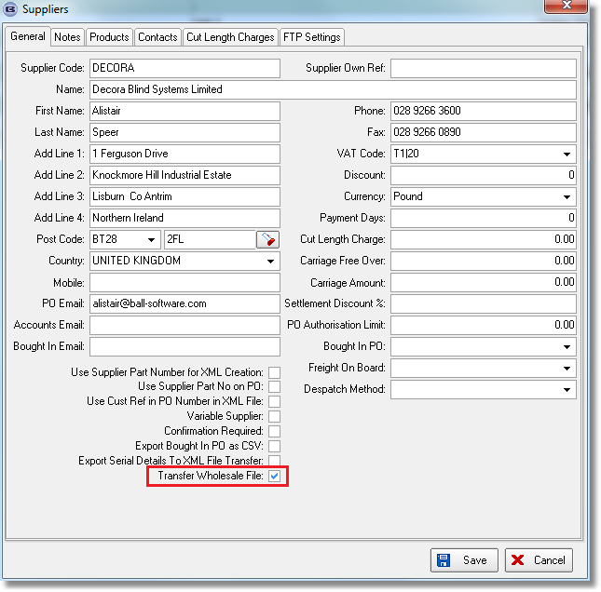

3067. Administration > Import From Excel > Option Price Table

There is now an option to overwrite option price tables in the same way there is in the ‘Price Tables’ import.Previously option prices had to be deleted before different prices for the same records were imported. A message now appears saying ‘Do you want to overwrite existing option price tables?’.

3068. Scheduling

On the Dates and Times form in the Scheduling menu option, any historic values in the ‘Normal Scheduled Time’ and ‘Priority Scheduled Time’ are no longer cleared down as the orders are completed.

Previously there was completely different logic for the two levels of the ‘Normal Scheduled Time’ figures calculation.

Level 2 Scheduled Time was calculated using the following logic: Scheduled Time is a sum of all scheduled details Manufactured Times for a certain date where Manufacture Date is blank or ‘(Manufactured Date + Reduce Schedule Day) > Scheduled Date’. This figure was not stored in database and was calculated for display only.
But for level 1 Scheduled Time is calculated as a sum of Scheduled Times for all details for a certain date. This value is taken from database, calculated during Scheduling functionality using the following rule: Scheduled Time for each detail is a sum of all scheduled details Manufactured Times for certain date where Manufacture Date is blank or ‘(Current Date + Schedule From Day) < Scheduled Date’.
In other words we hold one value in the database and use it for level 1 of the grid but show another calculated value in the level 2 and formulas for calculations are different. This explains why the figures were different.
Therefore we now use the condition from level 2 (‘(Manufactured Date + Reduce Schedule Day) > Scheduled Date’) in both cases above, and so the historic values are displayed.

3069. Order Processing > Orders > Order Category

There is a new field on the Blind Type form to store a Default Order Category. When saving a sales order, the program checks to see what the default category is for any blind types it contains. It is possible that there could be multiple default categories from the selected Blind Types. To resolve this, there is now a priority column (integer) in the Order Category system table. Whichever category has the highest priority is then get selected on the order. If none of the Blind Types on the order have a category selected, then the ‘Default’ category from the Order Category system table will be selected automatically.

This function also works for importing EDI/Online orders as well as manually processed quotes and orders. The check is done each time the order is saved in case any of the blind types have been deleted or changed. Lastly, if an order is split, the existing and new split order are both recalculated based on the remaining blind types.

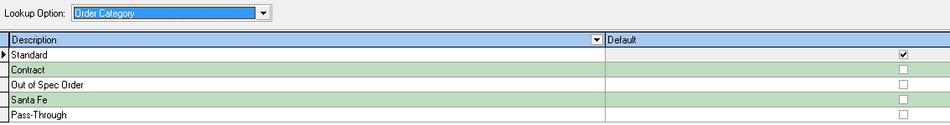

3070. Order Processing > Bought In Tracking Form

The ‘Manufactured’ button on the Bought in Tracking form, now contains the existing dates (if they exist).

The ‘Supplier Invoice No’ field on the Bought in Tracking form is currently set by using the PO Fields button. It has been added to the bottom of the ‘Manufactured’ button form, but only for the Bought in Tracking form.

3071. Order Processing > Bought In Tracking Form

If ‘Auto Generate Bought In PO’ is switched on, Bought in POs are now created automatically at the following points:

Copied Remakes – These are created from the Archive using the Remake/Repair copy function.

EDI/Online Orders – Any orders generated for Online/EDI customers should automatically generate a PO if they contain bought in blinds. Also the cost prices now generate for these Online/EDI orders.

Orders on Customer Hold – previously, if an order was saved whilst on customer hold, it did not generate a PO. It is now generated but not sent to the supplier whilst on customer hold. The Send PO and Export Single CSV buttons are disabled for orders on Customer Hold. Also, the Export Batch CSV ignores these orders.

3072. Order Processing > Bought In Tracking Form

A change was made recently for invoiced orders to be excluded from the Bought In Tracking However, there are occasions when operators need to see the invoiced orders. To resolve this, there is now a filter similar to the Status filter on Order Amend Enquiry, with multiple checkboxes in the status filter and Invoice Posted and Invoice Printed deselected by default.

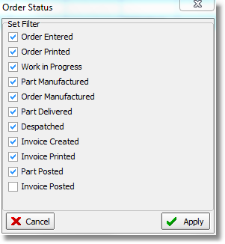

3073. Bought In Purchase Ordering

There is a new parameter called ‘Use Supplier Manufacture Status Desc’. If this is set to true, then order status ‘Order Manufactured’ will say ‘Supplier Manufactured’ and the detail line status ‘Blind Manufactured’ will say ‘Blind Supplier Manufactured’. But this will only be the case if the blind type is bought in. All other blind types will display the order status and detail line status as they currently do.

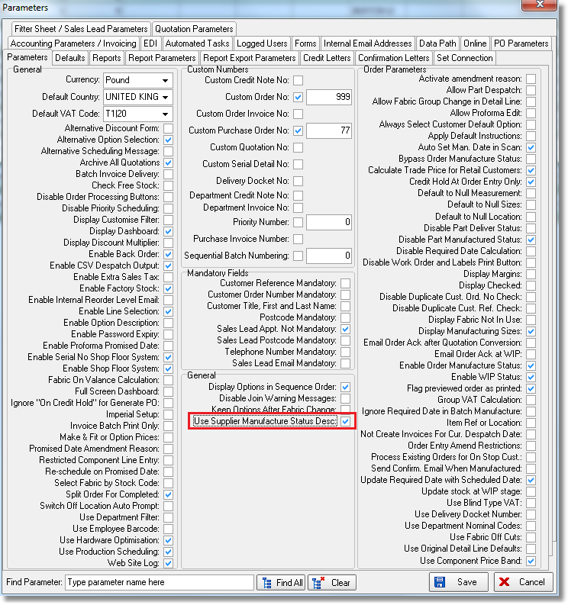

3074. Order Processing > Bought In Tracking Form

It is possible to select multiple suppliers at once in this form (and also for selecting other fields in other forms as the rules are applied to the grid component).

In the grid component there is the ability to create Custom filters. Here is an example.

- Click on the ‘Supplier Name’ column as usual to see the list of suppliers:
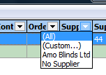
- Select one of suppliers to filter grid by. There are then filter options at the bottom.

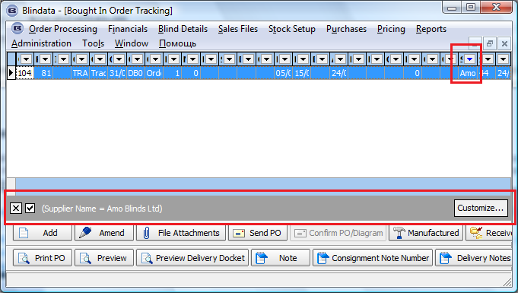

- Click ‘Customize…’ button in the grey area and the ‘Filter builder’ will appear.

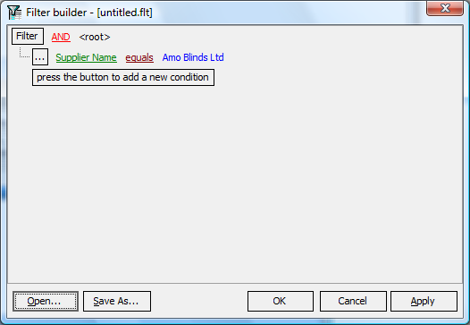

At the moment we can see grid is filtered by ‘Supplier Name equals Amo Blinds Ltd’.
- Select ‘OR’ at the form top and press ‘press the button to add a new condition’ button to add another condition. In the example below we added filter ‘Supplier Name like No%’:
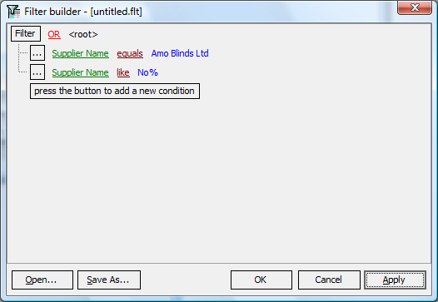
After that press ‘Apply’ to see the result or ‘OK’ for filter grid and close ‘Filter builder’.
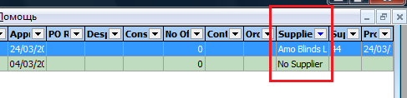
3075. Order Processing > Bought In Tracking Form

The following calculated fields have been added as columns to the Bought In Tracking form. They are not stored in the database and are display only, but are also filterable and sortable.

Approx Weeks Lead Time – this is the number of weeks (rounded up) from the ‘Diagram Check Date’ to the ‘Approx Receipt Date’. If the Approx Receipt Date is blank, then this field is also blank. If the ‘Diagram Check Date’ is blank, then the ‘Supplier Confirmation Date’ is used, and if this is also blank, then the ‘Date PO Sent’ is used as the start date. It has been positioned in the column to the right of ‘Approx Due Receipt Date’.

Actual Weeks Lead Time – Exactly the same logic as above, only the ‘PO Receipt Date’ is used as the end date in place of the ‘Approx Receipt Date’. It has been positioned to the right of ‘PO Receipt Date’ column.

Diagram Check Days – This is the number of days from the ‘Date PO Sent’ to ‘Diagram Check Date’. If either field is blank, then this is also blank. It has been positioned to the right of the ‘Diagram Check Date’ column.

3076. Order Processing > Bought In Tracking Form

There is now a column for the order Despatch Date in the Bought In Tracking form. It is positioned to the left of the Consignment No field and is hidden by default.

3077. Order Processing > Orders

There is a new advanced permission called ‘Amend Sent Bought In Orders’. If set to true, the user will be able to amend bought in lines on a sales order regardless of the Sent to Supplier flag. They will also be able to cancel a sales order.

3078. Wood Codes

It is now possible to specify alternative Bottom Bar and Valance codes for wood venetians. There are two new columns in the Wood Codes system table for ‘Alternative Bottom Bar Code’ and ‘Alternative Valance Code’.

In the example below, we have W4 as the bottom bar code and W6 as the valance code. We could have W16 as the alternative bottom bar code and W18 as the alternative valance code. When an order for a wood blind is processed, the program will first try and match the original Bottom Bar (W4) code and Valance code (W6) with the colour to select the valance and bottom bar stock item. However, if no stock code matches these codes, then it will attempt to use the alternative Bottom Bar code (W16) and alternative Valance Code (W18) to match stock items with the colour.

The exact logic is as follows.

1. The system first looks into the ‘Wood Codes’ system table for the blind type selected and gets a part of the stock code from ‘Slat Code’, ‘Bottom Bar’ or ‘Valance Code’ fields depending on what option is found.
2. If nothing is found anything in (1), the program analyses the first part of fabric/color code chosen in the order detail. This is hardcoded (W1 – W9) but is represented like this.

Two (or three) first characters in Fabric/Color Code selected | Slat | Bottom Bar | Valance
W10 | W10 | W11 | W12
W1 | W1 | W3 | W5
W2 | W2 | W4 | W6
W7 | W7 | W8 | W9

3. If something is found in (1) or (2) then the program looks into the ‘Wood Sizes’ system table to get another part of the searched stock item that is held in the ‘Slat Code’, ‘Valance Code’ and ‘Bottom Bar’ fields accordingly. It tries to find a record with the nearest width and it forms a new stock item code. Then the program checks a stock item by the stock code that was formed and checks if ‘Stock In Hand’ value > 0 (but only if the ‘Use Substitution’ is switched on for the blind type). If this condition is false, i.e. we didn’t find a stock item at all or ‘Stock In Hand’ value less or equal to 0 (for ‘Use Substitution’ blind types only), the program gets the next record by width from the ‘Wood Sizes’ table. If it does not find a stock item at all, it then looks in the relevant alternative field, and tries to use that. If there is not enough stock in hand for it and ‘Use Substitution’ is true, it should look at the next record by width.

4. If it doesn’t find the stock item in 3, the program finds a record with the nearest width in the ‘Wood Sizes’ table, but ignores the ‘Stock In Hand’ value for ‘Use Substitution’ blinds as it was in (3).

3079. Order Acknowledgement / Delivery Docket XML

The naming convention for the acknowledgement and delivery docket XML files has been changed to include the customer’s reference. This comes after the Blindata Order Number on both the Order Acknowledgment and Delivery Docket

3080. CSV File Export

There is a new option called ‘Panels’ that now appears in column 20 on the Blaze csv order file.

3086. Invoice – Bespoke 44

The settlement discount information now shows on this invoice in the same way it does for ‘Invoice – Bespoke 34’.

Also the detail lines do not overwrite the payment text.

