Blindata Release Note 6.3.3 

15 March 2013

Bug Fixes and Enhancements

4135. Tuffnells File Creation

If an order is on customer hold or marked as out of stock then the order is not put in the Tuffnells file.
Carriage lines are not exported to the file.
If a blind has been manufactured before the CSV file is created then the order now goes into the Tuffnells file.
Customer notes now import from Blindata to the file.
For offshore deliveries (Jersey, Guernsey, non UK), the price of the goods now goes into the file.

4137. Works Order – Bespoke 45

- The headings have been tidied up so they can be seen properly.
- This shows description instead of the code and is in bold.
- This is in bold.

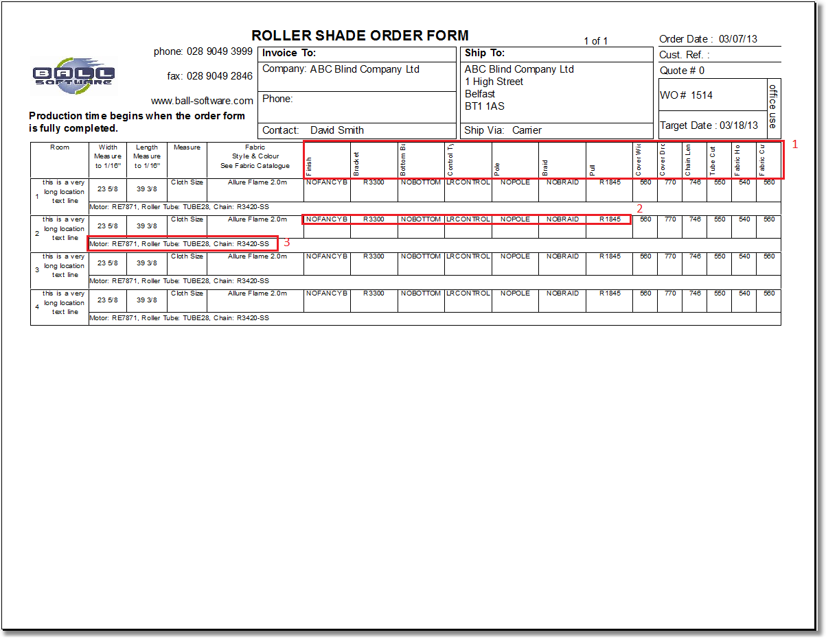

4141. Invoice – Bespoke 44

The settlement discount text has now been removed from the invoice, but the VAT calculation still takes settlement discount into account.

New Work and Customer Requests

3082. Sage 200 Integration

It is now possible to integrate sales invoices, credit notes and customers to Sage 200.

Sage 200 uses a SQL database, so there is now a connection to this. There is a new parameter called ‘Use Sage 200 Accounting’ in Parameters > Accounting Parameters / Invoicing.
If this is set to true, then it is possible to specify connection details to it.

Updating Customer Records From Sage 200

There is a new option in Administration > Accounting Utilities called ‘Create/ Update Customer Details From Sage 200’.

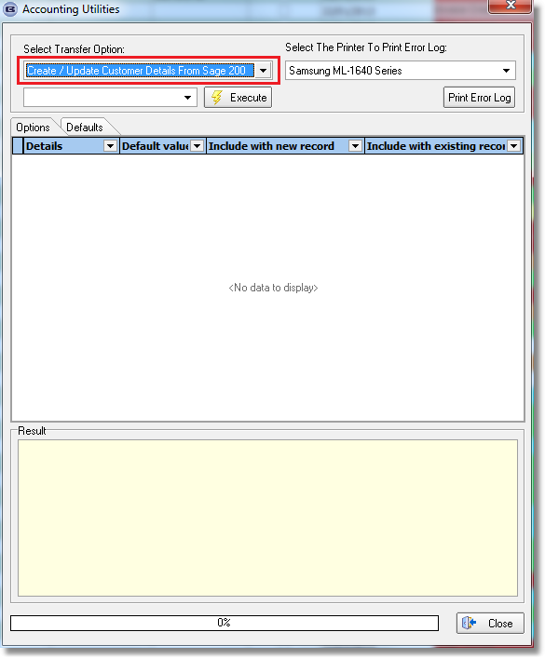

Posting Sales Invoices / Credit Notes

If ‘Use Sage 200’ is switched on in Administration > Parameters, then invoices and credit notes will be printed to Sage 200.

3083. Despatch Order

There is now an option to select the despatch method at the despatch stage, both in ‘Order Amend Enquiry’ > Despatch and Order Enquiry > Deliver. There is a new parameter called ‘Select Despatch Method at Delivery Stage’ in Parameters. If this is set to true (it defaults to false) then the user is able to alter the despatch method for that order.

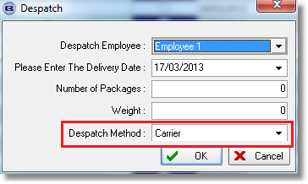

3084. Works Order - Label Blind Size

Previously if ‘Print Crease Lines’ = true for a blind identifier = Austrian/Roman, then something like 6-23-23-6 printed out. This is actually showing where the wires will go. There is now a flag to determine the number of wires called ‘Print Number Of Wires’. If this is set to true, then ‘Print Crease Lines’ = false and vice versa, but both could be false.

3085. Order Processing > Orders > Window Blind Amend

There is now a detail line column choice to show the full price (base + option) before discount.

3099. Works Order – Bespoke 37

There is no longer a page break between each blind type. The report is still grouped by blind type but there are only detail column headings at the start of each new blind type, with no page breaks.

Also the detail line headings are now displaying properly.

3100. Quotation – Bespoke 37

Some changes to this report. Dispatch method is now included and the detail lines have been tidied up.

