Blindata Release Note 6.3.0 

22 February 2013

Bug Fixes and Enhancements

4117. Order Processing > Orders > Despatch

If ‘Auto Email Delivery Docket’ is switched on in the customer record, when the ‘Despatch’ button is used (and in ‘Order Enquiry’ as well), an email is sent but the pdf attachment was missing from the email.

Please note that parameter ‘Attach PDF to Auto Email Delivery Docket’ must be switched on in Administration > Parameters.

4120. Purchase Order Enquiry

When you go into ‘Generate Regular PO’ the cursor is now focused on the supplier, not ‘Add’.

4121. Credit Note – Bespoke 34

VAT total was only showing the VAT for the last detail line. Fixed.

4122. Label Print – Bespoke 33A

The fabric description in the red rectangle has been moved down to below ‘Louvres W& C / Brkts’.

4123. Reports > System Reports > Contact Management Reports

If there is a record entered for contact management against the customer record, it appeared in this report against ‘No Customer’. It is now grouped with the customer it was entered against.

New Work and Customer Requests

3016. Grouped Fabric Discount

There is now a way of grouping discounts for component sales by customer. This is done by setting up special pricing in the ‘Special Pricing’ tab in the customer record.

First of all discount classes must be applied to stock items here.

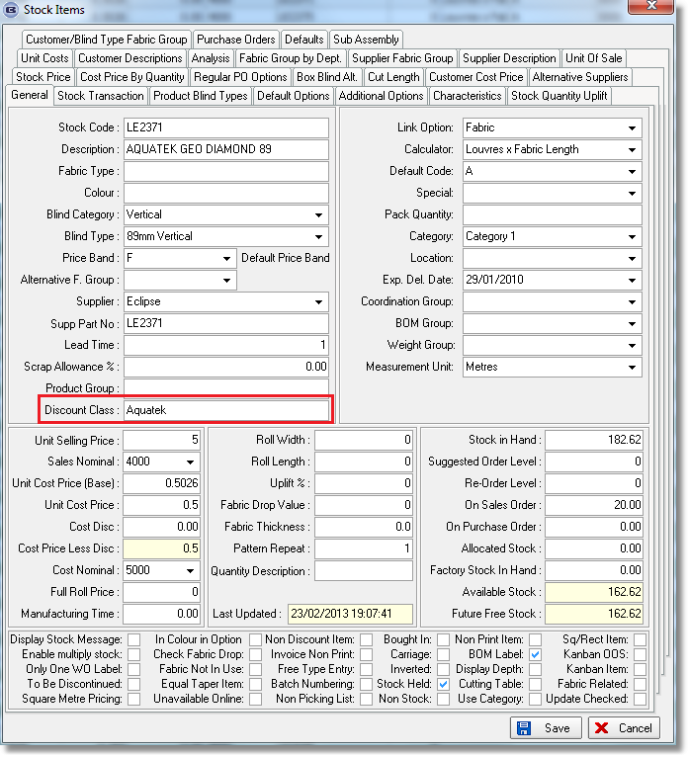

Then the special pricing must be set up in the customer record.

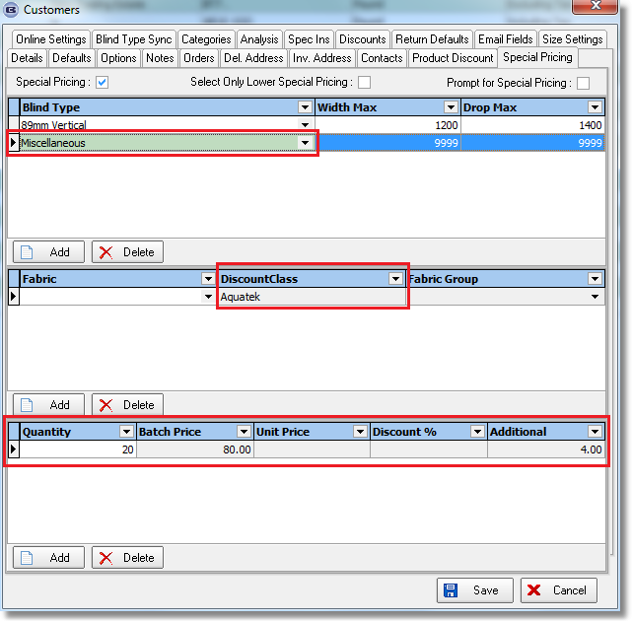

When an order is saved, the order detail records for component detail lines will be examined. If the quantity of the sum of discount class items is >= quantity in the bottom record, then the discount in that record will be applied to all relevant detail lines. The batch price is actually the price for the quantity in the record ie in this case the item price will be 4.00 per unit.

3020. Order Processing > Orders

There is a new parameter called ‘Keep Options After Fabric Change’. If this is switched on, then when a fabric is changed after options have been changed in an order detail line, the options will not revert to the previous choices.

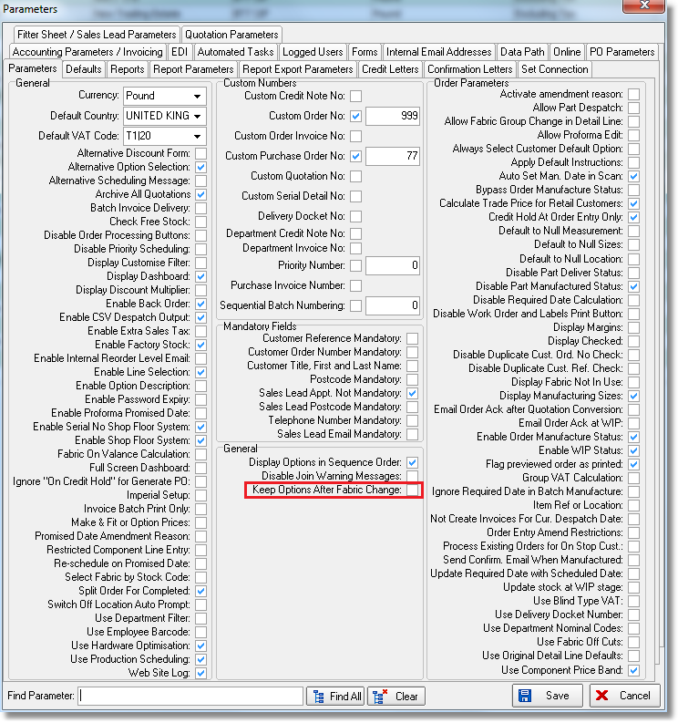

3042. Quotation – Bespoke 37 (pdf as well)

There is a new quotation report layout called ‘Quotation – Bespoke 37’. The page size is portrait 8.5 x 11”.

3046. Additional Options

There is now a dependent choice by blind type in the ‘Additional Options’ tab in the stock record.. If this is left blank, then it will behave as it currently does. If it has a blind type in here, then the additional stock item will only be added to the BOM if the blind type matches the blind type in the detail line.

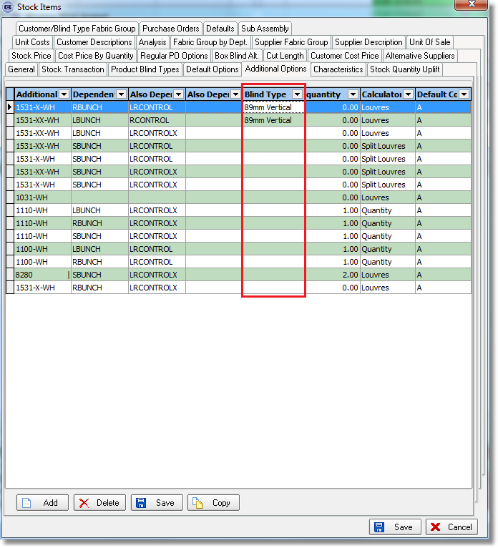

3047. Order Processing > Orders

If an appointment is taken for a company, and then converted to a quotation or order (assigned to the retail account), when the quote/order ack/invoice is printed, it prints the contact name and not the company name. The company name is held in the delivery company name.

There is a new parameter in the ‘Totals’ tab of the order entry called ‘Print Delivery Company Name’. If this is ticked then certain reports will show the delivery company name instead of the contact name (retail sales only).

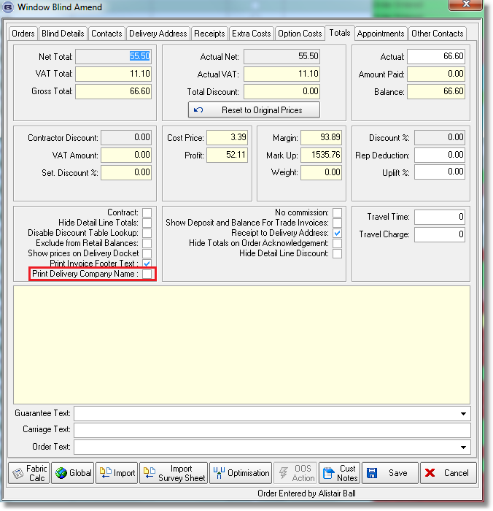

3050. Global Search

There are now extra lookups for contact name, address lines, postcode, telephone no. and mobile on this form.

3051. Duplicate Stock Record Fix

There is now a routine to delete a record and move all related records to new (duplicated) record.

We have a number of customers that have many instances of duplicate fabrics in the stock table – they have different stock codes. It would take a very long time to manually remove individual stock items and assign the related records to the other code, so this routine is designed to help with this.

This can be done by importing a spreadsheet that has two columns, one called ‘Redundant Stock Code’ and a second column called ‘Live Stock Code’. The procedure then goes through each line in the spreadsheet, assigning all related records in the redundant stock code to the live stock code, then deleting the redundant stock code record.

This function is in Administration > Import From Excel

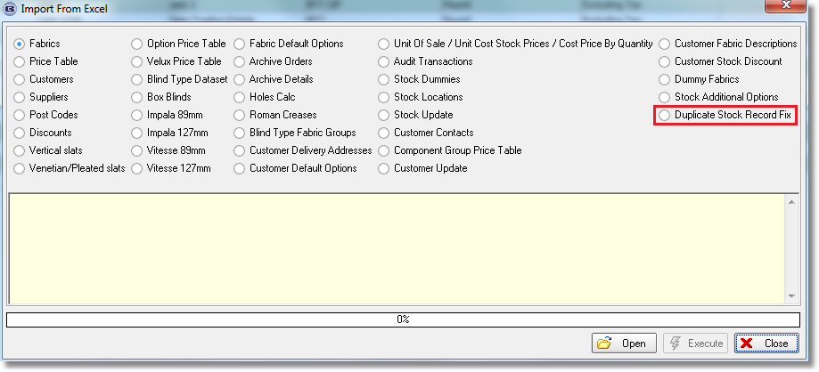

3053. System Reports > All Contact Management Reports

If there are records that are only tied to customers and not just orders ie contact records that were entered in Sales Files > Customers as well as those entered in Order Processing > Orders, then they now appear in all the contact management reports.

3056. Pricing > Option Price Enquiry

There is now a ‘Global Price Uplift’ button in the ‘Option Price Enquiry’ form, similar to the one in ‘Price Enquiry’. It will allow the user to globally update option prices or copy them to new option price tables. This also includes a choice for product code, as well as blind type and price code.

