Blindata Release Note 6.2.9 

15 February 2013

Bug Fixes and Enhancements

4109. Order Processing > Quotations

If a quotation is entered with a text detail line, you can now amend the ‘Actual Net’ or ‘Actual’ or ‘Discount %’.

4112. Export Invoice

The contact name for the invoice is now taken from the order, not the customer.

4114. Reports > System Reports > Quotation Analysis

Quotation text no longer appears in this report. All records with blind identifier = Header are excluded.

4115. Techno Barcode

The first 4 characters in the barcode are filled with the vane length (man drop – headrail depth + fold over size).
The order number previously went into a four character area – it is now six. So, for example, 1484 goes in as 001484.

New Work and Customer Requests

2975. Quotation Conversion Analysis

There is a new report that will analyse quotations by customer and by blind type. It also shows whether quotations have become orders, and if flagged as ‘Don’t Follow Up’, the reason why.

The report is held in Reports > System Reports and is called ‘Quotation Analysis’. There should be a start and end quotation date.

3031. Label Print – 3 ½ x 1” Standard

There is now an option to print out a Techno barcode on this label. However it has to go on a separate label of it’s own, along with the ‘Order No’, ‘Customer Company Name’ and ‘Blind Id’. We have done this by having a ‘Type’ choice ‘Techno Barcode’ label choice in Blind Types > Label Control.

3034. Purchase Order Regular - Bespoke 37

There is a new report is required based on ‘Purchase Order Regular – Standard’ called ‘Purchase Order Regular – Bespoke 37’ with the following differences.

It’s size should be 8.5” x 11” Portrait
‘Fabric Description’ is now ‘Product Description’.
Detail lines appear in the order they were entered
Unit of measure prints
Supplier part number prints
Removed VAT number and delivery note no,
Removed ‘Supplier Own Ref’, remove ‘Reference’.

3035. Purchase Order Enquiry > Regular / Bought In PO

It is now possible to hold a dispatch method against a PO. This is taken from a default held against the supplier, so the ‘Despatch Method’ is now held against the supplier.

There is also another lookup field in the supplier record called ‘F.O.B’. This is held in a new table called ‘Freight On Board’ in System Tables.

3036. Acknowledgement – Bespoke 37

The stock description is now shown in the option fields, but trimmed to show everything before the ‘-‘ character. For example, if a stock description is ABCD-abcdefghijklmnopqrstuvwxyz, it will show as ABCD in the option.

Also, for blinds this acknowledgement prints, but for miscellaneous items, ‘Acknowledgement – Bespoke 37a’ prints.

3037. Acknowledgement – Bespoke 37a

There is a new portrait report for wholesale orders – this is based on ‘Acknowledgement – Bespoke 35’. In addition to what is currently printed, ‘Rep’ prints in the top right, and Terms print in bottom left (from ‘Invoice Terms’ in the customer record).

3039. Emailing

When an email order confirmation is sent or a quotation sent, it is now possible for a ‘Request Read Receipt’ to be sent with the email. There are new flag for this here, against each email option.

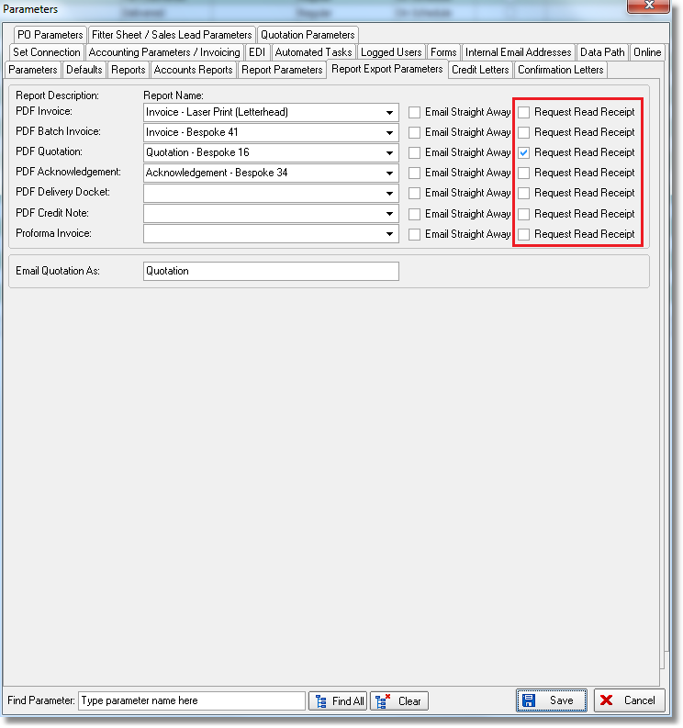

3040. Order Processing > Orders/Quotations

There is a user advanced permission called ‘Alternative Sizes Change’ that allows ‘Width’ and ‘Drop’ to be entered in this form. If this parameter is set to true, it is now also possible to amend the ‘Location’ field.

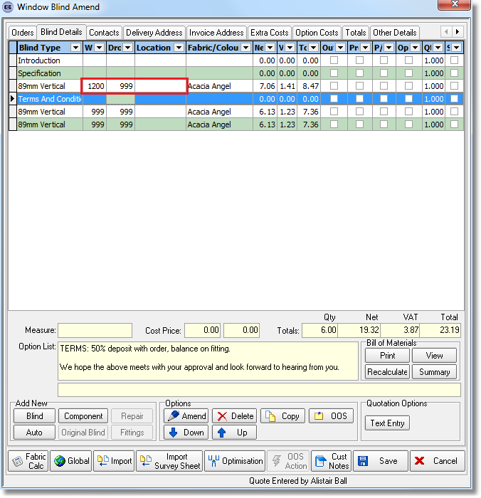

3041. Administration > Maintenance

There is a new option called ‘Clean Up Locations’. This will allow locations to be changed to all ‘Proper Case’ or all ‘Upper Case’.

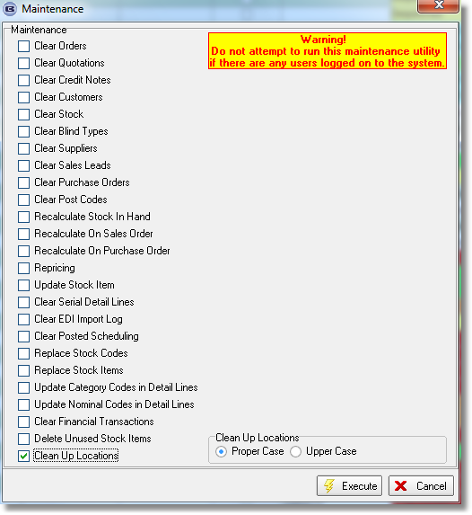

3043. Quotation Stored Text

When a quotation is created, it is now possible to add quotation stored text automatically, using a new button called ‘Auto Text’.

There is a new flag held against quotation stored texts called ‘Default Text’.

There is a new button in the ‘Window Blind Amend’ form called ‘Auto Text’. If this is selected then the quotation text lines that are flagged as ‘Default Text’ will be automatically added to the quotation.

3045. Works Order – Bespoke 34a

5 digits now print for cutting sizes – sometimes the cutting size is > 9999mm.

No of louvres now appears for vanes only and headrail only.

