Blindata Release Note 6.2.8 

8 February 2013

Bug Fixes and Enhancements

4103. Quotation – Laser Print (Letterhead) (pdf as well)

This quotation has the same font and same size font all over.

4104. Label Print – A4 88mm x 14mm

The text on all the labels has been moved up 2mm. Margins stay the same.

4106. Hardware Cutting Sheet

If a cutting size is calculated as 0, then it it does not print the 0 at all on this report.

4107. Order Processing > Quotations > Create Order

If you convert a quotation to an order, the fields held in the ‘Other Contacts’ tab held against the quotation are also be copied across to the order.

4108. Works Order – Bespoke 42

The dates shown on this report are the required date..

New Work and Customer Requests

3010. Intrastat

Stock Setup > Stock Items

There is a new field in stock items called ‘Commodity Code’, held in the ‘Regular PO Options’ tab.

It has been included as a field choice in Import From Excel > Stock Update.

There is a new report in Reports > System Reports called ‘Intrastat Report’. There is a start and end ‘Purchase Invoice Date’ and a choice to choose by supplier. The report then lists commodity code (grouped by), value total (total of net prices), net mass, supplier units, country.

3015. Post Invoices to Blindata

If ‘Use Blindata Accounts’ is switched on, if a sales invoice is for a zero value, then it is posted to the sales ledger and the order status is changed to ‘Invoice Posted’. If Sage integration is switched on, then invoices will still have to be changed to posted manually, because Sage does not allow zero value invoices to be posted.

3017. Control Length Default by Customer

There is now a customer field in Blind Types > Chain Length tab. This means it is possible to set specific chain lengths for specific customers. If a record is set up here, it will override the chain length settings in the blind type form.

3018. Order Processing > Orders > Component Detail Entry

Previously, if ‘Cost Price’ and ‘Cost Price Overridden’ were switched on in the ‘Forms Visibility’ in Users, then they only appeared in the component detail entry if ‘Cost Price Related’ was switched on in the blind type record.

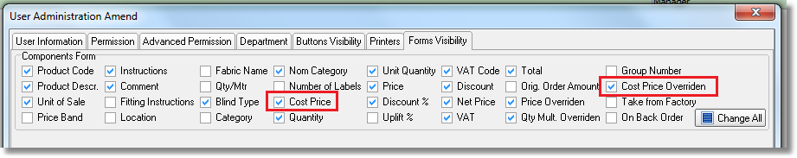

The cost price now appears if ‘Cost Price Related’ is not switched on. When the cost price is entered, it also updates the cost price in the order detail line.

If the user does not have advanced permission ‘Display Costs’ and ‘Amend Cost Price’ switched on, then they will not be able to see/amend the component cost price.

3021. Order Processing > Orders

There is now a choice to allow options (as set up in Link Options) to be shown in ascending sequence number. The new parameter is in Administration > Parameters and is called ‘Display Options in Sequence Order’.

At the moment they are displayed in order detail entry in alphabetical order.

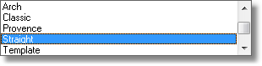

3022. Order Processing > Orders > Print BOM

There is now an option to only show quantity and unit of measure on this report. If advanced permission ‘Display Costs’ is switched off for a user, then the unit cost, scrap %, price inc. scrap % and cost fields are not displayed on any BOM reports.

3023. Order Processing > Orders > Window Blind Amend

There is now a ‘Summary’ button to see all BOM records for an order. It displays the same format as the ‘View’ button above but for all detail lines in the order, grouped by product code. This button is not visible if the advanced permission ‘Display Costs’ is switched off.

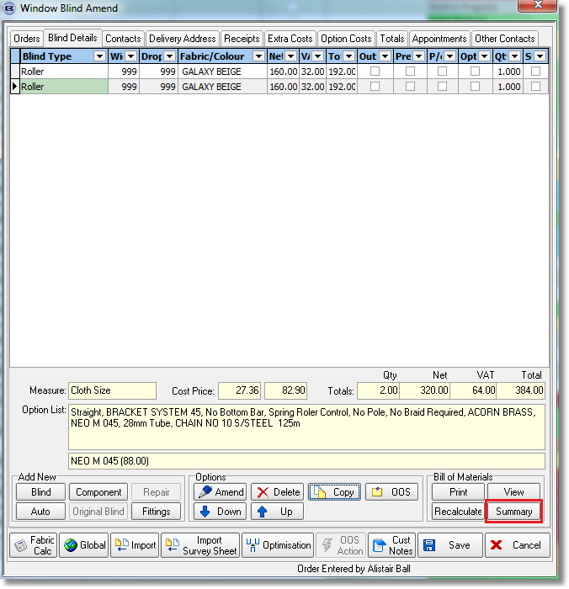

3024. Order Processing > Quotation

We need to make some improvements to the quotation so we can analyse conversion rates and why quotes have been lost.

There is a new table called ‘Unconverted Quotation Reason’. This is held in Administration > System Tables. It has two fields, one called ‘Reason Description’ and another called ‘Reason Lost’.

In Quotations, if ‘Don’t Follow Up’ is ticked, then there should be a lookup for this called ‘Unconverted Quote Reason’.

3025. Order Processing > Quotations/Orders

There is a new parameter in Administration > Parameters called ‘Disable Join Warning Messages’, which defaults to false. If it is set to true, then the following join messages will never be displayed.

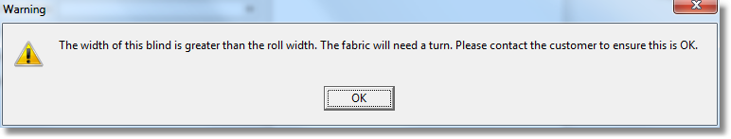
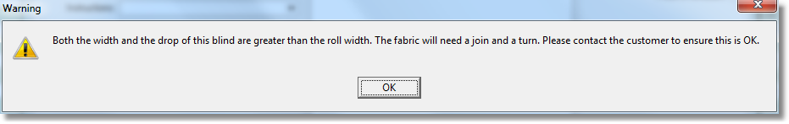

3026. Fedex CSV File

There is a new carrier name called ‘Fedex’ in the ‘Despatch Method’ table. There is also a new field in here called ‘Weight Type’.

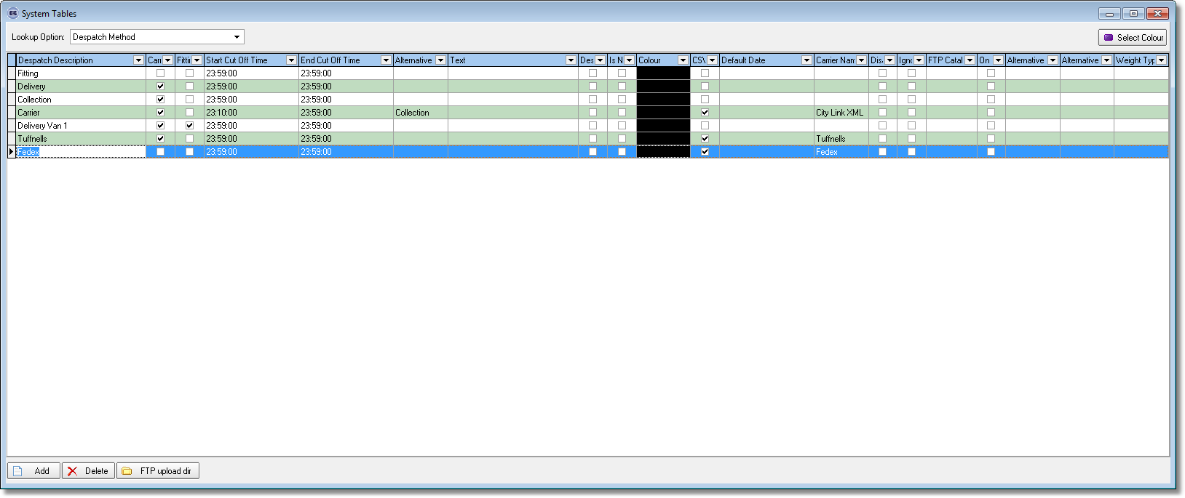

There are also new fields for ‘Payment Type’ and ‘Package Type’ in the ‘Carriage Type’ table.

The Fedex csv file is created at the ‘Despatch’ stage in the same way as it is for City Link.

3027. Order Processing > Order Enquiry > Re-export Carrier CSV

There is a new button on this form called ‘Re-export Carrier CSV’. It allows the user to re-export orders that have already gone into a csv file. It does not export an order if it has not been previously exported. It should bring up a window with the orders it is going to re-export. The orders can be filtered prior to exporting, and only filtered orders that have previously been exported will be exported.

This new button is only visible if ‘Export Carrier CSV Files’ is switched on in Advanced Permissions.

3029. Works Order – Bespoke 34a

One more cutting size now appears on this works order.

3030. Acknowledgement – Bespoke 34

These address fields in the order address header no longer print on this report.

