Blindata Release Note 6.2.7 

4 February 2013

Bug Fixes and Enhancements

4089. Works Order – Bespoke 45

The quantity column has been removed and the option columns made slightly wider.

4090. Label Print – 3 ½ x 1 Standard

- The tube cut now prints in imperial (if set to imperial) and if ‘Tube Cut’ is a cutting size, it uses that.
- The required date now prints in the date format of the PC.

4091. Label – 5161 Bespoke 35

For a box blind blind type and ‘Use Measurement in Works Order Label’ = *, Imperial’, the ‘Trim’ now prints in Imperial. It previously only printed in metric.

4093. Administration > System Tables > Dimension Codes

The control length button in the ‘Formula’ window is no longer greyed out.

4094. Paul Simon Import

The delivery address no longer imports “ “ at the front of the delivery address fields.

4095. Order Processing > Orders > Print BOM

If you printed all BOM records together, miscellaneous items were missing. Fixed.

4096. Stock Update

Admissible Deflection now imports properly.

4097. Order Processing > Orders

The roll up diameter was being multiplied by 2 twice and was causing the feasibility test to produce the following message.

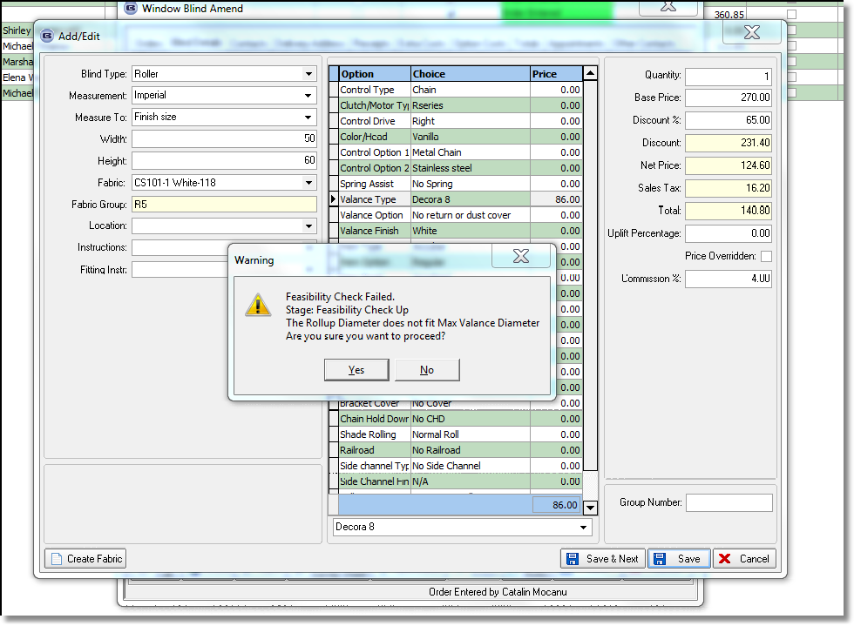

4098. Administration > Parameters > Report Export Parameters

‘Acknowledgement – Bespoke 37’ is now a choice in ‘PDF Acknowledgement’.

4099. Order Processing > Order Enquiry

When the ‘Export Carrier CSV File’ option was selected, it now only selects orders where the csv functionality has been switched on in ‘despatch Method’.

4101. Gross Profit by Order by Blind Type

The variances were the wrong way round (negatives should be positive and vice versa). Fixed.

4102. Works Order – Bespoke 34a

The control drop now always prints in metric.

New Work and Customer Requests

2973. Internal Invoicing

We have introduced a method of internal invoicing which is required by customers that run factories and shops, but the shops are treated as different accounting companies. At the moment This has only been applied to a customer that runs an Omnis accounting system, so it is not currently applicable to Sage.

For example, if a sales order is taken in a shop, the blind can either be made at the central factory or bought in from a supplier. The order is processed and eventually the customer (end user) is invoiced. However because they are in effect making an internal purchase ie to the factory, an invoice has to be sent from the factory to the shop. At the moment an invoice is manually updated into the relevant shop company.

We need to identify (by blind type) that an order detail line is being manufactured internally, and then get the system to generate two invoices – one to the end user customer and one to the shop from the factory. The latter does not have to be printed – just generated for Omnis.

Here is an example of what may happen.

A sales order is taken at the shop for a bought in blind. It is recorded as a sales order for customer account SHOP01. Customer SHOP01 is assigned to department 002.
A PO is generated.
The blind(s) arrive at the shop from the supplier
The order is despatched.
The order is invoiced.
The invoice is posted to account SHOP01 in company 002 in the Omnis system.

Here is a separate example, the difference being that the order is for blinds that are being made in the central factory.

A sales order is taken at the shop for a manufactured in house blind. It is recorded as a sales order for customer account SHOP01. Customer SHOP01 is assigned to department 002.
The blind(s) are manufactured.
The order is despatched.
The order is invoiced.
The invoice is posted to account SHOP01 in company 002 in the Omnis system.
Another sales invoice is posted to sales account SHOP01 in company 001 in the Omnis system, from the factory.

So in effect two invoices are being posted for the same order. The invoice for the blinds that go to the end user, and a further invoice that goes from the ‘central factory’ company to the ‘shop’ company.

Work Done

We need to identify the blind types that made in house - they are all ticked as 'Stock Control'. There is a new flag that identifies the blind type as being ‘Internal Invoice’.

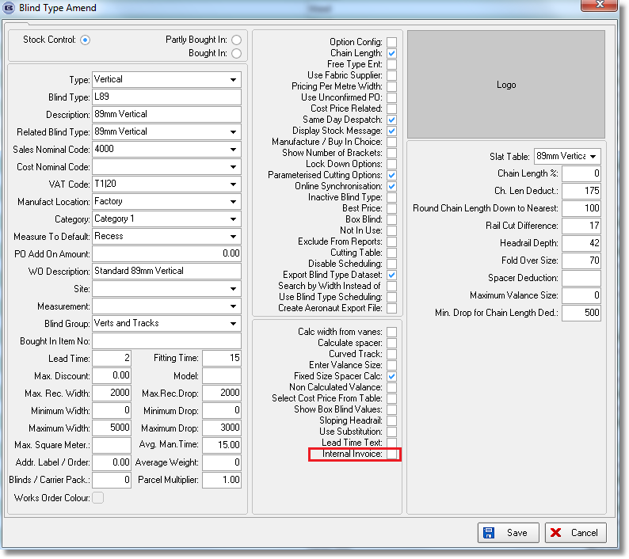

We also need to identify which customers the internal invoices will be sent to ie the shop accounts, so there is a new flag against the customer record called 'Receive Internal Invoice'.

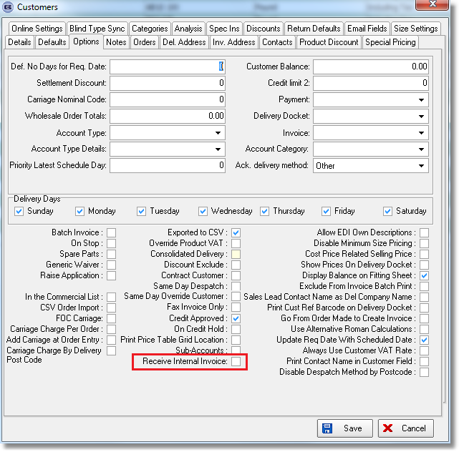

This will only be applicable if ‘Omnis CSV Export’ is switched on.

A change has been made to ‘Line 50 Export File’, if ‘Omnis CSV Export’ is switched on.
If there are detail lines in these orders that are for blinds that are being made in the factory, then a separate csv file is created called INTERNAL.csv. The columns will all have the same information except for the last two columns – they will contain the total of the ‘Trade Price’ in the detail lines for blinds that are being manufactured internally. These records will only be created for customers that have ‘Receive Internal Invoice’ = true.

2993. Invoice – Bespoke 47

A new invoice layout has been created called ‘Invoice – Bespoke 47’. No VAT shows, just a total. Contract text only appears in item box.

2980. Administration > Import From Excel > Additional Options

There is a new import option called ‘Additional Options’. This is used to import records to the ‘Additional Options’ tab in Stock Items.

The import option is called ‘Stock Additional Options’ and the spreadsheet contains columns for Stock Code, Additional Option, Dependent 1, Dependent 2, Dependent 3, Quantity, calculator, Default Code.

3000. Administration > Maintenance

There is now an option in the maintenance program to automatically delete stock items that have no orders against them and are flagged as ‘Fabric Not In Use’. This option is called ‘Delete Unused Stock Items’.

3002. Order Processing > Global Search

There is now a ‘Consignment Number’ search field.

There is now a ‘Preview Delivery Docket’ button.

There is also now the ability To ‘View BOM’ in the same way as it is done in Archive Enquiry ie right click to get context menu then ‘View Detail Lines’ then see BOM.

3003. Order Processing > Orders

If an entered promised date in the order entry is not for one of the delivery days held in the customer record, then a message now appears saying – This customer is only set up for the following delivery days: Someday’.

3004. Order Processing > Production List

There is now a 'Show Only Bought In Blinds' option to the Production List form.

3005. Works Order – Label 1

If a stock code (option) has ‘In Colour In Option’ = true, then it now prints in colour on this report.

3006. Order Processing > Orders > Component Detail Entry

There is now an option so only a very restricted number of stock records are shown in ‘Component Detail Entry’.

First of all, there is a new parameter called ‘Restricted Component Line Entry’ in Parameters.

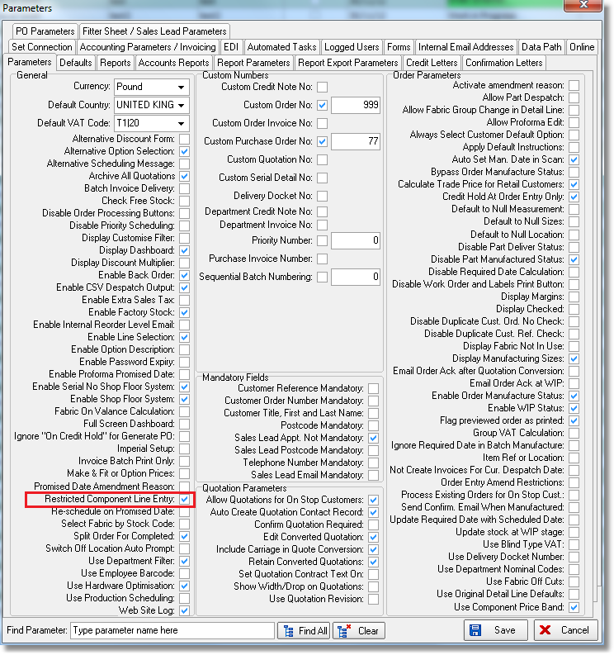

There is also another new flag in ‘Stock Items’ called ‘Show In Component Line’. This second flag will only be visible if ‘Restricted Component Line Entry’ is set to true.

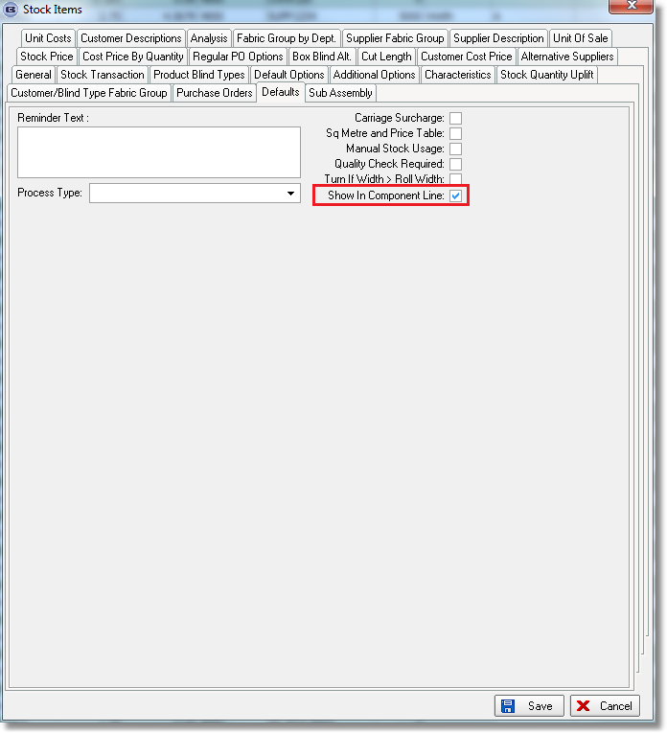

If ‘Restricted Component Line Entry’ = true, then only stock records with ‘Show In Component Line’ will appear in the product lookup in component detail line entry.

3007. Order Processing > Orders

If ‘Same Day Despatch’ is selected when entering an order, the order is now flagged as ‘Must Go’ automatically. This means a ‘Must Go Reason’ has to be assigned automatically as well.
You wrote: ‘This means we will have to assign a ‘Must Go Reason’ automatically as well. There is now a new ‘true/false’ column called ‘Same Day Despatch’ in the ‘Must Go Reason’ system table to identify SDD Must Go reason.

3008. Quotation – Bespoke 1

There is a new quotation print called ‘Quotation Bespoke 1’. This has the same header style as ‘Quotation – Laser Print’ but the details lines should have the same layout as the detail lines in ‘Acknowledgement – Schedule Date’.

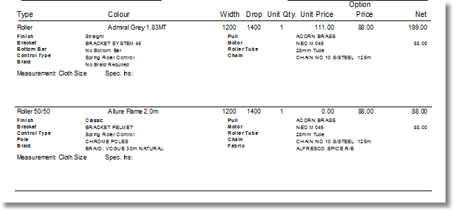
3012. Sales Files > Customers

It is now possible to hold carriage type against a customer, but it is not mandatory. In order entry, the default carriage type is still be taken from the carriage type system table unless there is a carriage type held against the customer.

3014. Administration > Export Data > Stock Unit Cost Prices

There is now a filter by supplier for this report.

3019. Stock Setup > Stock Items

There are now column choices for Fabric Type, Colour.

3028. Acknowledgement – Bespoke 34 (normal and pdf)

Sizes now always print in metric even if they have been entered in imperial.

