Blindata Release Note 6.2.6 

25 January 2013

Bug Fixes and Enhancements

4067. Order Processing > Orders (re-release of 6.1.6 required)
There was a problem with amending the dispatch method when a particular combination of ‘same day despatch’ and ‘long length’ flags were setup against the dispatch method.

Now if the order is not long length or same day, then it is still possible to amend the dispatch method on the order. The system does not revert it to the default for these orders on saving.
4068. Order Processing > Bought In Order Tracking (re-release of 6.1.6 required)

The ‘DatePOSent’ did not get completed with today’s date when the ‘Export Batch CSV’ or ‘Export Single CSV’ buttons were used. Fixed.

4069. Order Processing > Bought In Order Tracking (re-release of 6.1.6 required)

Imperial measurements did not convert correctly to metric for the export CSV file. They appeared as 5 digit numbers. Fixed.

4071. Order Processing > Bought In Order Tracking (re-release of 6.1.6 required)
When using the Manufactured button on the Bought In Order form, if you select the Manufactured Date to be in advance of today, it did not save. The current date was recorded regardless.
Also when using Manufactured button on the Bought In Order form, if there had been an improvement on the Reciept Date, the Appox Due Receipt date could not be brought forward, only pushed back.

4072. Gross Profit By Order By Blind Type

The list price is now correct.

4073. Order Processing > Orders > History (re-release of 6.1.6 required)

The customer’s account code now only show once on the order history at the start ie when the EDI import is done. The user’s login is stored in the history afterwards. Previously, if the status of the order was changed back to ‘Order Entered’, the customer account code was shown – it is now the user name.

4074. Administration > Import From Excel > Stock Update (re-release of 6.1.6 required)

It is now possible to import ‘Roll Width’ in the stock update.

4079. Blind Details > Blind Types

The blind type lookup in the top left now displays the records in alphabetical order.

4080. Feasibility

The formula used to calculate the rollup diameter has the length (L_{T}) multiplied by the thickness of fabric t. The multiplication was not done. Fixed.
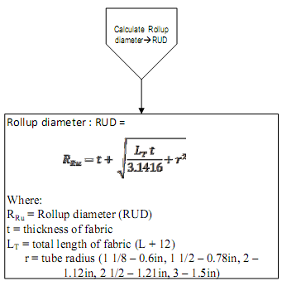
RUD=2 * (t + sqrt ((L_{T} * t/3.1416) + r²))

4081. Works Order Portrait 8.5 x 11

Date format is now taken from Windows format – in this case mm/dd/yyyy.
‘Slat Deduct’ and ‘Special Instructions’ are no longer overwriting one another.

4082. Works Order – Bespoke 34a

If blind identifier = ‘Track’, ‘No of Gliders’ is displayed 9in same place as ‘No Of Louvres’).
In the top left there was not enough room for the blind type description, so blind type description, order no, and required date fields have been moved down a line each.

4083. Works Order – Bespoke 42

‘DB’ is ‘DB’ if trade type = ‘Including VAT’ and ‘BB’ if trade type = ‘Excluding VAT’.

4085. Order Processing > Orders > All Contact Records > Contact Management by Employee

When this report is run, it did not show any records. Fixed.

4086. Works Order Portrait 8.5. x 11

If the order is for a box blind and entered in imperial (and measurement settings are ‘Blind Size – Imperial’), the ‘Trim’ now prints an imperial size. Previously it was metric.

4088. Works Order – Bespoke 34a

- This now shows 7 cutting sizes and 8 options.
- ‘Chain Drop’ now says ‘Control Drop’.

New Work and Customer Requests

2985. Label Print – Fabric Cutting Sizes

There is a new report called ‘Label Print – Fabric Cutting Sizes’ which prints out cutting sizes for blind types with both one and two fabrics in them.

The first column is actually ‘Location’ but the column header says ‘Blind Ref’. The cover width and cover drop are the cutting width and drop sizes for the blind. If there is fabric choice in the options, then it is also printed as well – so extra columns have been created for Fabric (bottom), Cover Width (B) and Cover Drop (B).

There is a new column in Blind Type -> Cutting Options tab -> Top Grid called ‘On Fabric Cutting Label’. This will identify cutting sizes to be printed on this label.

The Cutting Options should be set up as follows:

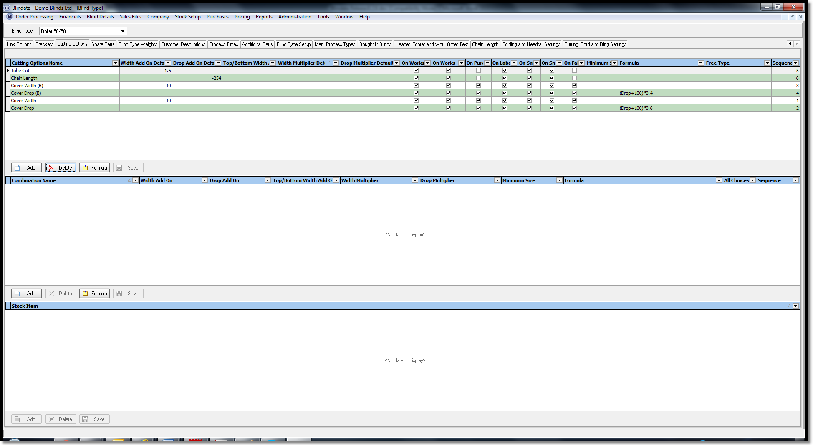

On report ‘Label Print – Fabric Cutting Sizes’ all we do is print the cutting sizes for the cutting sizes with the ‘On Fabric Cutting Sizes’ = true. We do not need to set up any combinations. The cutting sizes are printed across the way using the sequence numbers, so we know what order they go in.

2986. Order Processing > Bought In Order Tracking (re-release of 6.1.6 required)

There is now a new selectable column on the Bought In Order Tracking form for the order ‘Promised Date’. This appears to the right of ‘Order Date’.
Also, when the ‘Approx Due Reciept Date’ is updated using the ‘Manufactured’ button, the ‘Promised Date’ is updated in the sales order.

2988. Pricing > Price Table Enquiry

There is now a ‘Last Updated Date’ field in the price table enquiry form. If a price is amended in a price table, then the ‘Last Updated Date’ is updated. The date is shown as a column in the ‘Price Table Enquiry’ form.

2989. Administration > Import From Excel

When prices are imported to the price table, they are now date stamped the ‘Last Updated Date’ with the current date.

2990. Stock Setup > Fabric Group Setup

We have changed the form so we can select a field to be updated from a lookup. Previously we kept adding a new button and choice each time a new field was added.

There is now a column choice context menu option.

There is now an option to update the ‘Unit Selling Price’.

2991. Order Processing > Orders

Currently, if a customer default record exists, and a detail line is entered and that particular option changed, when you enter a subsequent blind, the selected option is shown until the sizes are changed – it then defaults back to the customer default option. It should remain as the option that was selected.

There is a new parameter relating to this called ‘Always Select Customer Default Option’, which should default to false. If it is set to true, then the customer default option is not selected for subsequent detail lines if another option choice has been made in the previous line.

2992. Administration > Parameters > Report Export Parameters

There is now a choice for ‘Invoice – Batch Print A4’ in ‘PDF Invoice’.

2994. Works Order – A4 Packing Slip

In header replaced ‘Cust Ref’ with ‘Location’.
Removed ‘Notes’ title from header and ‘Special Instructions’ title.

The barcode has been changed to be the serial detail id. This will need to be done in conjunction with switching on the serial number shop floor system.

2995. Delivery Docket – Batched Orders

Changed ‘Customer Ref’ to ‘Cust Ord No’ and grouped by ‘Cust Ord No’.

2996. Invoice – Batch Print A4

Changed ‘Customer Ref’ to ‘Cust Ord No’ and grouped by Cust Ord No’.

2997. Order Processing > Orders > Roman Fabric

The Roman fabric BOM now works properly. Previously it was incorrect if a join was required. It now multiplies the amount of fabric required in the same way as it does for a roller blind (if a join is required).

It is now possible to optimise roman fabric as well.

