Blindata Release Note 6.2.2 

29 December 2012

Bug Fixes and Enhancements

4037. Stock Items > Stock History

There are now only 3 decimal places displayed here.

4038. System Reports > Contact Management By Customer / Employee

There was an error message appearing when you tried to run these reports. Fixed.

4039. Order Processing > Orders

If ‘Imperial Setup’ is set to true, then the figures entered in Blind Types > Blind Type Setup will be imperial sizes. The order entry program was treating them as metric sizes. Fixed.

4040. Works Order – Bespoke 34A

- Moved note to detail line from bottom left – reduced the number of options shown to 5.
- Moved footer boxes to bottom left.
- The ‘Fin Width’ and ‘Fin Drop’ sizes now print man width and man drop sizes.

New Work and Customer Requests

2945. Order Processing > Quotations

We have an option to amend a quote completely (ie any part of it) after it has been converted to an order. There is a permission flag for this called ‘Edit Converted Quotation’ in Parameters. If this is switched on, then it is possible to edit all of a detail line in the quotation.

Also, after the quotation is saved, the ‘Quote Total’ field in the order it was converted to is updated.

2946. Order Processing > Orders > Confirmation Email

There is a new button on the Order Amend Enquiry form. This will trigger an email to ‘Order Ack Email’. If it is being sent the first time, then no message will appear. If it is being sent again, a message should appear saying ‘This confirmation has already been sent to [Order Ack Email]’. The text required can be set up in Company Details > Email Texts 2.

It is also possible to attach a pdf. The location for this can also be held in Company Details > Email Texts 2.

Emailed order confirmations are also held in the order history.

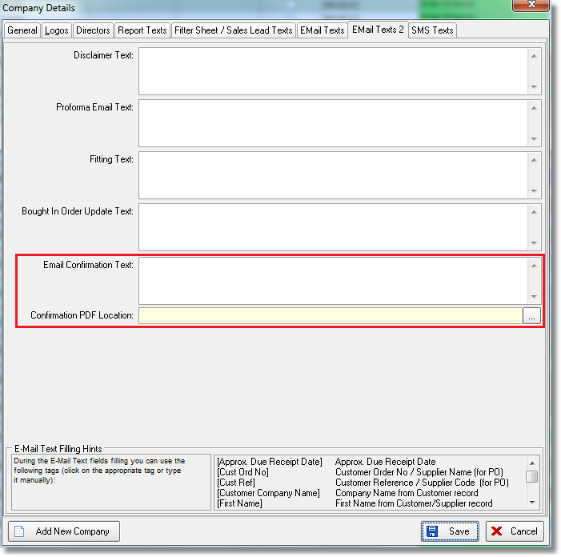

2957. Administration > Import From Excel > Dummy Fabrics

There is now an import routine called ‘Dummy Fabrics’ so records can be imported to the ‘Fabric Roll Widths’ system table. The spreadsheet contains fields for Dummy Stock Code, Roll Width, Real Stock Code.

If ‘Imperial Setup’ = true, then the roll widths will be in imperial sizes. The dummy/real fabric functionality in order entry will allow for this.

2958. Contact Management

The existing email ‘Subject’ field is now displayed regardless of whether ‘Email’ is ticked or not.

There is now a context menu in the contact management form with choices for ‘Columns’, ‘Save Configuration’, ‘Default Configuration’. All these fields are now column choices.

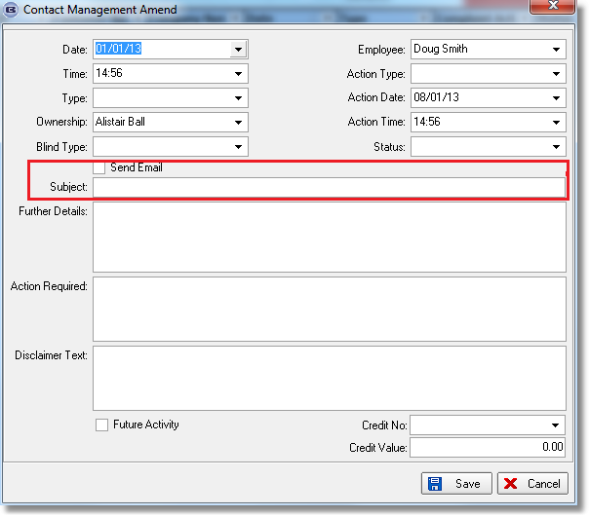

2959. Users > Advanced Permissions

There is now an advanced permission called ‘View Appointments Only’, which defaults to false. If set to true, users are not able to move appointments in the diary or edit them.

2960. Bought In Order Tracking > Export CSV

Column 12 is now used for the blind ‘serial ID’ rather than phone number.
There is now a field for a ftp location for the export CSV file.
Column 18 is now used for the blind number.
The ‘Export CSV’ button has been renamed ‘Export Batch CSV’
The function of this button has been changed so that it will generate CSV files for any outstanding orders with a PO date ‘up to’ the selected date on the pop up.
Also, it will only run for orders that have been flagged as ‘checked’ (if ‘Display Checked’ = true).
Thereis also be a new button called ‘Export Single CSV’ that will generate a csv file only for the highlighted order on the Bought in form.
2961. Order Processing > Orders > Import

The first row of the spreadsheet now contains the column descriptions (headings). The first five columns headings should be ‘Blind Type’, ‘Measure To’, ‘Fabric’, ‘Width’ and ‘Drop’. All other columns may have different headings but their order is hardcoded.

There is a new column to import the quantity (column 9).

The error messages have been tidied up.

2962. Order Processing > Orders > Split Orders

We have improved the back ordering functionality. There is a new parameter called ‘Enable Back Order’.

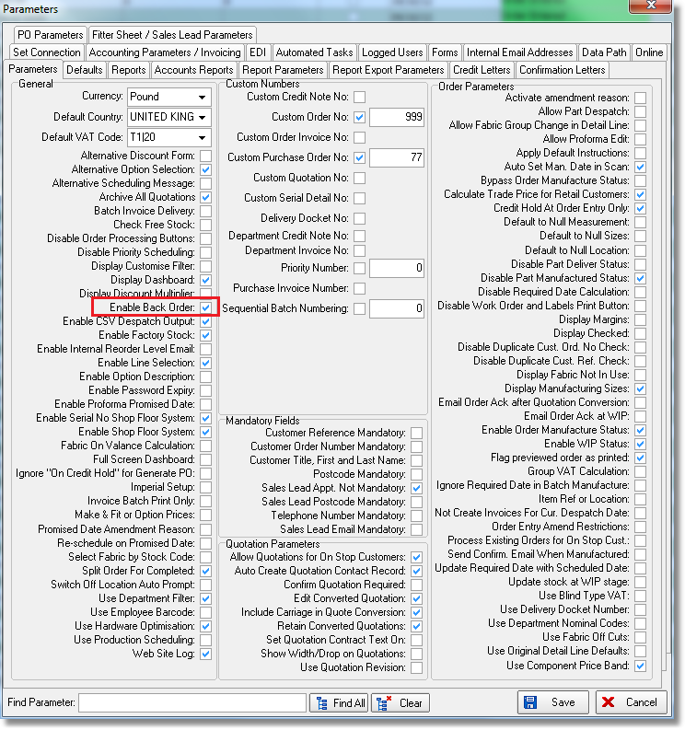

Previously there was an option to split orders, but only by splitting entire detail lines. We now have a number of customers that do a lot of component sales, and they will often have situations where a customer has ordered 10 of something, but only 6 are delivered (for example). We need to be able to indicate on the delivery docket that 10 were ordered, 6 were delivered, 4 are on back order and show the new order number.

In the component detail line entry, we can amend the quantity amount and it saves the original order amount. There is now another field in here for ‘On Back Order’.

There is a further complication here because we need to take into account the ‘Unit Of Sale’.

In the example above the user should have the choice of amending the ‘On Back Order’ amount because the back order amount may be changed to 0.

When the order is saved, if there are detail lines that have an amount on back order, the ‘Split Order’ form should be displayed. There should be extra fields on this form for ‘Quantity’, ‘Unit Quantity’, ‘Original Order Amount’, ‘On Back Order’. If ‘On Back Order’ > 0, then the ‘Include’ flag should be ticked.

When the split is done and the new order created, and if ‘On Back Order’ > 0 in the original order, it is put into the quantity field. The ‘Unit Of Sale’ is also taken into account. It is also possible for the user to choose other detail lines as before. If ‘On Back Order’ = 0 and the split is made, the original order quantity is updated with the quantity, the quantity becomes zero and ‘On Back Order’ has the quantity in it. The order detail line is left in the old order. Detail lines with quantities of zero are not included in invoices and are not posted to the sales ledger.

2963. Purchases > Suppliers > XML File Transfer

Previously if an XML file was created from a sales order, the quantity was stored in the detail line. This record is generated from the order detail line.

There is now an extra option so that the XML file will be generated from the serial detail line. This means the quantity will always be 1. The value for the order detail ID is the serial detail id.

There is a new parameter for this in the supplier record called ‘Export Serial Details to XML File Transfer’. This parameter is only applicable to ‘File Transfer’ and will only appear if ‘Transfer File’ = true.

2966. City Link XML File

A few minor changes have been made to this.

- <AccountNumber> is taken from the courier account number in the customer record.
- <reference> is now the order number (order_id)
- <Service> is the courier code from the ‘Carriage Type’ table.
- The value of goods is now left blank unless the delivery postcode starts with JE or GY.

