Blindata Release Note 6.2.3 

4 January 2013

Bug Fixes and Enhancements

4045. Order Processing > Orders
If ‘Add Carriage at Order Entry’ is switched on, a message appeared about SDD when the order was saved. This no longer appears.
4046. Works Order – BOM
The cutting size was not being calculated properly for ‘imperial setup’ measurements. Fixed.
4047. Label Print - A4 88mm x 14mm

The fields were not fitting on the labels properly. The left hand column has been moved 10mm to the right.

4048. Works Order – Bespoke 34a

The right hand column ‘Reference’ now says ‘Cust Reference’.

4050. Works Order – Bespoke 34a

The layout of this report has been changed:
Number of brackets is now displayed.
Column headings are in a smaller font.

4051. Order Processing > Orders

If you selected the ‘Work In Progress’ button (and changed the order to WIP), and then tried to immediately select ‘Order Made’ for the same order, it did not work. You had to move onto another record and then back to that one. Fixed.

4052. Order Processing > Orders

If ‘Imperial Setup ‘ = true, the box blind lookup did not work properly. Fixed.

New Work and Customer Requests

2795. Export Tuffnells Carriage csv

Some changes have been made to the export file

It is now comma separated instead of pipe (|).
The service type being used is now taken from a new field in the ‘Carriage Type’ record called ‘Service Code’.
The carriage return has been removed from the end of each record.

2967. Reef Blind

There is a new calculation for rooflight blinds involving pocket and gap sizes. The calculation is a bit like a Roman blind so it has been set up as blind identifier = ‘Austrian/Roman’.

There is a new flag in the blind type record (only if blind identifier = A) called ‘Pocket Calculation’. If this is set to true, then the following field names change to be Pocket Size, Minimum Gap, End Pocket Size. The pockets/gaps will then be calculated.

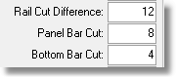

We hold 3 figures: Pocket Size, Minimum Gap, End Pocket Size.

This is how it will be calculated:

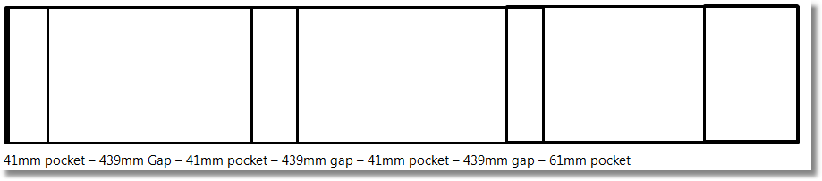

For the time being this calculation will only appear on ‘Works Order – Label Blind Size’.

2968. Box Blinds

Previously when the program looked through the box blind widths and drops (in System Tables > Box Blinds table) with the search was done by drop then width order. There is now an option to find by width then drop order. There is a new flag in the blind type record called ‘Search by Width Instead of Drop’. This flag is only visible if ‘Box Blind’ = true. The order detail line entry then takes this flag into account when selecting the box blind code to be used.

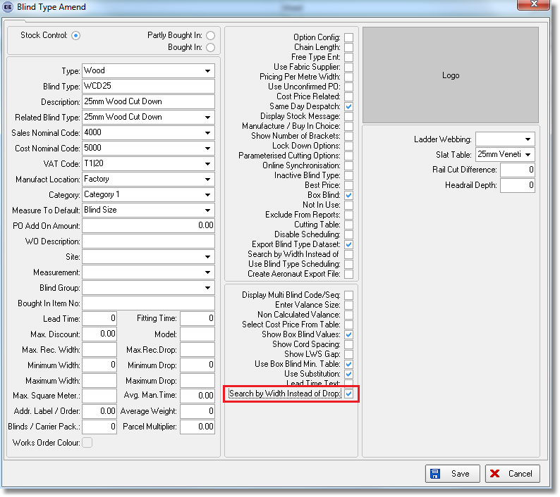

2970. All Works Orders

At the moment cutting sizes can be printed on a lot of the works orders. We can have a situation where a cutting size will appear even if we do not want it to appear. In this example here, ‘No Fascia’ has been selected as an option but the cutting size for a fascia still appears.

There is a new rule that if the cutting size = 0, then the cutting size does not appear on the works order. This has been applied to all works orders where cutting sizes appear.

2971. Blind Types > Cutting Sizes

We have made a change to make the cutting sizes set up a bit easier. Previously if you have (for example) 5 options that all have the same cutting size, they have to be added individually in ‘Cutting Sizes’.

We have added a new flag for this called ‘All Choices Match’, which is True by default. This means system will work as it does now.
If this flag is set to ‘false’ then the cutting size will apply if at least one option matches.

2972. City Link XML

The file is now exported to a location on the server, not to a ftp address. If the ftp setting is blank, then the XML file is now saved to this location.

