Blindata Release Note 6.2.0 

17 December 2012

Bug Fixes and Enhancements

4032. Invoice – Bespoke 44

Some minor adjustments have been made to field positions.

4033. Order Processing > Orders

When entering an appointment from the order form, it finds the next available time in a day. This only worked if you chose the date before the employee. It now works either way – in other words, after the date is selected, it refreshes the start time.

4034. Order Processing > Orders
There was a bug when deleting an order detail line. If ‘Use Factory Stock’ is switched on and ‘Update Stock at WIP Stage’ is switched on, if a detail line was deleted at the ‘Work In Progress’ stage or later, the ‘Stock In Hand’ figure was being increased – it should have increased the ‘Factory Stock In Hand’ figure instead and leave the ‘Stock In Hand’ figure as it is. Fixed.

4035. Stock Setup > Stock Items

‘Antimcrobial’ is now spelt ‘Antimicrobial’ in the column choice.

4036. Works Order – Bespoke 34A

‘Customer Ref’ and ‘Date Completed’ have been removed from the header section and ‘Location’ widened in the detail section.

New Work and Customer Requests

2923. Link Options > Exclusions

In the centre part of Link Options, previously there have only been combinations which have the logic ‘and’. It is now possible to create rules which include ‘AND’, ‘NOT’ and ‘OR’.

This can be done by selecting the ‘Rule’ button in the middle of the ‘Link Options’ form.

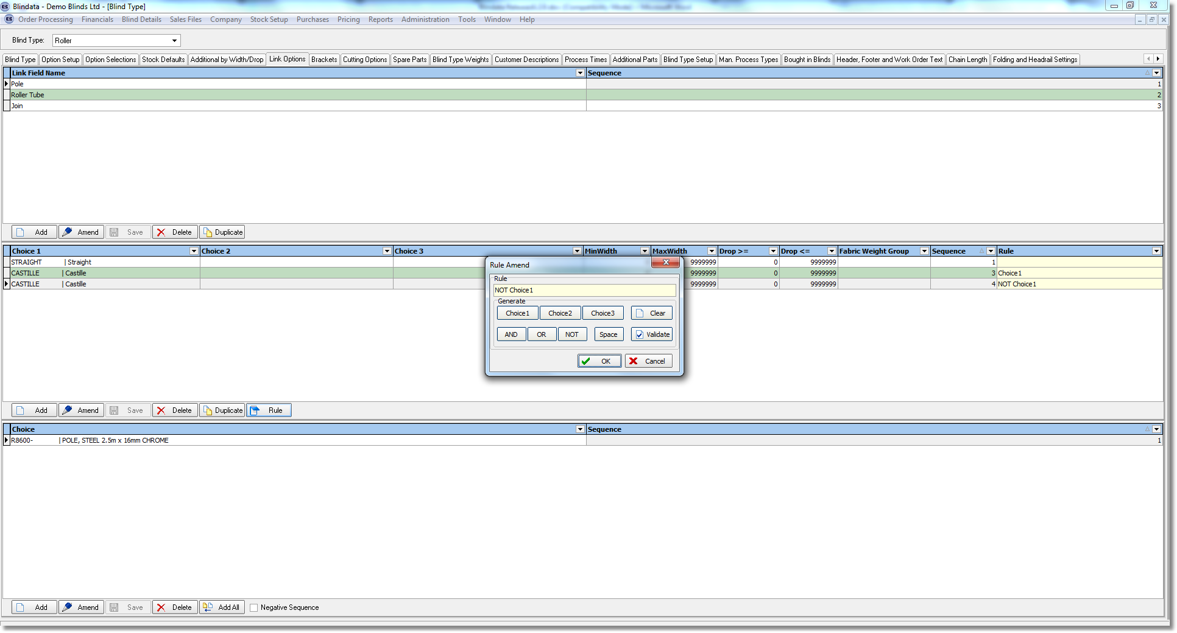

2928. Reorder Level Internal Email

It is now possible to send an internal email if a stock item ‘stock in hand’ falls below its reorder level. This can be done when an order detail line is saved. Once this is done, it flags the stock item as ‘Reorder email sent’ (to stop it happening repeatedly). When the PO is received for the stock item, the flag is reset.

There is a new email address in Parameters > Internal Email Addresses called ‘Reorder Level Email’.

There is also a new parameter called ‘Enable Internal Reorder Level Email’. If this is switched on, then an email will be sent with the subject ‘Reorder Level Warning – stock code XXXXXX, and the message ‘Stock Item [stock code], [stock description] has fallen below its reorder level’.

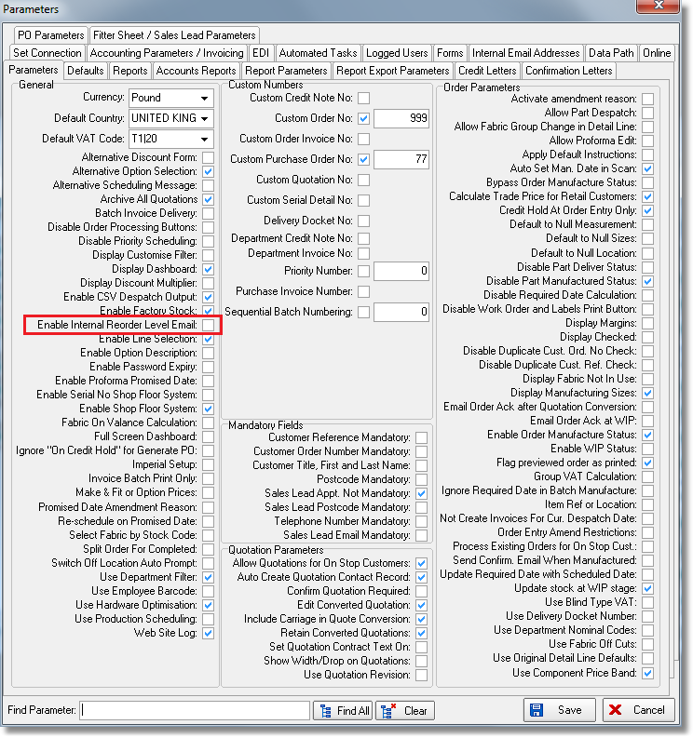

2929. Stock Setup > Stock Items Stock History

It is now possible to view the stock history (receipts and issues) in the ‘Stock Items’ form.

The purpose of this is to make it easier to decide how much to purchase in a regular purchase order.

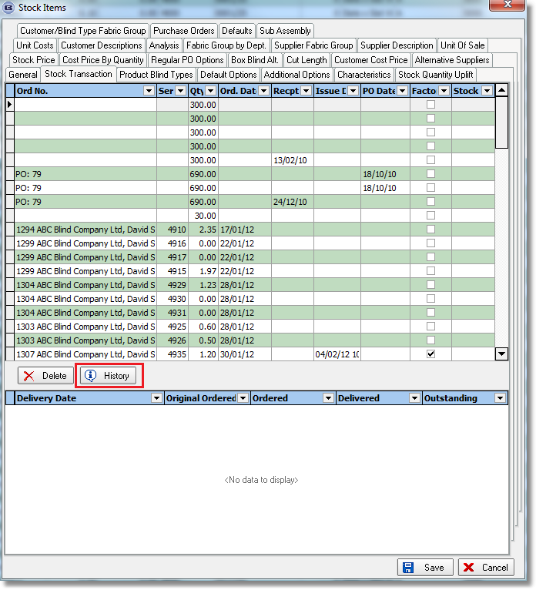

2943. Feasibility Changes

The following changes have been made to the feasibility functionality.

- For feasibility test instead of exact match it will check if the option it is at least the option given by the feasibility calculation.
I.E. If the feasibility calculation determines that the tube to be used should be 1.1, than, if the radius of the tube already chosen is bigger than the radius of 1.1, the feasibility will pass.
This works for tubes and clutches.

- The warning for Tube selection:
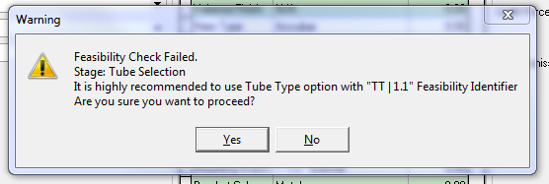
The text is now ‘It is highly recommended to use at least “1.1” tube’.
- The message now has three buttons: Yes, No, and Proceed. The third button is to put into option choices the value generated by the Feasibility.
- If an order is generated just for checking the feasibility, and feasibility pass, if the order is to be discarded (cancel) the system generate the following message:
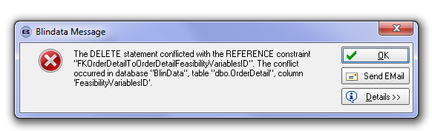
If the order has failed the feasibility, than the order can be scrapped.
- If the user decides to proceed even when the feasibility steps fail, than the calculation of rollup diameter, parameter D, and fabric and tube go with the values of the choice made by the user.
- For the Admissible Deflection, the display values are now at least 3 decimals. The usual value is in between 0.003 and 0.006
- The “Weight g/m2” has been be replaced with “Specific weight” and the unit of measure specified separately accordingly with the formula where this value is used.
- Fabric thickness is currently only held in millimetres.
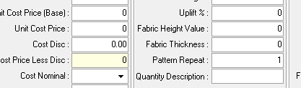
- How is the rollup diameter calculated? Which values are taken into account?
At the moment we use the following formula:
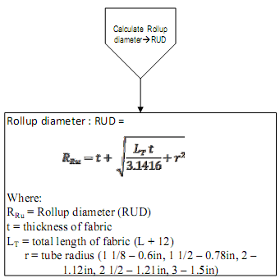
In this formula we use (Drop + 12) as a Total Length of Fabric (L_{T}).
The ”t” (fabric thickness) is taken from fabric selected and the tube radius from the stock Item with TT identifier determined at the tube selection stage and is checked against “Max Valance Diameter”.
If so, I have to make a correction. [Max Valance Diameter > 2*RUD] is now checking for admissible roller inside a valance.
- Width/Length ratio is in reality Length/Width ratio. The Length shouldn’t be greater than 2.5*Width, otherwise the shade become instable and tends to telescope.

2944. Works Order – Bespoke 34A

We now have up to 5 cutting sizes on this report.

