Blindata Release Note 6.2.1 

21 December 2012

Bug Fixes and Enhancements

New Work and Customer Requests

2939. Fabric As An Option

We have a customer that makes a roller blind that is made up of two different fabrics joined together. It could be any combination of two fabrics. The ratio of usage is 60/40, so we need to be able to work out the bill of materials for this.

First of we need to be able to choose a second fabric in an order detail line, so it could be chosen as an option. We can do this already. However the calculator is different for both the fabric choice and the fabric option.

First of all, a different blind type needs to be set up. The reason for having a different blind type is so that we can have a different calculator for the fabric according to the blind type. There is now also a flag called ‘Option’ in the ‘Product Blind Type’ tab to indicate if the fabric has been chosen as an option to use this record.

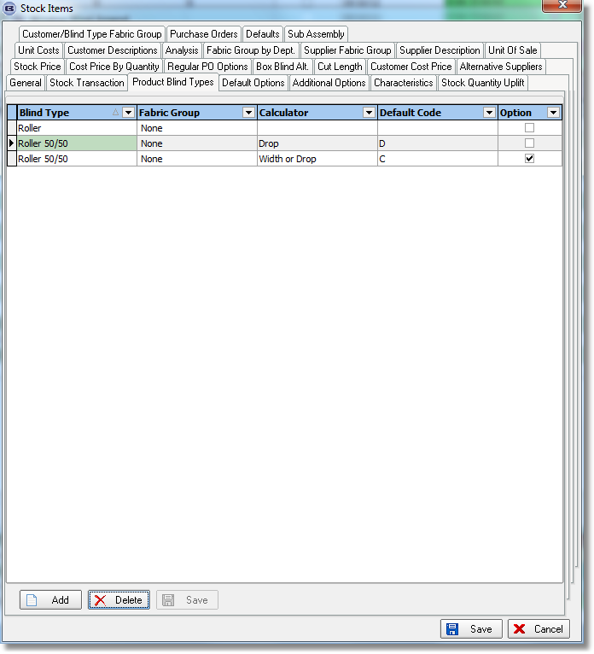
In this example (above), if the blind type is a Roller 50/50, then there will be two different calculations for fabric, depending on whether the fabric is chosen as a ‘fabric’ or as an ‘option’.

2947. Order Processing > Orders > Sales Info Sheet

The boxes with ‘Requirement/Quote from Other Source’ are now only on the first page, and also take up the bottom third of the page. The text that appears there should be entered by the user in a new window in the ‘Sales Info Sheet’, prior to printing.

2948. Contact Management

CTRL/T can now be used to display user’s contact management

2949. Fitters Sheet / Sales Lead

CTRL/D can now be used to bring up the Fitters Sheet / Sales Lead diary form.

2951. Contact Management Reports > Next Quotation Report

The contract number is now printed on this report. Also text was being chopped off and this now wraps around.

2952. Administration > Archiving > Quotations tab

It is now possible to archive ‘Don’t Follow Up’ quotations. There is a flag on this form called ‘Include ‘Don’t Follow Up’ Quotations’.

2953. Administration > Parameters

If ‘Enable WIP status’ is switched off, then ‘Update Stock at WIP Stage’ is also switched off.

2954. Order Processing > Quotations / Orders

At the moment there is a parameter called ‘Display message after order entry’. If this is switched on, then it is displayed for orders and quotations.

There is now a separate message for quotations, so there is a new parameter called ‘Display message after quote entry’ along with a text field. This message will only appear if switched on and after a quote is entered. The order message only appears after the order entry.

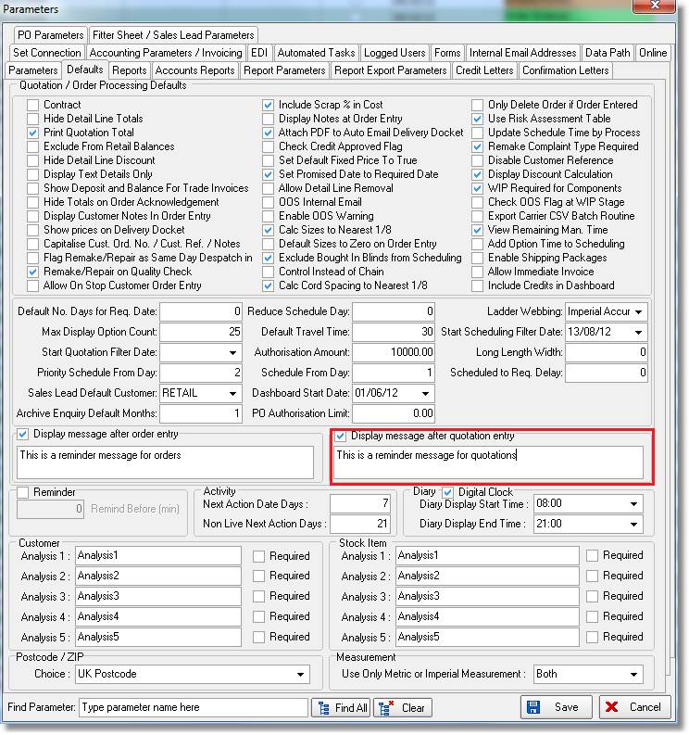

2955. Order Processing > Orders > Quantity Per Order Calculator

We have had a request from a customer that affects the bill of materials. A stock transaction should be added to the bill of materials but only one added per order. For example, if there are 3 blinds on an order, then only the BOM in the first blind should contain a specific stock item.

To do this there is a new calculator called ‘Quantity Per Order’. If a detail line is entered, and there is already a BOM record created for a stock item with calculator = ‘Quantity Per Order’, then this item is not added to the BOM. The quantity will be the ‘Quantity Default’ in the stock record – so this new calculator will behave in the same way as the ‘Quantity’ calculator except there will only be one per order.

2956. Invoice – Bespoke 42

There is a new invoice layout called ‘Invoice – Bespoke 42’.

There is also a pdf version of this report for emailing and a credit note version called ‘Credit – Bespoke 42’.

