Blindata Release Note 6.1.9 

10 December 2012

Bug Fixes and Enhancements

4023. Label Print – A4 88mm x 14mm

The labels have all been moved down 8mm.

4024. Order Processing > Orders

If the country is set to USA (so ‘Sidemark’ appears in order entry), the customer reference validation message now refers to ‘Sidemark’.

4026. Order Processing > Orders

The ‘Bottom width’ field name now lines up properly. This only appears for a shaped blind.

4027. Invoice For Payment

The invoice text was overwriting the amounts, but only when printed. Fixed.

4028. Works Order – Bespoke 34A

‘See Notes’ now say ‘Reference’.
Replaced descriptions with stock codes in the option choice and made font smaller.
Made the option name field (on side) a bit longer.
Made the font for fabric description – in both places

4029. Label Print – A4 88mm x 14mm

‘Cust Ref’ is now be ‘Ref’ followed by the ‘1 of n’ field.

New Work and Customer Requests

2920. Administration > System Tables > Invoice Terms

There is a new field in this table called ‘Payment Days’. When an invoice is created, it looks at this field and calculates the payment date for the invoice, and this date is stored in the order table. It is calculated as ‘Invoice Date’ + ‘Payment Days’.

This will appear on specific invoice layouts as requested.

2921. Administration > Import From Excel > Customer Update

‘Date Account Opened’ is now a field choice for importing.

2922. Sales Files > Customers

There is a new field called ‘Web Site’ in the customer record. This is held in the Details tab below ‘Mobile’. If the Country is set up as USA or Canada in Parameters, ‘Mobile’ says ‘Cellphone’.

2925. Invoice – Laser Print 11 Detail Lines

The ‘Invoice Terms’ (from the customer record) now prints on this invoice, above the invoice text in the bottom left.

2926. Parameters

There is now a parameter called ‘Promised Date Amendment Reason’. If this is switched off, then the user does not have to enter an amendment reason if the promised date is changed. The parameter defaults to false.

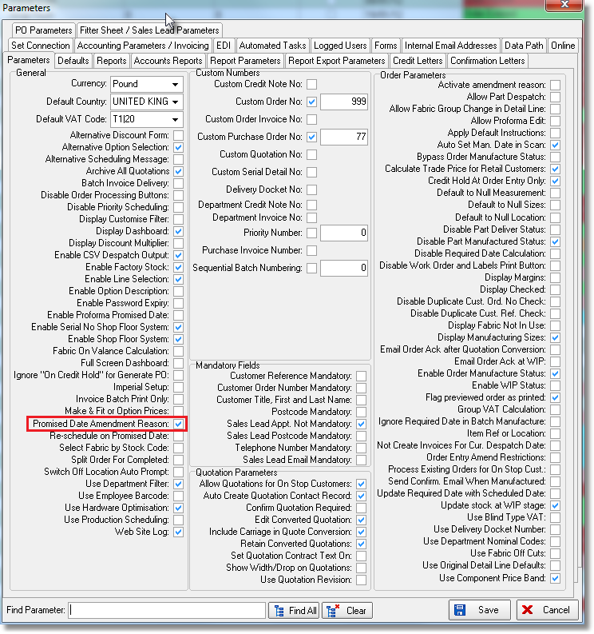

2927. Picking List

We are getting more customers that want to use the picking list and asking for different things to be put on it. Therefore we have made the following changes.

There is now an option for ‘Picking List’ report choice in Parameters > Reports, below ‘Works Order 2’. The current picking list is called ‘Picking List 1’ and is in there as the default.
If ‘Utilise Picking List’ is switched on, then if there are miscellaneous detail lines on an order, the picking list print out after the works order, regardless of which works order is used.

There is a parameter to decide what order to print the detail lines. The default is the order in which they are entered, and there is now a choice of ‘By Location Order’.

There is also a new column for amount picked, called ‘Despatched’.

There is also functionality to print a bar code on the picking list. This is on the first detail line – only one barcode is required.

It is also possible to print location on picking list and print the order of items by stock location.

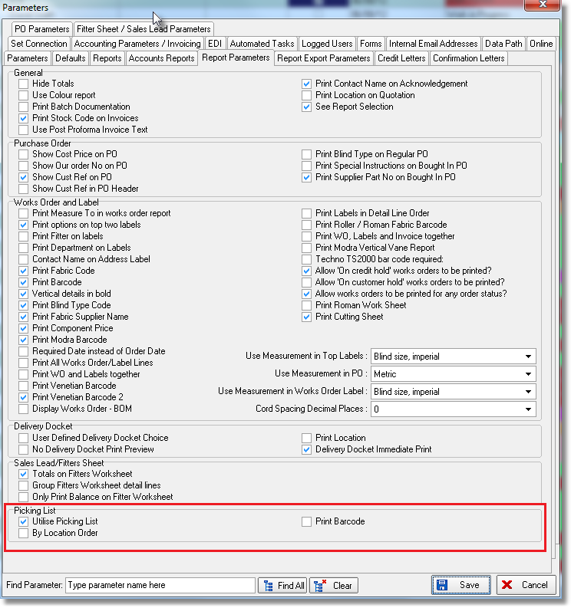

2930. Delivery Docket – Laser Print Non Itemised

The text from Company Details > Report Texts > Delivery Text now prints in the bottom left in this report.

2931. Order Processing > Quotations

If the quotation is a proforma – need to record the promised delivery date, and when its converted to an order, that should become the required date and a must go.

There should be a new parameter for this called ‘Enable Proforma Promised Date’, which should default to false. If true, then a promised date must be entered and when converted to an order, it will become the required date and the order should be flagged as ‘Must Go’.

2932. Order Processing Menu

There is now a CTRL/A function to jump to Archive Enquiry

2933. Sales Files > Customers

There is now an option to show all detail lines for a customer – by right clicking on the customer record.

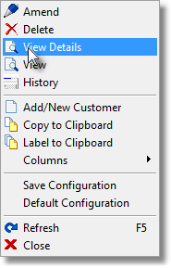

This shows the same information as is shown in ‘View Details’ when you right click in the ‘Order Amend Enquiry’ form, except it also shows the order number and invoice number. It is also possible to then right click on this form and ‘copy to Clipboard’, which gives a quick way of seeing what has been bought by that customer.

2935. Purchase Order Enquiry > Regular PO

For a regular PO, it is common for a supplier to send 90 metres of fabric (for example) when 100 metres has been ordered. When this happens, the remaining 10 metres will not be sent at a later date. The system should therefore be capable of completing the order in this situation, but until now a situation existed where the purchase invoice may have been posted for the purchase order, but it still has a status of ‘Part Delivered’.

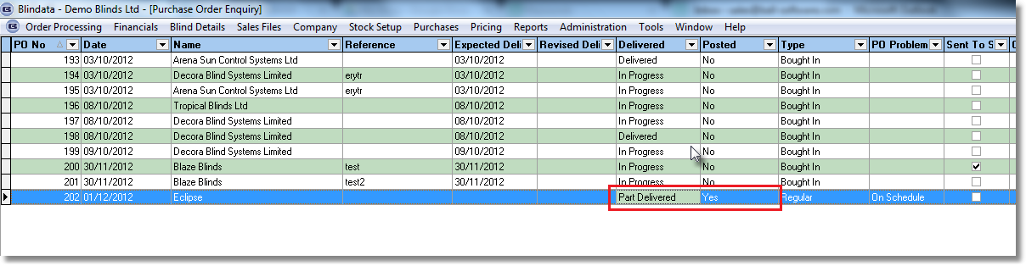

We have resolved this issue at the point the PO is delivered. Let’s use this example where 100 metres is ordered, but only 90 metres is on the roll. The remaining 10 metres will never be sent, and so this detail line should not have anything outstanding.

There is now a flag called ‘Completed’. If this is set to true, then the outstanding amount is set to zero and ‘On Back Order’ is set to false (in the ‘Update’ form). If all the detail lines in the purchase order then delivered (and there is nothing outstanding), then the status of the PO is changed to ‘Delivered’.

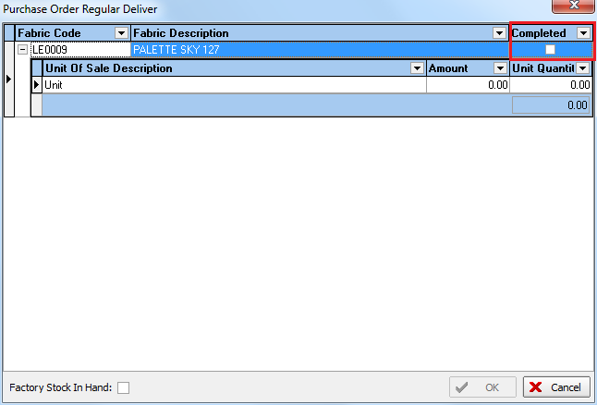

Also we could have a situation where more than the amount ordered is delivered. The ‘Stock In Hand’ is now being updated with the correct amount. If 100 is ordered and 105 is delivered, stock in hand increases by 105, not 100.

2937. Stock Setup > Stock Items

There is now a ‘Copy to Clipboard’ in the stock transactions tab (right click on form).

