Blindata Release Note 6.1.8 

30 November 2012

Bug Fixes and Enhancements

4006. Works Order – Bespoke 34A

We have changed what goes in the notes. Each line is now filled with the line number (batch no from the detail line), then special instructions. Previously the numbering was wrong, the spec ins from the first detail line were missing and there was a space between each line.

4007. Order Processing > Orders (re-release of 6.1.6 required)

There was a problem with the BOM if a large roller blind is entered ie width and drop > roll width and it had a calculator = Drop and ‘Turn If Width > Roll width’.

Although there is a parameter for it for ‘Allow Vertical Join’, this is not something that should really be done, because the blind will not roll up and down properly. However, because we are turning a fabric ie temporarily making the calculator ‘Width’ instead of ‘Drop’, we have an artificial situation where the ‘Vertical Join’ logic has to be applied – imagine the blind on it’s side.

We have tried to keep this as simple as possible. If the logic for ‘Turn If Width > Roll Width’ is applied and both the width and drop > roll width, then we should assume ‘Allow Vertical Join’ = true, even if it isn’t.

4008. Bought In Order Tracking > Export CSV (re-release of 6.1.6)

Column 1 was for ‘Order Reference’. ‘Order No’ now goes in here rather than the customer reference.
Columns 6 to 12 are for address and phone details. These previously came from the orders delivery address, but now come from ‘Company Details’.
According to Blaze, column 14 is for ‘Lining’, but ‘Headrail’ is currently going in here.
According to Blaze, column 15 is for ‘Control’, but ‘Lining’ is currently going in here.
According to Blaze, column 17 is for ‘Headrail’, but ‘Control’ is currently going in here.
If the quantity > 1 in an order detail line, we now create an export CSV record for each individual blind. This is because the quantity is not held in the import CSV file.
To try and reduce the possibility of duplicating orders, when ‘Export CSV’ is clicked, it fills in today’s date in the ‘Date PO Sent’ field for all selected orders, and changes the status to Works In Progress. Also, the ‘Export CSV’ function only include detail lines at status ‘Order Entered’. (same as the Send PO Button).

4009. Invoice – Laser Print (Letterhead Logo)

Quantities of > 9999 did not print out properly – this is printer related. The field has been made a bit wider.

4010. Purchase Order Regular – Bespoke 28

Supplier part no now print here if selected to print in supplier record ie ‘Use Supplier Part No in PO’ = true in the supplier record.

4011. Quotation – Laser Print

The ‘Location’ from the detail line now appear to the right of ‘Measurement’ for a blind detail line. Product codes should print for component detail lines.

- ‘Location’ will print on this report if ‘Print Location On Quotation’ is ticked in the Parameters.
- ‘Product Code’ will print on this report if ‘Print Fabric Code’ is ticked in the Parameters.

4016. Delivery Docket – Customer Special

- The quantity now only print to 3 decimal places for component lines.
- The ‘Carrier’ box has been made a bit wider.

4017. Archive Enquiry

After archiving is done, the link was lost to ‘File Attachments’. This has been fixed.

New Work and Customer Requests

2907. Imperial Setup

Previously it was only possible to enter metric sizes in certain forms. There is now a new parameter called ‘Imperial Setup’ in Parameters. If this is set to true (default will be false), then it is possible to hold imperial sizes in the following forms:

Blind Types > Blind Type tab

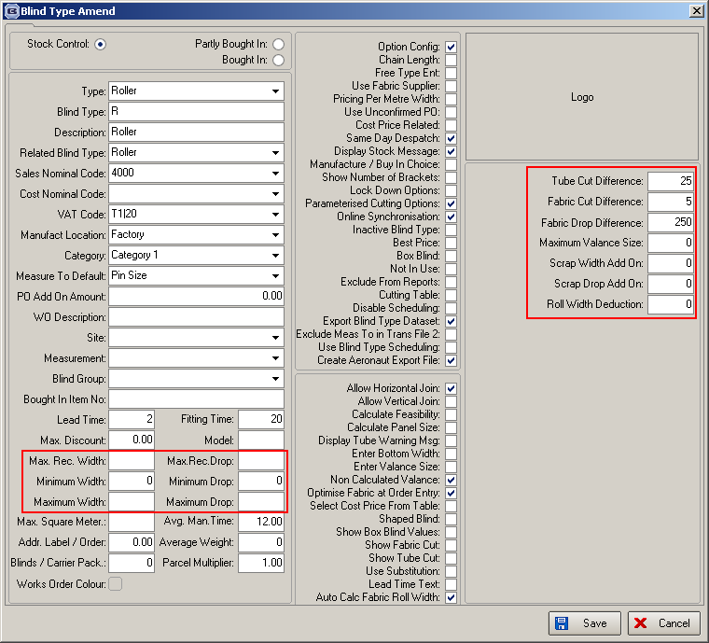

Max.Rec.Width
Max.Rec.Drop
Minimum Width
Minimum Drop
Maximum Width
Maximum Drop
Chain Length %
Chain Len. Deduct
Round Chain Length Down to Nearest
Min Drop for Chain Length Ded.
Val. Size Add On
Return
GapBetweenBlinds
Fabric > Roll_width
Fabric > RollLength
DimCalc > width_amount
DimCalc > drop_amount

Blind Types > Cutting Sizes

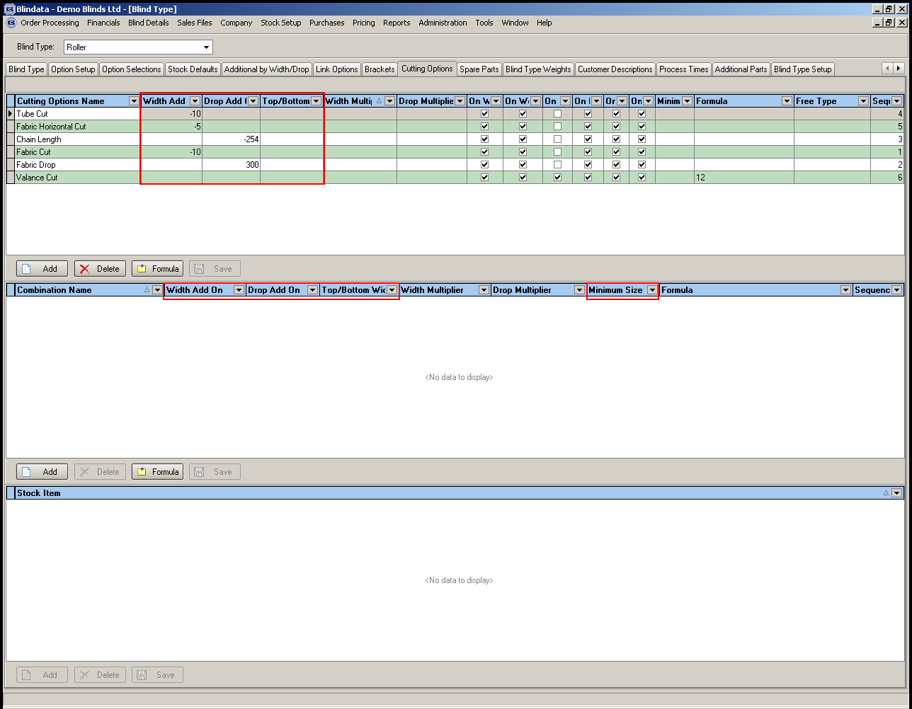

Blind Types > Link Options

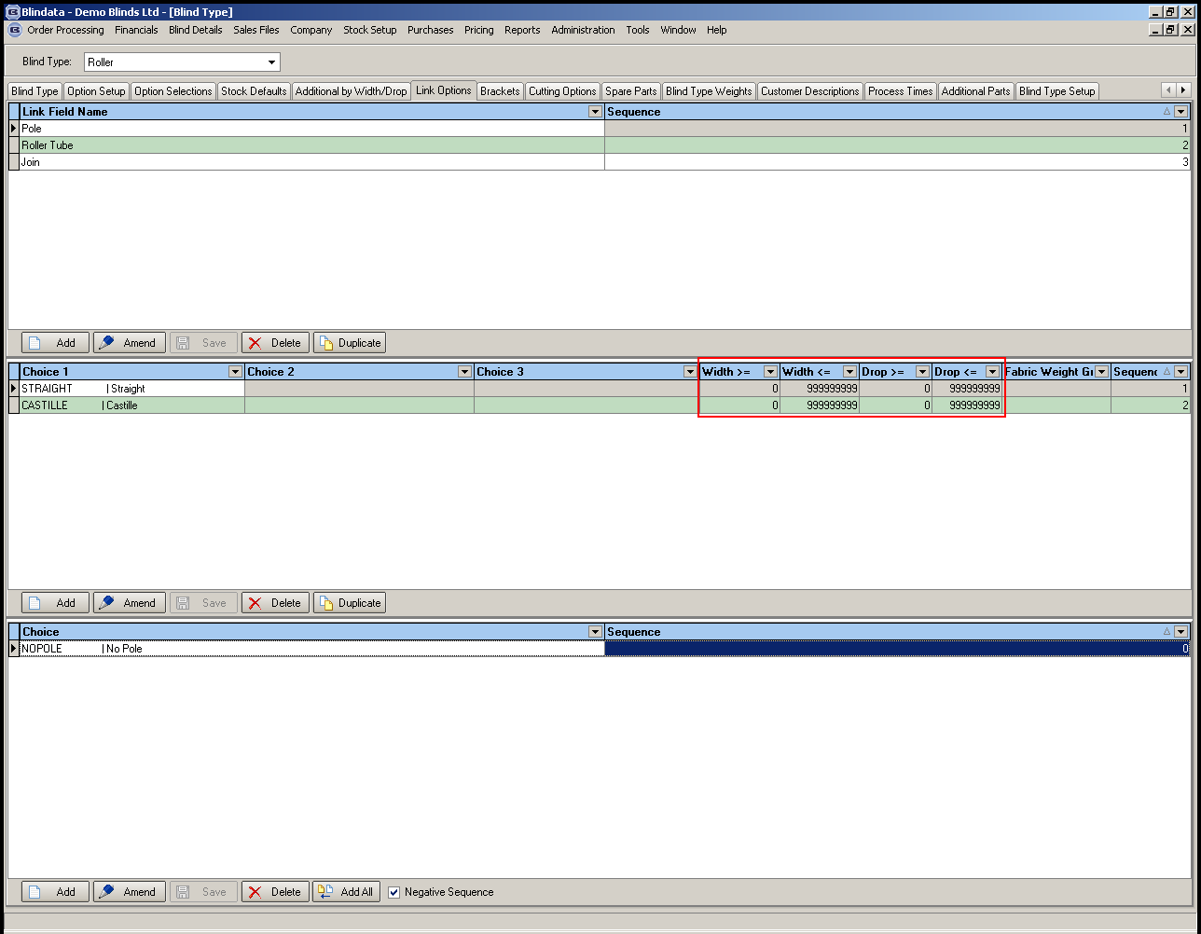

Blind Types > Additional by Width/Drop

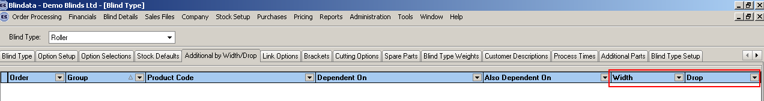

Blind Types > Brackets

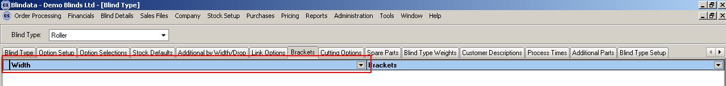

Blind Types > Additional Parts

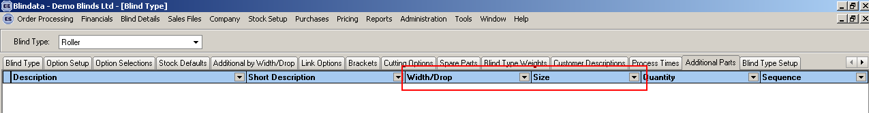

Stock Items > Roll Width

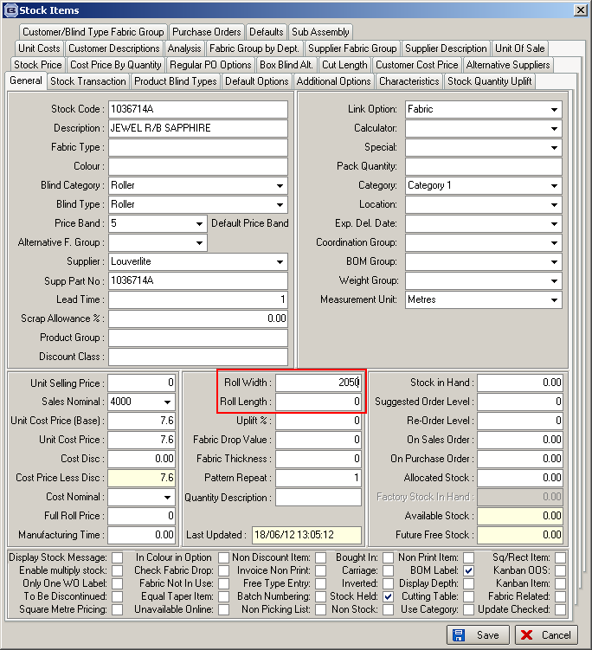

Stock Setup > Dimension Calculations

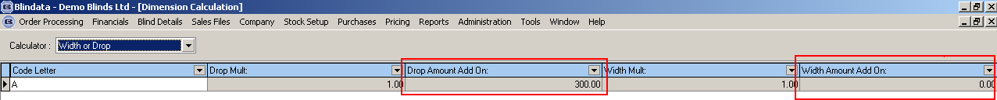

System Tables > Venetian Slats

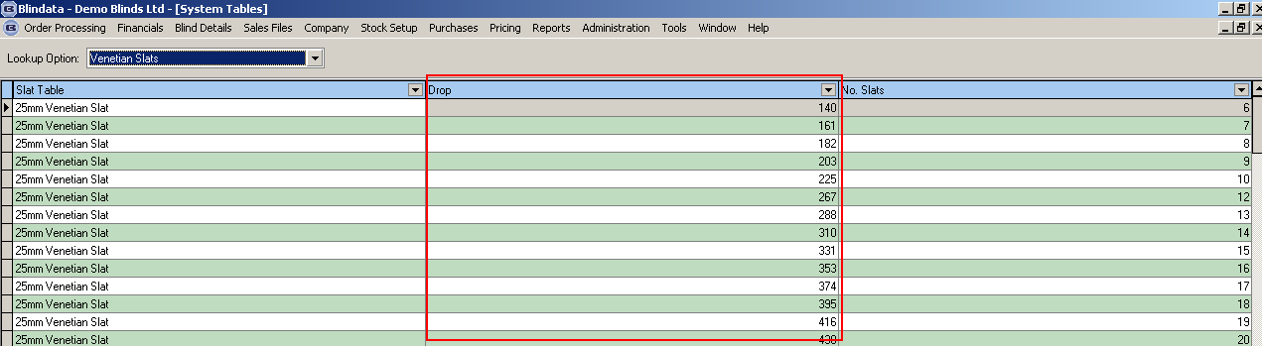

System Tables > Single/Split Bunch Louvre Slats

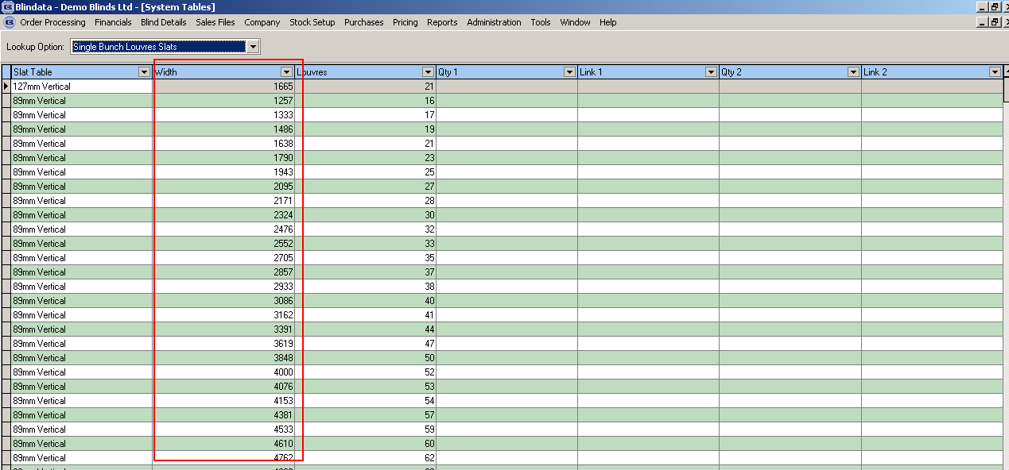

If ‘Imperial Setup’ = true, then all lookups etc relate to imperial sizes.

2911. Invoice – Bespoke 44

A new invoice report has been created called ‘Invoice – Bespoke 44’. The page size is A4 and prints on pre-printed paper.

2917. Credit Note – Bespoke 34

There is now settlement discount shown on here and also updated into Sage in the same way as an invoice is updated. It shows information in the same way as it is done in ‘Invoice – Bespoke 34’.

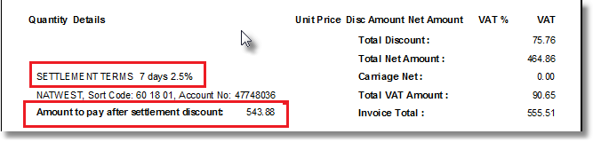

2918. Quotation – Bespoke 21

The quotation text is now parmeterisable – the text is held in the ‘Department’ table in Administration > Departments. If nothing is held there, then the current text prints.

2934. Stock Setup > Stock Items

There are now column choices for ‘Alternative Fabric Group’, ‘Analysis 1’, ‘Analysis 2’, ‘Analysis 3’, ‘Analysis 4’, ‘Analysis 5’.

2936. Works Order Portrait Barcode

Barcodes now print on the works order for each blind.

