Blindata Release Note 6.1.6 

19 November 2012

Bug Fixes and Enhancements

4001. Issues Relating to 2871

If an incorrect batch number is entered in ‘Processes’, the process was still completed but ‘On Sales Order’ and ‘Stock In Hand’ was not updated.. The process is now stopped from completing at this point.

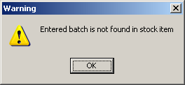

4002. Order Processing > Orders

If a fabric has ‘Turn If Width > Roll Width’ = true, then the size of the fabric was calculated incorrectly. Fixed.

4003. Fitter Sheet / Sales Lead

You no longer have to enter a space immediately after the number in the first part of the address line 1.

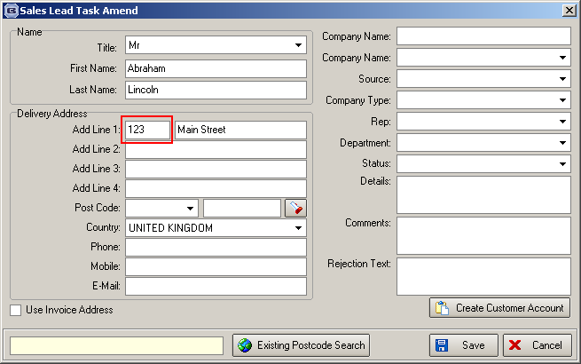
New Work and Customer Requests

2871. Order Enquiry > Processes

It is now possible to record actual usage of fabric when the ‘Processes’ button is used. It is the actual usage that will deduct from the stock amount. This can be entered in the ‘Processes’ form along with the batch number – it will then deduct stock from the relevant stock in hand figure.

Therefore we can now distinguish between two stock calculations.

- Theoretical – this is the amount calculated at the moment in the bill of materials and will not change.
- Actual – this is the amount that is going to be entered in ‘Processes’.

Work Required

There is a new flag held against the stock record called ‘Manual Stock Usage’.

If this flag is switched on, then at the blind manufactured blind stage, the stock in hand figure will not be reduced for that item. The ‘On Sales Order’ figure will still be reduced, though. Instead the stock in hand figure will be reduced by a manual entry in Order Enquiry > Processes.

We now hold extra columns in this form for ‘Batch Number’ and ‘Amount Used’. For a fabric, there may be multiple records in here that have the same batch number. As we are cutting them all at once, we only need to put the amount used in against one of the records. When ‘Complete’ is selected, the stock in hand figure will be updated in the ‘Stock In Hand’ field and also in the batch.

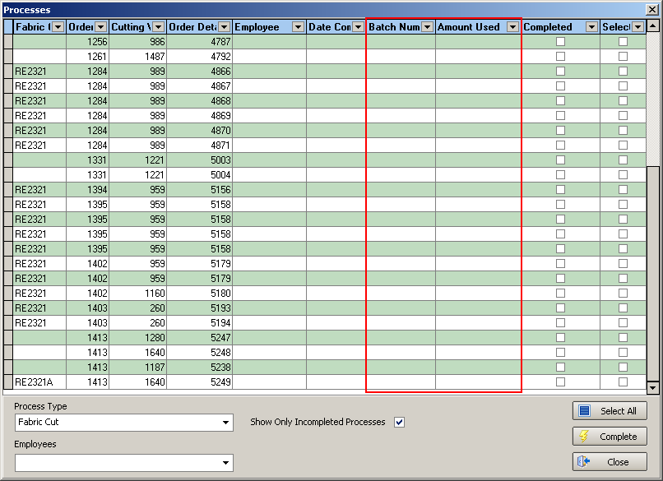

Additional notes - batch numbering

At the moment we have the possibility of setting up stock items as having ‘Batch Numbering’. This is required because some customers want to hold fabrics in different batches. The reason they want to do that is because fabrics sometimes come in very slightly different shades (because of the way they are manufactured), even though they are supposed to be identical.

We have completed sequential numbering for batch numbers when stock comes in. The problem we have is how to handle the batches when stock goes out.

Let’s use the example of a fabric that has 3 different roll widths, with stock codes FABRIC1, FABRIC2, FABRIC3.

We could have a stock holding like this.

FABRIC1

Batch 100: stock of 56
Batch 101: stock of 20
Batch 102: stock of 40

FABRIC2

Batch 104: stock of 20

FABRIC3

Batch 105: stock of 40
Batch 106: stock of 40

When a sales order is entered, we can get the system to work out which fabric to use, so let’s say that it is selecting FABRIC3. At this stage we could also work out which batch number could be used – in this case it will use the first one, 105. If there is a large order, then it is possible that more than a quantity of 40 will be used and it will move onto 106.

The ‘Processes’ form can then be used to flag the process as being completed. When the ‘Fabric Cut’ process is flagged as completed, it is possible to enter how much fabric has actually been used, and which batch has been used. If everything is straightforward, then the batch that is used will be the one that was automatically chosen at order entry.

But in reality it will not be as simple as that. First of all, there may be flaws in the fabric, or the amount that is actually held in the batch may be wrong. This means that they will have to use a different batch. This is why they do not want to reduce the stock by the ‘on sales order’ amount (which is theoretical) and enter the actual amount used.

There is a second possible issue. You might use a different roll width of the same fabric, so you might want to reduce batch 100, which is assigned to FABRIC1. This means that if we change the batch, it needs to update the stock for a different fabric code. It will still reduce the ‘On Sales order’ figure for the fabric that is held in the order detail line (FABRIC3), but actually reduce the stock in hand for the fabric actually used (FABRIC1).

2876. Order Processing > Orders

The Global routine is now able to update options. If you select one option it looks through all the options in the order to see if any match and then replace them with the new one. To enable this, the option flag must be switched on.

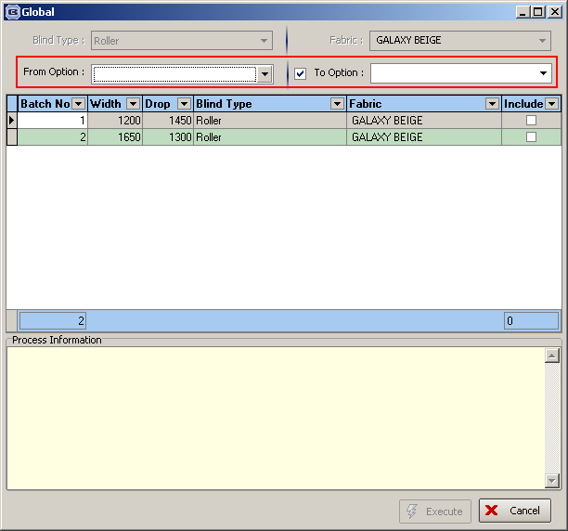

2887. Order Processing > Quotations

When a quotation is converted to an order, the Customer Promised Date is not copied into the order and is left blank. The main reason for this is that if the quotation is entered a while back and then the customer wants the quotation converted to an order, the customer promised date is going to be incorrect when converted.

2888. Order Processing > Orders

If a ‘Promised Date’ is changed in an order, it is now possible to record the reason for the change. This is separate from the standard order amend reason code but the reason codes are held in the existing ‘Amendment Reason’ system table. There is a new flag to this table to indicate which codes are ‘Promised Date Reasons’.

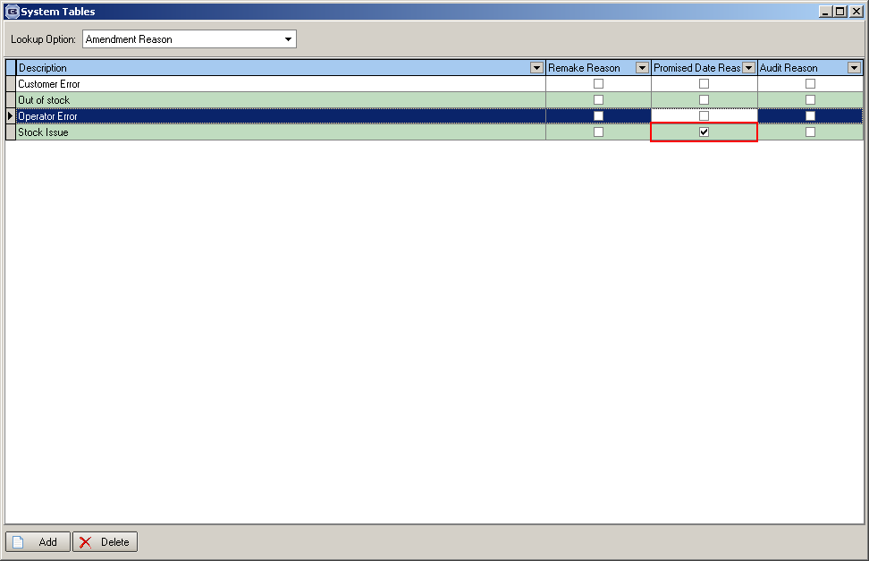

When a promised date is changed on an order, the user is prompted for a reason code as per the standard functionality, but the list is limited only to the selected Promised Date Reasons. This reason code is then recorded in the history. A reason code is not required when a promised date is first added (ie when the field is blank). Also, note that this is separate to the standard amendment reason functionality and is not be dependent on this being activated.

2889. Order Processing > Quotations

The history for a quotations detail lines is now carried across once it has been converted to an order. Previously if a quotation was amended and then converted to an order, the amend history disappeared for the detail lines.

2890. Order Processing > Orders

There are now separate ‘Price Override’ permissions for blind and component detail lines. Previously there was only one advanced permission flag for both. The name of the existing flag has been changed to ‘Blind price override’ and a new flag has been created in advanced permissions called ‘Component Price Override’, which defaults to the same setting as the current ‘Amend Price Override’.

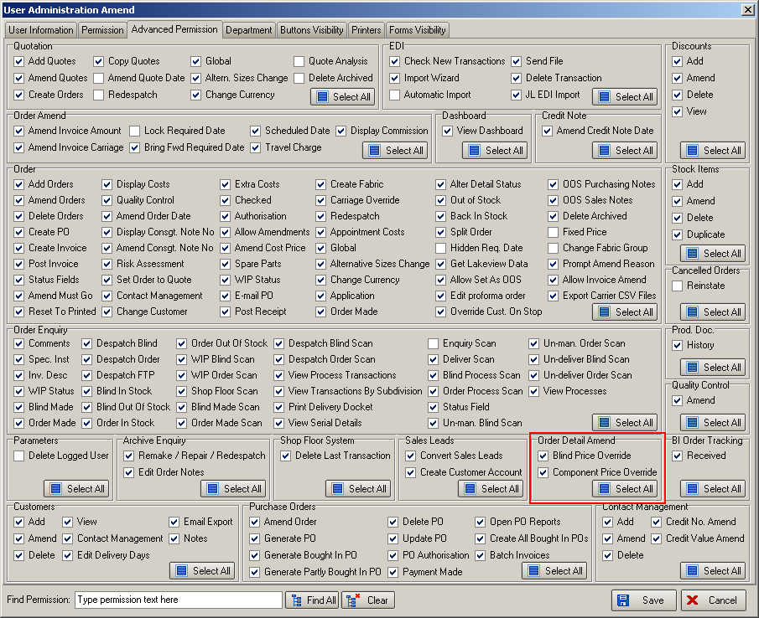

2891. Order Processing > Orders

There has been a problem in the BOM calculation for fabrics (with calculator = Drop) entered on roller blinds where the width is greater than the roll width and the fabric has to be been turned. For example, if you entered a roller blind for a fabric with a width of 3000 which is greater than a roll width of 2000mm, the following message appeared.

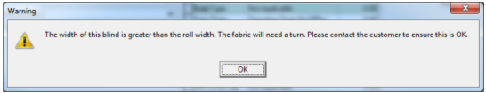

If you click OK, the detail line can be saved. However the BOM for this blind has calculated that 0 metres of fabric was required.

To resolve this, there is now a flag against the stock record called ‘Turn If Width > Roll Width’. This will only be relevant if calculator = Drop. If this flag is switched on, then the fabric will be treated as if it has a calculator = ‘Width or Drop’ and the fabric will be turned.

2892. EDI Import

Currently when importing ‘EDI Orders’ it is possible to import multiple orders for a customer at the one time. This functionality has also been applied to ‘Online EDI Orders’ as well.
2893. EDI Import

The automatic import routine for the EDI Import now skips one cycle when a manual EDI import is being done. This is to avoid a clash occurring when a manual import is being done at the same time as an automatic import.

2895. Acknowledgement – Lead Time Text

The ‘Out of Spec Warranty’ message is now in red text.

2896. Order Processing > Orders

There is currently the ability to globally assign a ‘Same Day Despatch’ Despatch Method and also a ‘Long Length’ despatch method. The ‘Same Day Despatch’ global default is set by a flag in the despatch method system table and the Long Length despatch method is set on the Parameters form. This does not always work as different alternative couriers may be used depending on the original despatch method.

To resolve this issue the following changes have been made.

The Same Day Despatch flag and Ignored by Long Length check fields have been removed from the Despatch Method table
The Long Length Despatch Method field has been removed from the Parameters form.
These two fields have been replaced with two new fields in the Despatch Method table called ‘Alternative Same Day’ and ‘Alternative Long Length’. These are both lookup fields containing a list of Despatch Methods.

When an order is determining the Despatch Method for a same day order, it checks the ‘Alternative Same Day’ despatch method for the original despatch method for the order. Similarly, when checking to apply for a Long Length order, it applies the ‘Alternative Long Length’ despatch method for the original despatch method for the order. If the Alternative Same Day or Alternative Long Length is blank for any despatch methods, then the original despatch method remains. Note that before applying this functionality, the program first applies the ‘Postcode Despatch Method’ function (dev 2898) as described below. Also, where the long length functionality previously checked the customers despatch method, it now checks the order instead.

2897. Delivery Docket (A4 Pre Printed)

A ‘Thank you for your custom’ message now prints at the bottom of this report.

2898. Order Processing > Orders

A change has been made to the way ‘Despatch Method’ is applied to an order. There is now functionality to select the despatch method based on the delivery address postcode.

To enable this, there is a new field in System Tables > Postcode called ‘Despatch Method’. There is a similar method to update the new field as there was for ‘Delivery Address Carriage Charge’. If ‘Update Selected Records’ is chosen, the records on the form (after filtering) can be updated.

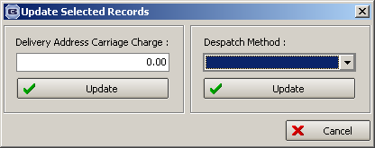

When an order or quote is created (manually or via EDI) or the delivery postcode is amended, the first part of the delivery address post code is checked to see if it matches any of the entries in the ‘Postcode’ table. If a match is found, then the relevant Despatch Method is used. If no match is found, then the customer default Despatch Method applies as normal.

There may be some customers that are exempt from this rule and have special default couriers assigned. To cater for this, there is a new flag on the customer form, Options tab called ‘Disable Despatch Method by Postcode’. Orders placed for these customers will use default Despatch Method as normal.

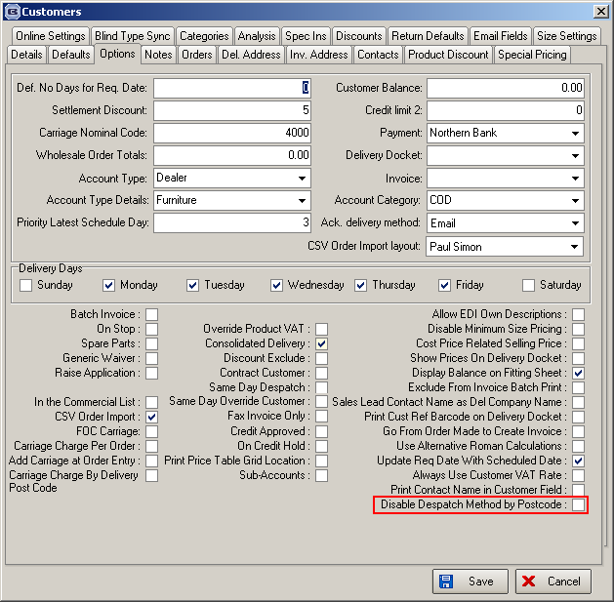

2900. Order Processing > Orders

If a proforma customer requests a chargeable remake the ‘Remake/Repair/Redespatch’ button can be used to copy the original order and remake the blinds. This caused a problem because proforma customers need to pay upfront before any work is done.

To resolve this issue, remake/repair/redespatch jobs for proforma customers are now generated as quotations.

2901. Order Processing > Orders

If an option is set up with an option code = ‘Type Of Roller’ or ‘Tube Calc’ or ‘Tube Type’ and there are different tube choices in an order, the following message will appear in the order entry.

The purpose of this is to alert operators to the fact that mixed tube sizes are present in an order, and this may not meet the requirements of the customer.

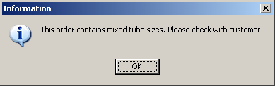

2902. Bought In Tracking Form

Auto Customer Email at Shipping Date Confirmed

There is now a customer notification function for bought in orders in the ‘Bought In Tracking Form’. An email can be generated to the customer informing them when they are due to receive their goods. This happens once an ‘Approx. Due Receipt Date’ is entered. This is checked for whenever OK is clicked on the ‘Manufactured Dates’ pop up in the Bought In Tracking form.
If there is an ‘Approx. Due Receipt Date’, then there is another prompt ‘Do you wish to send an email order update to this customer now?’. If the user clicks Yes then an email is generated to the customer’s ‘Order Ack Email’ address. The title is ‘Order Update: xxxx’ where xxxx is the Order ID.
For the body of the email, there is a new text section in Company Details – Email Text tab. This is called ‘Bought In Order Update Text. There are also new parameter fields added to the bottom list for [Order Promised Date] and [Approx. Due Receipt Date].
Also the ‘Approx. Due Receipt Date’ field on the ‘Manufactured Dates’ pop up in the Bought In Tracking form has been modified and is now editable.

Other Modifications to Administration > Company Details.
- Renamed ‘Parameterised, Invoice, Quotation, Proforma, Delivery, Receipt Text’ tab to ‘Report Texts’.
- Moved ‘Registered Office’ from ‘Sales Lead, Child Safety Text’ tab to the ‘Report Texts’ tab.
- Renamed ‘Sales Lead, Child Safety Text’ tab to ‘Fitter Sheet / Sales Lead Text’.
- Created a new tab called ‘SMS Texts’ and moved ‘SMS Delivery Text’ and ‘SMS Acknowledgement Text’ fields from ‘Email Text’ tab to the new one.
- Created a new tab called ‘Email Texts 2’ and added new field (‘Bought In Order Update Text’) and moved some existing ones (‘Disclaimer Text’, ‘Proforma Email Text’ and ‘Fitting Text’) from ‘Email Text’ to the new tab.

2903. Order Processing > Orders

Spot Checking Audit Function

There is a new flag to the Orders tab of the ‘Window Blind Amend’ form.

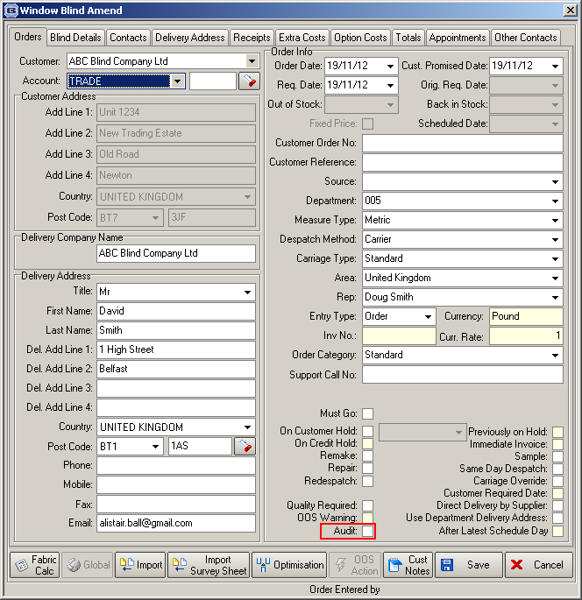

This field is available for all users with order amend permission. When this is checked, the user has to enter an amendment reason when the order is saved. However only selected codes to appear. The Amendment Reason system table has been used for this, and has a new column in called ‘Audit Reason’. Only reason codes flagged as Audit Reason appear in the popup.
When this is checked, the user name, date and time and reason code are recorded in the history under ‘Audited By’.

2908. Label Print - A4 88mm x 14mm

A new label print has been created, which has 2 labels across (88mm each) and 17 labels down (14mm deep). The label contains the following:

Order No:
Customer:
Cust Order No:
Cust Ref:
Size:
Loc/Ref:

2912. Remake/Repair/Redespatch

Orders copied using the Remake/Repair function now generate an auto PO and appear in the Bought In Tracking form. This will only happen if there is an order detail line that has a bought in blind and ‘Auto Generate Bought In PO’ is switched on.

2913. Order Processing > Quotations

Quotes converted to orders now generate an auto PO and appear in the Bought In Tracking form. This will only happen if there is an order detail line that has a bought in blind and ‘Auto Generate Bought In PO’ is switched on.

2914. Order Processing > Orders

There is a new parameter (in Parameters > PO Parameters) called ‘Ignore ‘On Credit Hold’ for Generate PO’.

If this is set to true, orders that go on credit hold now generate an auto PO or appear in the Bought In Tracking form.

2915. Acknowledgement – Schedule Time

The No of Panels field from the order detail of blind identifier = ‘Shutters’ blind types now appears on our order acknowledgement.

‘Extra text’ options now appear on this order acknowledgement.

W174. Acknowledgement Print ‘Quotation’ before it is Submitted

If an order has not yet been submitted it now say ‘Quotation’ instead of ‘Order Acknowledgement’.

