Blindata Release Note 6.1.4 

2 November 2012

Bug Fixes and Enhancements

3993. Order Processing > Orders

If a despatch method record has been set up with ‘On Credit Hold’ = true, when the order is saved, it now brings up the following message.

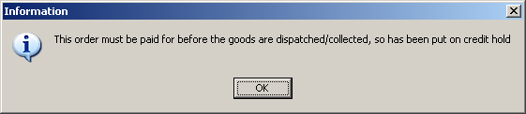

3994. Order Processing > Orders

If you entered a blind detail line, and overrode the base price (which switches on the ‘Price Overridden’ flag) and then change the quantity > 1, and also then manually enter an option price, the net price did not calculate correctly. Fixed.

3995. Fitting SMS

We have change the subject of text message that is sent with the fitting text. Instead of ‘Fitting Appointment for order #1389 Retail Sales has been made’, it now says ‘This is a fitting appointment reminder from [Company Name]’. Company name is taken from Administration > Company Details.

3996. Order Processing > Bought In Order Tracking

If you select the ‘Manufactured’ button but then x out of the form, it still changed the status of the order to ‘Order Manufactured’. It now only does this if the manufactured date is filled in and ‘Ok’ is selected.

New Work and Customer Requests

2748. Batch Numbering

An option to create sequential batch numbers when delivering fabric into stock is now available.

There a new parameter called ‘Enable Sequential Batch Numbering’. If this is enabled, then the batch number is automatically assigned when the goods are delivered into stock.

The starting batch number can be set up in Administration > Parameters.

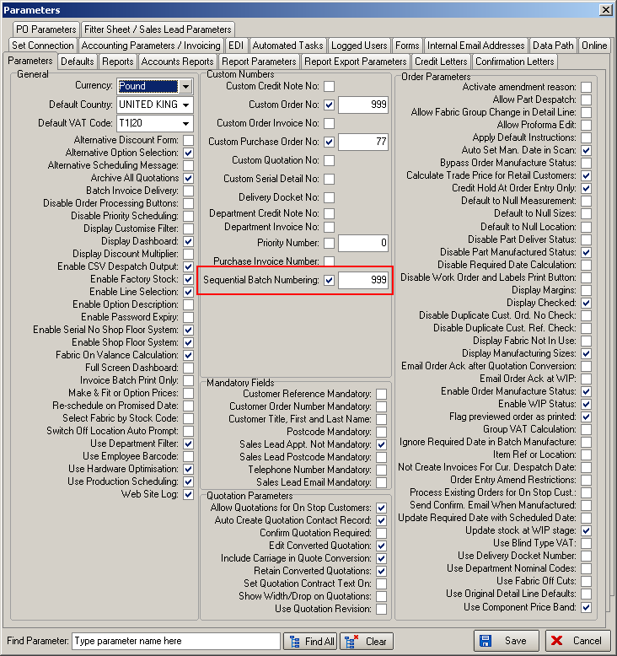

2862. PO Fabric Batches

This is only applicable when automated batch numbering is switched on. This means when regular purchase orders are delivered, each roll is assigned a batch number. A label for each batch can be printed using the ‘Print Batch Label’ button in ‘Purchase Order Enquiry’. The label shows the stock code, barcode for stock code, batch no, batch no barcode, and prints on 3” x 1” labels.

Regular PO Delivery

It is also possible to record stock location when fabric is delivered into stock.

2878. Administration > Users

The system can now hold birthday against the user.

2879. Order Processing > Orders > Fabric Widths

We already have a calculator called ‘Roll Width’ against stock item record and it indicates that is a dummy fabric with different roll widths and the ‘Fabric Roll Widths’ system table.

There is now a choice so the user does not have to choose the specific fabric after they have selected the dummy fabric. It can be calculated automatically using the biggest roll width.

There is a new parameter in the blind type record (only show if blind identifier = Roller or Austrian/Roman) called ‘Auto Calc Fabric Roll Width’.

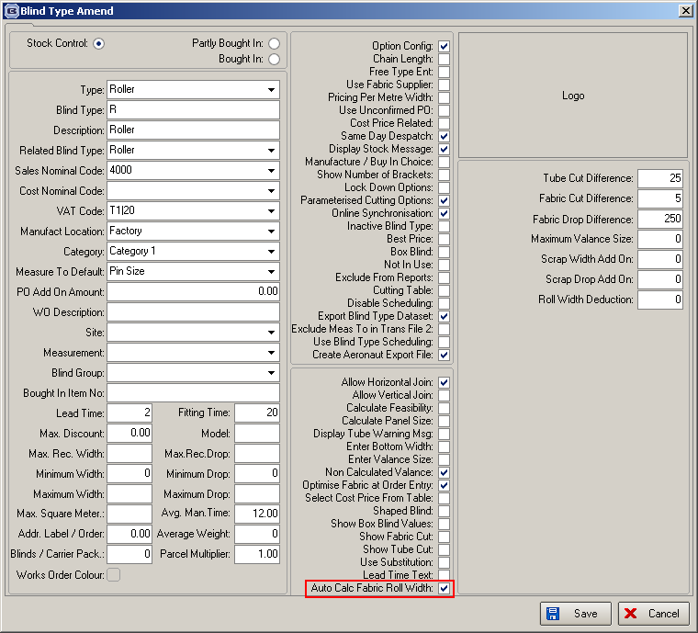

The dummy fabric should be set up with calculator = ‘Roll Width’. In Administration > System Tables > Fabric Roll Widths, we can hold the real fabrics that are related to the dummy fabrics.

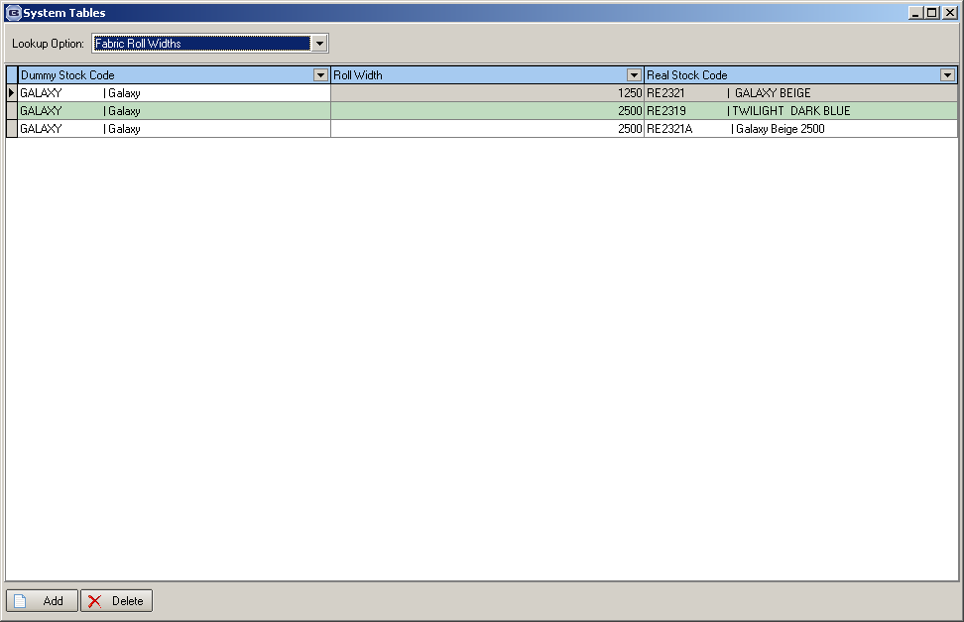

When an order is entered for a fabric with calculator = ‘Roll Width’, it will then try to find the associated fabric with the widest roll width and use it.

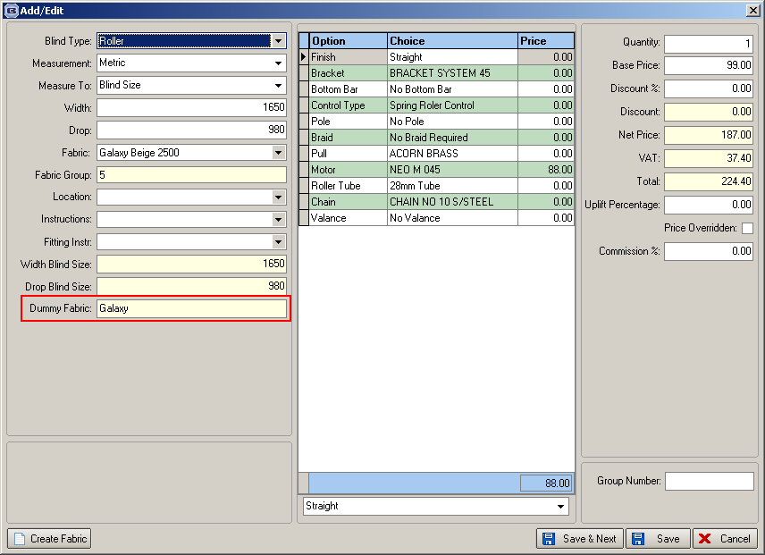

Therefore we now hold the dummy fabric chosen against the order detail – and display it in the order detail entry form.

There is one other issue we need to address, though. When an order is entered with the dummy fabric, the dummy fabric description needs to appear on certain reports ie the ones the customer gets – quotations, acknowledgements, invoices.

2882. Administration > Company Details

There is now a field choice for [Fitting Time] in here so it can be used in the fitting text.

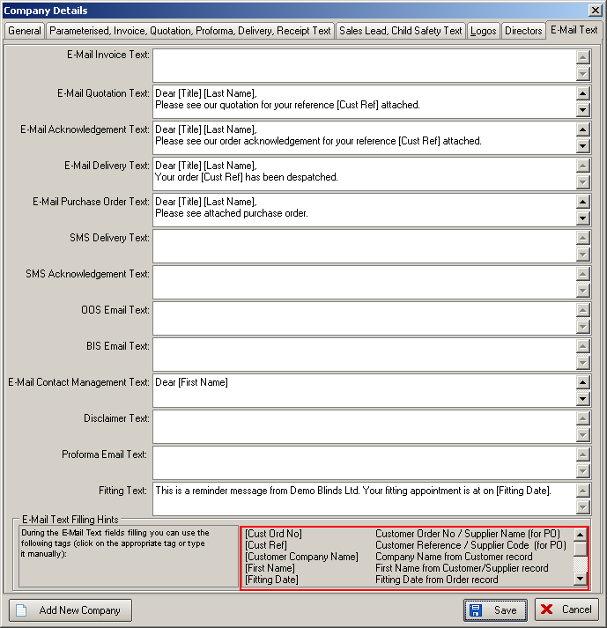

2904. Order Processing > Orders > Picking List

The ‘Picking List’ has been changed so there are hard coded fields for ‘Picked By’ and ‘Checked By’.

