Blindata Release Note 6.1.5 

9 November 2012

Bug Fixes and Enhancements

3997. Order Processing > Quotations

The ‘Products’ column did not show any data, even after you saved the configuration, exit and re-entered the form. Fixed.

3998. Acknowledgement XML

If an order was received and it was put on credit hold, on customer hold or the fabric was not in use, the acknowledgement XML file was not generated properly. Fixed.

3999. Invoice Posting

There was an issue with posting certain misc invoices to Sage. Fixed.

4000. Order Processing > Orders > Component Detail Entry

If we set up multiple ‘Unit’ records in the ‘Unit Of Sale’ against a stock item like this, it then showed ‘Unit’ twice in the lookup in the component detail entry. Fixed.

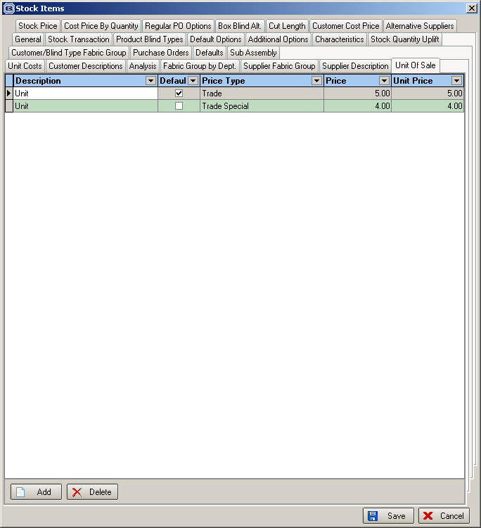

New Work and Customer Requests

2860. Order Processing > Orders > Split Order

There is a new parameter called ‘Split Order For Completed’.

When we split an order, when this parameter is set to true, a new order for the completed work and not for the outstanding detail lines.

Previously when the split was done, the detail lines that were not manufactured and were chosen, were added to the new order. We now have this parameter choice so that the blinds that have been made are turned into the new order. The reason for doing this is so that the status of the other blinds can remain the same and not get changed back to ‘Order Entered’.

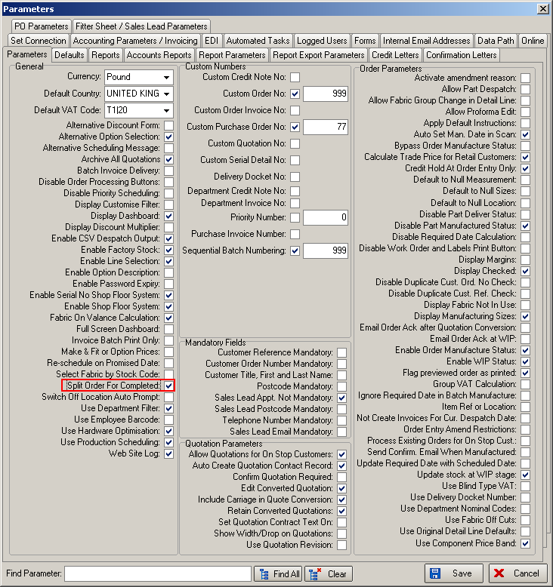

2861. Order Processing > Orders > Batch Numbering

If automated sequential batch numbering is switched on, then the sales order processing is now able to work out which batch number to use. It starts with the lowest batch number available for the fabric. This is done when the order detail line is saved.

To do this properly we now to hold the ‘On Sales Order’ amount against the batch number record. This means that when an order detail line is saved, the (‘Quantity’ - ‘On Sales Order’) calculation is inspected at batch number level (as well as stock record level) and if there is enough free stock in that batch, then it is used. If there is not enough, then it has to move onto the next available batch.

If there is not enough in any batches, but the available stock figure in the stock record is still high enough, then no batch number is recorded. This means that when the ‘Processes’ button is displayed, there will be no batch number held against the relevant process.

2875. Order Processing > Orders > Import

We now have the ability to import options in the ‘Import’ feature. The options should be held in column I and be separated by semi colons.

2883. Sales Files > Mapping

EDI Mapping – Restrict Duplicate Manual Mapping Entries – Decora issue

There is now a restriction so that one blind type cannot be mapped to multiple blind types. This was causing the EDI import routine to generate a detail line for each blind type. Existing duplicate mappings have been removed in the upgrade.

2884. Order Processing > Orders

There is a new flag held against the stock record called ‘Quality Check Required’. If this is set to true and is selected when an order detail line is entered, then the order is set to ‘Quality Check’.

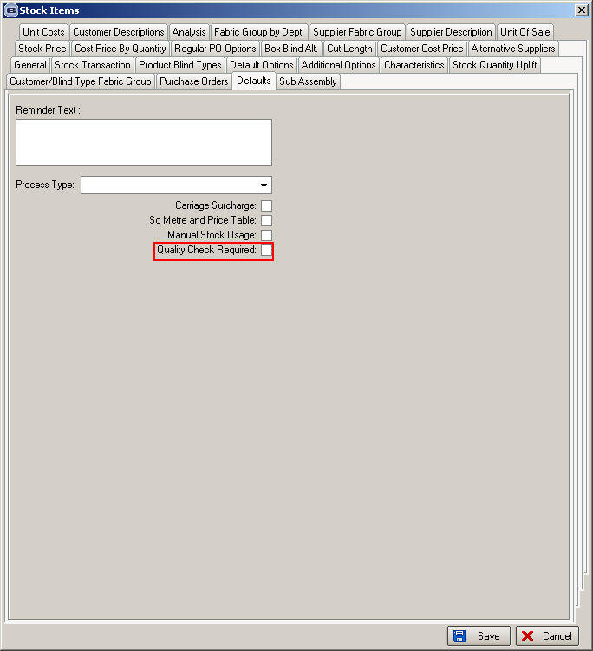

2885. Order Processing > Orders

Order Entry – Quantity field to Default to Blank Instead of 0
If ‘Default Sizes to Zero in Order Entry’ is set to true in Parameters, when the quantity is entered, the ‘0’ is now removed. This is to stop operators accidently entering 10 instead of 1.

2905. Bought In Order Tracking > Export CSV

When the sizes are exported to the csv file, it now always exports the ‘Blind Size’ sizes. ‘Blind Size’ always appears in column 5 of the spreadsheet.

Also, the field that is used for the options is ‘Supplier Part No’, not ‘Stock Code (ie columns M,N,O,P,Q).

2906. Label Print – 3 ½ x 2 – Process Barcode

There is a new label print based on ‘Label Print – 3 ½ x 1 – Process Barcode’, called ‘Label Print – 3 ½ x 2 – Process Barcode’. The main difference is that the label is 2” deep.

