Blindata Release Note 6.1.2 

19 October 2012

Bug Fixes and Enhancements

3978. Works Order – Bespoke 31

Special instructions were being cut off if more than one line of instructions was entered. Fixed.

New Work and Customer Requests

2848. Feasibility

There is a further development within the feasibility function. Please contact us for more details.

2851. Administration > Import From Excel > Discounts

There is now a column for importing the commission % in the discount import.

2852. Order Processing > Order Entry

It is now possible to get commission to display on order detail lines. It is also possible to change the commission for the whole order in the Totals tab.

There is a new flag to say whether the commission amount is displayed in the order detail line. This is held against the user in ‘Advanced Permissions’ and is called ‘Display Commission’. If this is set to true, then the commission field is displayed on the order detail line and is amendable.

Also if this permission is set to true, then it is possible to enter a commission % in the totals tab.

2854. Fabric On Valance Calculation

In North America it is very common for a valance to be supplied with a blind. This is a strip of wood or metal that covers the top of the blind – thereby hiding the roller tube or headrail. Sometimes the valance will have fabric on it, which will match the fabric on the blind. We can now calculate the size of this piece of fabric and include it in optimisation and in the export file for the Aeronaut table.

Here is my idea. First of all we need to identify the option that is chosen and determine that it is a valance with a piece of fabric on it. We have use the ‘Special’ field in the stock record to do this. We then need to calculate the width and drop of the piece of fabric. The drop will be a static figure dependent on the option choice and the width will be the man width less an amount. We need to work out where to hold these figures. We store the static drop size in the ‘Fabric Drop Value’ in the stock record that is used for the valance choice. The width is calculated by subtracting an amount from the man width.

Work Done:

For this functionality a new parameter called ‘Fabric On Valance Calculation’ flag was added in Parameters.

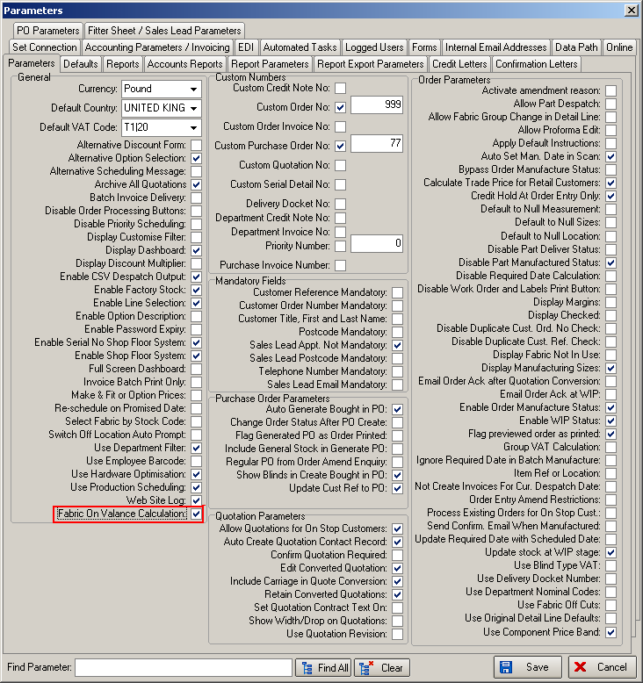

The program then checks to see if Order Detail > Fabric > Special = Valance”.

If it is not found then we trying find it again with following criteria “Order Detail > Option > Special = Valance”.

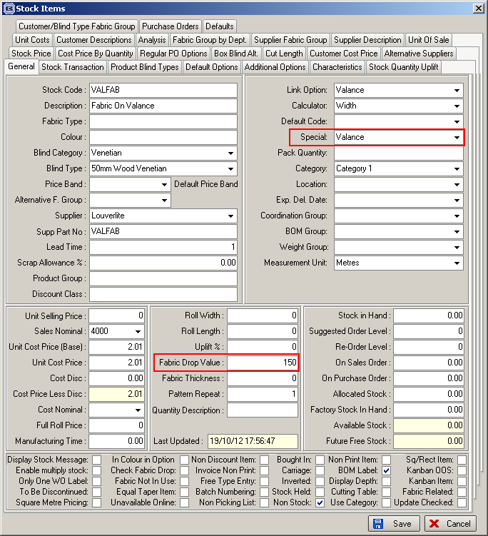

If such a stock item is found in the detail record we create a ‘Valance’ record in the Stock Transaction table with “Width = ManWidth – Valance Cut“ and “Drop = Fabric > Fabric Drop Value”. After that it is included in the optimisation and Aeronaut export.

2855. Acknowledgement – Bespoke 37

We now show a lot more columns for options and also net price on the right hand side. To achieve this, the font has been made smaller, option name is now printed on it’s side, and there is function to put certain options into list at end. The supplier part code is used to store the two digit code which now appears on the report instead of the option (stock) descriptions.

Therefore there will be options that will print individually in their columns (if ‘On Works’ is ticked in Option Setup) and the remaining options will print together in one field to the right of the options (like the ‘Option List’) except it will only print options that are not in the individual option columns.

The page size is now 8.5 x 11.

2856. Aeronaut Cutting Table Export

The widths and drops that go in here are now the ones that are generated from the feasibility (W & D).

We have also included valance fabric sizes in the Aeronaut table. See dev 2854.

The number of the records in the file is now restricted to 50. If there are more than 50 records, a separate file is created(called *.1, *.2 etc).

2858. Order Enquiry

There is a new button on this form called ‘Processes’. From this the user is able to select a process type, which will then show a list of all processes for blinds that have a status of WIP.

The list of processes shows order no, stock code and cutting sizes. To achieve this, stock code, cutting size and process types have to be related by process type. This is done by filling in the following fields:

Stock record:

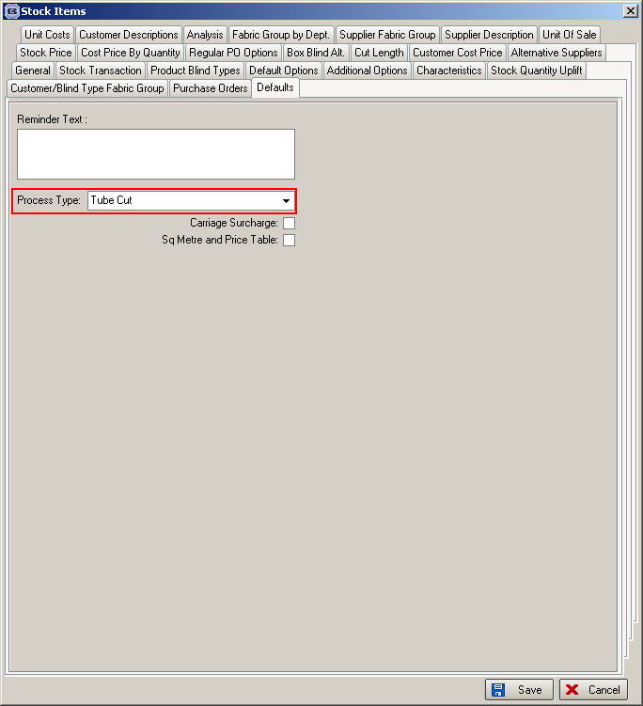

Blind Types > Man Process Types

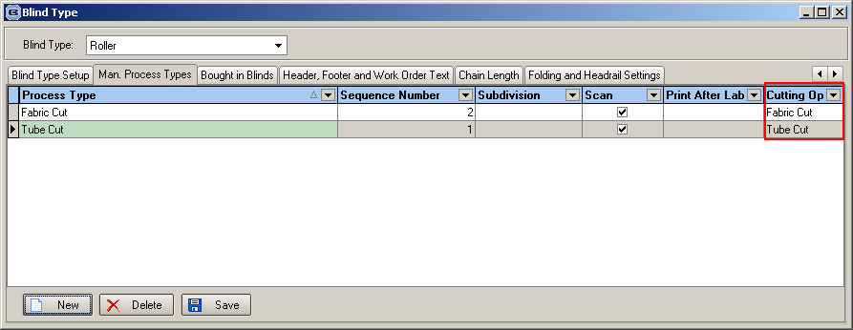

This is the form that is displayed after selecting the ‘Processes’ button.

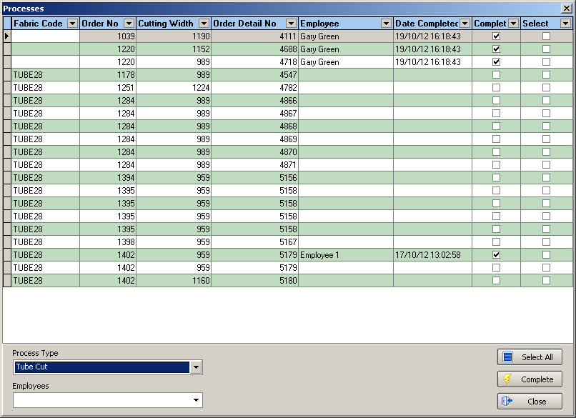

The user will then be able to select the blinds that have been completed. Once they have selected records, they will then select their own employee name. The record will also be updated with the date and time the process was done at. It will then be possible to see the completed processes in Order Enquiry > View Process Transactions.

The ‘Processes’ button has an ‘View Processes’ choice in ‘Advanced Permissions’. It is displayed to the right of the ‘Order Out Of Stock’ button on the top row of buttons.

2859. Order Processing > Orders > Print Bill Of Materials

There is now a choice for printing all of an order together or for each individual blind. There is also be a button for ‘Print BOM’ in the Order Enquiry form.

2872. Alterative XML File Changes

We have made an amendment to the System Tables > Options / Characteristics rules to include a ‘Measure To’ field. This means that certain characteristics can be excluded base on other options and ‘Measure To’ answers.

If the new column is left blank, then the record behaves as previously.

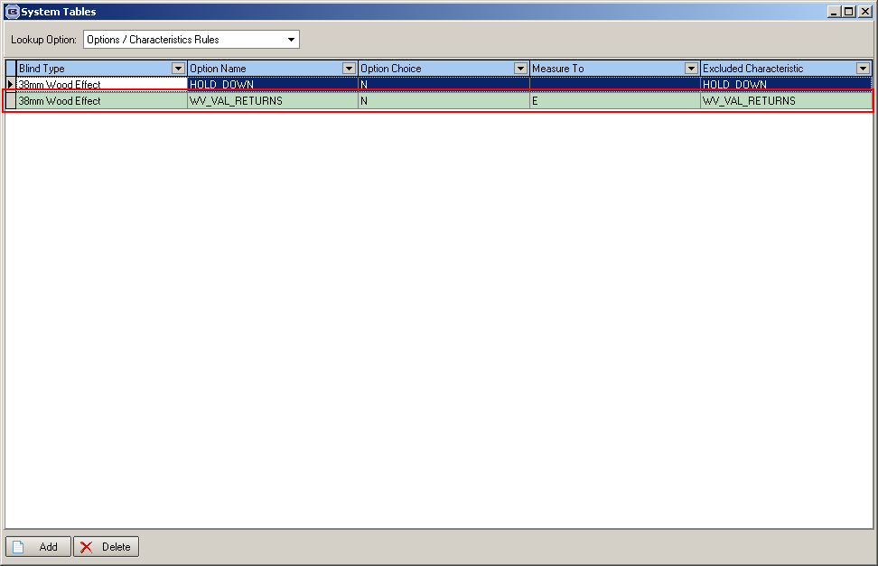

2873. City Link XML

There were some fields that were not being populated in the City Link XML file

<Service><Service/> (required for all items despatched e.g. pre 5.30, pre 10.30)
<NoOfItems><NoOfItems/> (required for all items despatched e.g. number of city link labels required)
<Weight><Weight/>< (required for channel islands)
<SpecialInstructions2>< SpecialInstructions2/> (required when given instruction by customer)

The following fields are now being populated:

Service – this is the description from ‘Carriage Type’ field in order entry.
NoOfItems – this is the amount specified at the delivery create stage (Number of Packages).
Weight – this is also now entered in the ‘Despatch’ form, below ‘Number of Packages’, but should only appears if despatch is for ‘City Link XML’ despatch method.

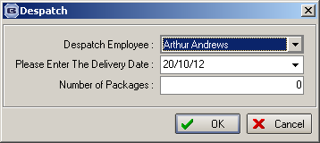

Special Instructions – this is ‘Delivery Notes’ from the order (entered using ‘Delivery Notes’ button in ‘Order Amend Enquiry’).

