Blindata Release Note 6.1.3 

26 October 2012

Bug Fixes and Enhancements

3979. Financials > Create Invoices (Decora v6.0.1.8)

If an order is for a ‘Same Day Despatch’ and there is a stock record set up with link option = ‘Same Day Despatch’, a carriage detail line now gets added to the order at the ‘Create Invoice’ stage.

3981. Quotation – Laser Print (pdf)

If a quotation prints on more than one page, the discount was being printed on the first line of the second page when it shouldn’t be. Fixed.

3982. Order Processing > Orders

Check control length if imperial entered.

When you entered an order for certain blind types as an Imperial measurement, the control length was calculated incorrectly (always appeared as 400). Fixed.

3983. Order Processing > Orders > Create Invoice

If a customer is set up as ‘FOC Carriage’, it was still charging carriage for some customers. If a customer is set up as ‘FOC Carriage’, they should never have carriage added automatically.

3984. Order Enquiry > Processes

Previously this only showed processes for orders with status ‘Work In Progress’. This is still the case if ‘Enable WIP Status’ = true. If false, then orders with status ‘Order Printed’ will be displayed.

If records are filtered on this form, when ‘Complete’ is clicked, it only completes the records that have been filtered and are selected. If you filter records then click ‘Select All’, it only selects the filtered records.

3985. Invoice – Sage Tractor Feed Letterhead

There was a message ‘Amount to pay after settlement discount’ on the bottom of the invoice. This no longer prints if the settlement discount % is 0.

3987. Acknowledgement – Bespoke 34

We changed ‘Cust Order No’ to ‘Cust Ord No’ and allowed more space for field entry.

3989. Acknowledgement – Bespoke 34

When a quote for components is converted to an order, the unit of sale was missing in ‘Acknowledgement – Bespoke 34’.

3990. Works Order Label Blind Size

- Cord spacing was being overwritten by ‘Operator’.
- ‘No of Slats’ no longer appears unless ‘Blind Identifier’ = V.

3991. Report Selection

The report choices now appear in alphabetical order.

3992. EDI Enquiry > Import

The lookups for blind type code and fabric code now display the codes in alphabetical order.

New Work and Customer Requests

2857. Label Print – Bespoke 37A

This is a specific label size, using Avery 5160 labels.

Labels are 2 5/8” x 1”, 3 across on page, 10 down.

The contents are the same as the existing ‘Label Print – Bespoke 37’.

2864. Works Order – Bespoke 37

This has a similar layout to ‘Acknowledgement – Bespoke 37’. It is also set up so that the picking list will print out as well if necessary ie if there are miscellaneous detail lines on the order.

The page size is 8.5” x 11”.

2865. Delivery Docket – Bespoke 37

This is based on ‘Delivery Docket – Laser Print 8.5 x 11’. The following changes have been made.

- Company details come from ‘Company Details, not ‘Department’.
- The company name and address have been moved up to the right of the image.
- Dates now print in the format of the PC ie if mm/dd/yy, then they should print like that.

2866. Invoice – Bespoke 37

This is based on ‘Invoice – Laser Print (Letterhead Logo)’.

Company name and address come from ‘Company Details’.

Page size needs is 8.5 x 11
VAT now say HST
‘Order No’ now says ‘Sales Order No’
‘Cust Ref’ is now ‘Tag’
Due Date now appears
Terms appear in header
Sales Consultant (Rep) appears in header
Date Shipped appears (despatch date)
Deliver To is now ‘Ship To’.
‘Attention’ (contact name) appear under invoice address
‘Fax’ prints beneath ‘Ship to’ address.
‘Ship via’ now prints – this is ‘Despatch Method’
No of packages now prints.

2867. Order Processing > Orders

There is a new flag in System Tables > Despatch Method called ‘On Credit Hold’. If this flag is set to true, and the despatch method in an order is set to a relevant record, then the order goes on credit hold.

Similarly, in the ‘Account Category’ table there is also a new flag called ‘On Credit Hold’. If this flag is set to true, and the account category for a in an order is set to a relevant record, then the order goes on credit hold.

2868. Sub Assembly

There is a new tab in the stock record called ‘Sub Assembly’. In this tab it is possible to enter stock records that, when assembled, make up the main stock item. This is required because some stock items that are sold are made up from other stock items.

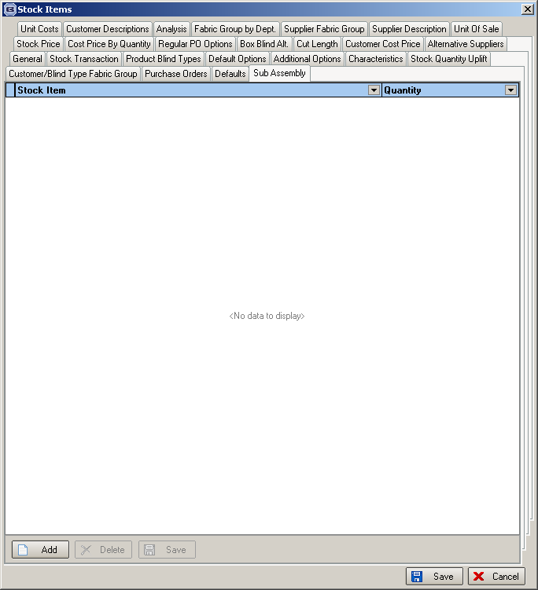

There are two new options on the context menu, one called ‘Assemble’ and another called ‘Dissemble’. If ‘Assemble’ is selected, then the user is asked for a quantity to assemble. Once ‘Ok’ is clicked, the stock of the main product is increased and the stock in hand of the sub assembly items reduced. ‘Dissemble’ does the opposite. There are stock transactions recorded for both these processes.

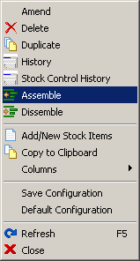

2870. Credit Notes

There is now an option to create a credit note directly from an order (right click on context menu).

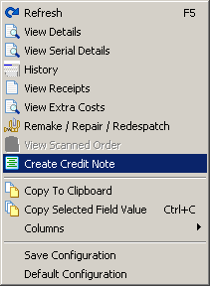

This is only be available to a user if they have permission to enter a credit note. It is applied to the ‘Order Amend Enquiry’ and ‘Archive Enquiry’ forms.

Once selected, the following form appears:

