Blindata Release Note 6.1.0 

5 October 2012

Bug Fixes and Enhancements

3972. Stock Setup > Stock Take Entry > Import

When the file is imported with records like this in it, it now imports all 3 batches and makes the ‘Stock In Hand’ figure = 7. Previously the records were overwritten, which was wrong.

ECBAN190BUF | Banlight BO Buff Roller Fabric (E) | 4 | 0 |  | A
ECBAN190BUF | Banlight BO Buff Roller Fabric (E) | 2 | 0 |  | B
ECBAN190BUF | Banlight BO Buff Roller Fabric (E) | 1 | 0 |  | C

3973. Sales Files > customers

When you tried to delete a customer record (only in certain databases), the following error message appeared. Fixed.

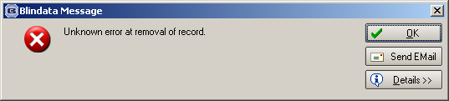

3974. Bought In Order Tracking

If ‘Use Supplier Part No in PO’ and ‘Export Bought IN PO as csv’ are both switched on in the supplier record, the fabric code and the option codes in the csv file are now filled with the supplier part no from the relevant stock record.

3975. Feasibility Calculation

The feasibility calculation in order detail line entry now uses the ‘Weight g/m2’ from the Characteristics tab in the stock record instead of looking at the ‘Weight Group’ in the stock record.

New Work and Customer Requests

2326. Commissions

At a particular customer site, sales staff are allowed to set a client discount rate. The company policy is that if the company makes more money the sales rep makes more money. Hence the larger the discount given by the rep, the smaller the commission received by the sales rep. This means we now hold commission % rates against discounts, both for blind and component sales.

Pricing > Discounts

In each form where discount can be entered, there is a new field for ‘Commission%’.

Customers > Discounts

There is a column in this tab for ‘Commission %’.

Pricing > Component Discount % by Category

There is a column in this tab for ‘Commission %’.

Order Processing > Orders

When detail lines are saved, the commission % is also saved.

The commission will only be available to see/amend in the order detail form if the following permission is set.

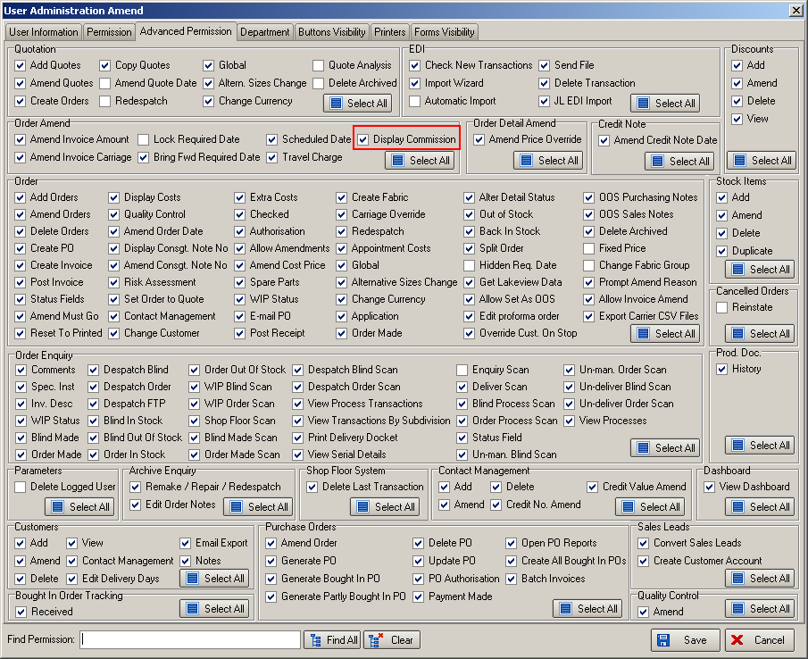

2829. Stock Control

There is a new function in Blindata to hold the stock transaction history. This can be seen accessing the context menu in Stock Setup > Stock Items (right clicking).

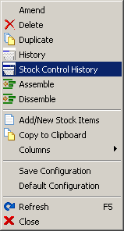

The following form is displayed when ‘Stock Control History’ is selected.

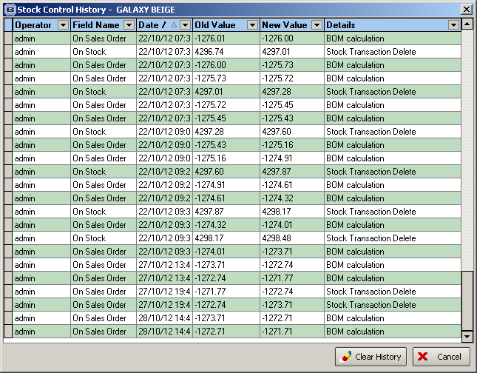

2836. Scheduling

It is now possible to run scheduling for miscellaneous detail lines, in association with ‘Man Processes’ being set up and being allocated scheduled time.

2837. Order Processing > Orders

At the moment we can get the system to bring up a message saying that there is not enough stock to fulfil an order. This will happen if ‘Display Stock Message’ is switched on in the stock record and also in the blind type record, and there is not enough stock, the following message appears:

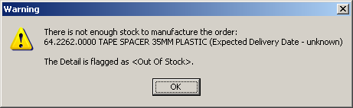

However this does not take into account existing sales orders. We therefore have added a new flag in Administration > Parameters called ‘Check Free Stock’. If this is set to true, then if the Free Stock figure in stock in hand is less than zero, a window appears showing this:

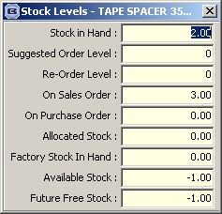

There is also a message saying ‘There is not enough available stock to satisfy this order’. It will only be a warning message and nothing else will happen.

This has been applied to both the blind detail line and component detail line entry.

2838. Administration > Maintenance

There is a new option to remove financial transactions. This is only be available if ‘Blindata Accounting’ is switched on. The new option is called ‘Clear Financial Transactions’ and will remove all financial transactions and zeroise balances on nominal codes (similar to clearing transactions in Sage > Maintenance > Rebuild, with only ‘Keep My Transactions’ unticked).

2840. Production Documentation

We have a customer that uses an Aeronaut roller fabric cutting table, so we need to export data to a text file in the following format (see below). There is a new parameter in Blind Types called ‘Create Aeronaut Export File’, which defaults to false. If set to true, then this file will be exported when ‘Production Documentation’ is run.

START## HOLLAND BLIND
ORDER NUMBER X58070
LINE NUMBER 464
MEASURED WIDTH 1630
MEASURED DROP 1700
CONTROL TYPE Standard Chain Drive
FABRIC TYPE Alexus
FABRIC COLOUR Alexus White
TRIM TYPE 25
START## HOLLAND BLIND
ORDER NUMBER X58070
LINE NUMBER 463
MEASURED WIDTH 1480
MEASURED DROP 1500
CONTROL TYPE Standard Chain Drive
FABRIC TYPE Broadway
FABRIC COLOUR Broadway Beech Rose
TRIM TYPE 25
START## HOLLAND BLIND
ORDER NUMBER X58047
LINE NUMBER 417
MEASURED WIDTH 2134
MEASURED DROP 1545
CONTROL TYPE Standard Chain Drive
FABRIC TYPE Moire
FABRIC COLOUR Moire Black
TRIM TYPE 18

2845. Stock Items > Additional Options tab

There is now a ‘Copy’ button here so an existing line can be copied.

2849. Administration > Import From Excel > Customers

There are now columns for ‘Account Type’, ‘Account Type Details’ and ‘Account Category’ in the customer import.

