Blindata Release Note 6.1.1 

12 October 2012

Bug Fixes and Enhancements

3976. Order Processing > Orders

When the commission was saved for a detail line, it saved as accumulated. This was incorrect. So if there are two discounts set up, the first with 8% discount and the second 5%, the order detail line now saves with commission of 5%.

3977. Administration > Import From Excel > Price Tables

If you import a spreadsheet with multiple price tables in it and a fabric group with an alphanumeric field follows in a price table below, an error occurred. Fixed.

New Work and Customer Requests

2803. Sales Analysis by Analysis Field

In the ‘Stock Items’ form we have a tab called ‘Analysis’. This tab form has 5 fields – ‘Analysis 1’ through to ‘Analysis 5’. There is a similar tab with similar fields in the ‘Customers’ form.

There is now an option to be able to restrict the sales analysis reports to only show analysis fields that have been filled in, but without having to make major changes to the sales analysis reports.

The ‘Sales Analysis’ form has been changed to display like this. If ‘Use Analysis Codes’ is switched on, then the analysis code fields become active.

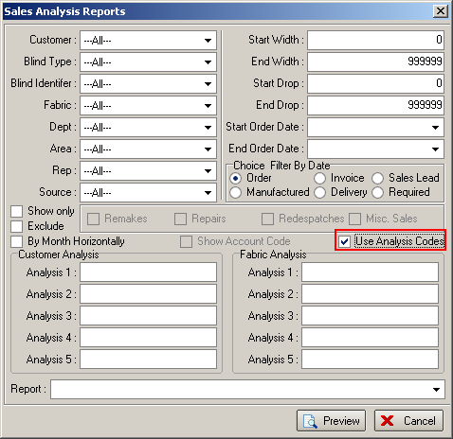

Then when the SA reports are run, it will only show records where the analysis fields match.

2824. Order Processing > Cancelled Orders

There is now a button on this form to ‘Reinstate’ a cancelled order. This has an Advanced Permission button. When an order is reinstated, the history for the order is kept, the order keeps the same order number and it has the same status it had prior to being cancelled. A new history record is created to say it has been reinstated.

2844. Order Processing > Fitters Sheet / Sales Leads

We have a customer that wants the diary form to open up showing only fitters and the week view of the diary. Therefore we have created a default setting for the diary form when it is opened.

There is now a tab in Parameters for ‘Fitter Sheet / Sales Leads’ which has these options, so that the defaults can be set up here.

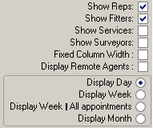

2846. Order Processing > Orders > Feasibility Check

This is only applicable to order detail lines for blinds with feasibility switched on.

The feasibility test is designed to stop operators entering options for blinds that cannot be made (like ‘Link Options’) but the problem with the feasibility function is that there is no way to save a detail line if it has failed the test.

This has been changed so it allows the user to save the detail line, but flags it as ‘Failed’, which in turn puts the order on customer hold.

2850. Administration > Import From Excel

There is a new import option called ‘Customer Stock Discount’. This imports records to the ‘Product Discounts’ tab in the customer record. We need customer account code, stock code, category, discount class, quantity, discount %, commission %. Stock code, category and discount class should be optional fields.

Account Code | Stock Code | Category | Discount Class | Quantity | Price | Discount % | Commision %
TRADE |  | Category 1 |  | 6 |  | 12 | 3

