Blindata Release Note 6.0.9 

28 September 2012

Bug Fixes and Enhancements

3968. Order Processing > Production List > Order Control Report

Sometimes an arithmetic overflow message appeared when trying to print this report. Fixed.

3969. Order Processing > Split Order

When ‘Split Order’ is chosen, you can select the detail lines that should be moved into a new order, and then click on the ‘Split Order’ button. The new order will then have a status of ‘Order Entered’ and the existing order will only have the non selected blinds on it.

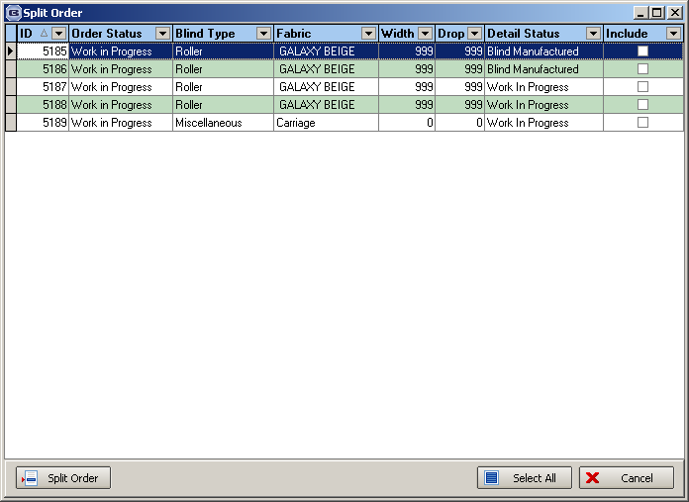

However, there is currently an issue with this. The new order will have an order status of ‘Order Entered’ but the detail lines may have a status of ‘Awaiting Manufacture’ or ‘Work In Progress’. The only way to resolve this at the moment is to use the ‘Status Field’ button to change the order status, which will in turn update the detail line statuses to a matching status. The order can then be processed.

When the new order is generated by splitting an existing order, it now changes the order status to ‘Order Entered’.

3970. Stock Setup > Stock Take Entry > Import

If a record is imported from a spreadsheet for a stock item that has ‘Batch Numbering’ = true, when the import is done, the record in the ‘Batches’ tab is deleted before the new batch is imported.

Also, if ‘Batch Numbering’ = false (but it had been true), then any record in ‘Batches’ for that stock item is also deleted.

3971. EDI Import

If an order exceeds the Large Qty Scheduler and it is a ‘Same Day Despatch’, then it is not saved as a ‘Same Day Despatch’. This applies to both the import and manual entry.

New Work and Customer Requests

2797. Carriage by Postcode

It is now possible to hold a carriage amount against a postcode. This is picked up when the order is first saved. The carriage is related to the postcode that is held against the delivery address.

We have also carried out a full review of how the carriage works in the system. There are now a lot of different ways of calculating carriage, and it has become complicated.

First of all, let’s distinguish between carriage that can be entered at order entry and carriage that is calculated at ‘Create Invoice’ stage. This is currently determined by ‘Add Carriage at Order Entry’. We also have two other fields in here – ‘FOC Carriage’ and ‘Carriage Charge Per Order. There is now a further flag called ‘Carriage Charge by Delivery Postcode’.

There is also a new field called ‘Delivery Address Carriage Charge’ which is held against the postcode record in System Tables > Postcodes. We also need some way of updating all these to a particular amount and then changing some. Maybe we could filter by postcode and have an update amount with a button called ‘Update Selected Records’.

There is a new condition that if ‘FOC Carriage’ = true, then all the other carriage flags are set to false. ‘FOC’ means free of charge’ so if this is set carriage should never be charged for the customer.

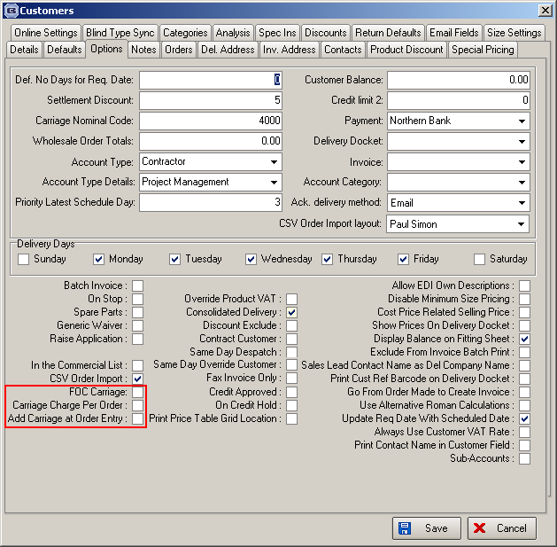

If ‘Carriage Charge Per Order’ or ‘Add Carriage at Order Entry’ or ‘Carriage Charge by Delivery Postcode’ = true, then ‘FOC Carriage’ is set to false. These changes are all recorded in the history.

If ‘Carriage Charge By Delivery Postcode’ = true, then ‘Carriage Charge Per Order’ is set to true, and ‘Add Carriage at Order Entry’ is also set to true.

At the ‘Create Invoices’ stage, carriage is only calculated if ‘FOC Carriage’ = false and ‘Add Carriage at Order Entry’ = false. If these criteria are met, at this point if ‘Carriage Charge Per Order’ = true then carriage is added to each invoice, otherwise it is only added to the first invoice for that customer. This checks the value of the order(s) and then looks at the ‘Carriage By Area and Total’ table. The exception to this is ‘Same Day Despatch’, which is added on an order by order basis.

Carriage Type – we can also have extra carriage in the system if a particular carriage type is selected, and it has an additional surcharge (‘Surcharge in System Tables > Carriage Type).

Other Changes

When an order is saved and carriage is added, a message appear saying what it was and for how much. This applies to both ‘Add Carriage at Order Entry’ carriage and ‘Carriage Type’ carriage. It is possible to add both of these.

If the program tries to add these carriage detail lines at order entry but cannot for setup reasons, a message appears saying what has not been set up properly.

2828. Feasibility Modifications

We have made some more changes to the feasibility calculations. Please contact us for specific documentation.

2831. Dashboard

We have a customer that wants to include the credit note totals on the dashboard. However not every customer will want this so there is a new parameter called ‘Include Credits in Dashboard’, which defaults to false. If true, the dashboard includes credit note totals in the totals ie it deducts the credit amount from the ‘Order Entered’ in ‘Value of Today’s Orders’ (if credit note is for the current date) and deduct the credit note from ‘Value Of Orders’ in ‘Weekly Sales Target’.

2832. Label Print – 5161 Bespoke 35

If the blind type record has ‘Box Blind’ = true, then the ‘Deduct Each End’ and ‘Slat Add/Ded’ fields are now printed on this label.

2833. Works Order – Portrait 8.5 x 11

If the blind type record has ‘Box Blind’ = true, then the ‘Deduct Each End’ and ‘Slat Add/Ded’ fields are printed on this works order.

2834. Administration > Parameters

A while ago we amended the parameters form and added in some new choices for the invoice posting to Sage. However we missed one out. We now have two more choices for ‘Sales Invoice Ref’ – they are ‘Update Customer Order No to Ref’ and ‘Update Cust. Ref. to Ref’.

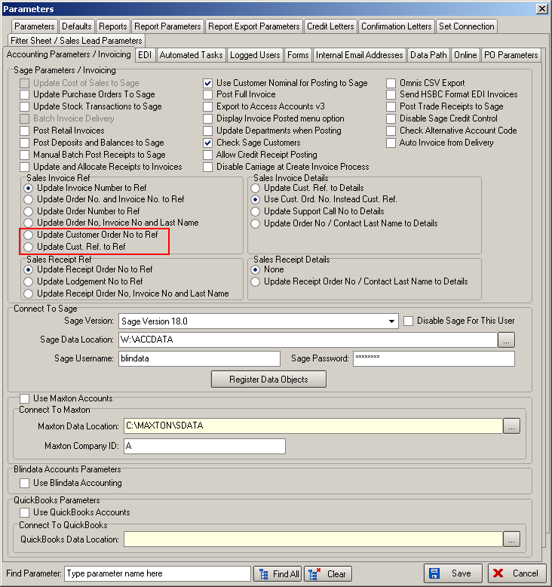

2835. Email/SMS Fitting Text

There is now functionality to send an email or a text message to a customer to show that a fitting appointment has been made.

There is a new field for ‘Fitting Text’ in Company Details > Email Text, for entering the text. This can be shared by both the email and SMS functionality.

When you right click on a fitting appointment in the diary, there is a new menu option choice called ‘Email/Text Customer’. If this is selected, then an email and/or a text message will be sent to the customer. It will only send an email if there is an email held against the order, and will only send a SMS/text message if there is a mobile number and the ‘Email to SMS’ parameter settings are switched on.

2839. Administration > Import From Excel > Stock Update

Customers really like the ‘Stock Update’ import routine. Therefore we have also included the fields in the ‘Fabrics’ import in ‘Stock Update’ as well. This will give a lot more flexibility to the import routine. These were the fields that are missing.

Description, Blind Category (Identifier), Link Option, Default Code, Quantity Default.

2842. Bought In Order Tracking

If the supplier has the ‘Export Bought In as PO’ flag switched on, when the ‘Send PO’ button on Bought In Order Tracking is selected, the csv file is created.

W171. Order Acknowledgement

- We now display the option price below the unit price.
- Changed the spelling of ‘Nett’ to ‘Net’ in all places in the report (and in all forms).
- If a Location is entered in the detail line, it is now displayed on this report.

W172. Order Processing

If an order is entered that exceeds the ‘Large Quantity’ number, then it is not possible to save it as a ‘Same Day Despatch’ order. This was working previously.

