Blindata Release Note 6.0.7 

14 September 2012

Bug Fixes and Enhancements

3948. Customers > CSV Order Import

When the records are imported, the bill of materials is now generated and the required date calculated. The option price is also now being calculated.

In fact this import routine now imports the order so it is similar to it being manually entered.

3952. CSV Order Import

S/C for standard/cascading fold type is now importing properly, providing sf/cf is set up in ‘Specials’ against the relevant stock items.

3955. Order Processing > Orders

Previously, if a component detail line was entered, the ‘On Sales Order’ figure in the stock record was added to. If the item is then made or became WIP, the ‘On Sales Order’ figure was reduced. However if the order detail line is then deleted, the ‘On Sales Order’ figure is reduced again. This could lead to negative ‘On Sales Order’ figures in the stock record.

We have stopped this happening, but in doing so also need to check the ‘Update Stock at WIP Stage’ flag. If ‘Update Stock at WIP Stage’ = true, then if a detail line is deleted after this stage, the ‘On Sales Order’ figure is not reduced. If ‘Update Stock at WIP Stage’ = false, then the ‘On Sales Order’ figure is not reduced if the detail line is deleted after the manufactured stage.

3959. Purchase Order Enquiry > Generate Regular PO

There was a problem whereby some regular purchase orders were increasing the ‘On Purchase Order’ by an additional 1 unit. This has been fixed.

3960. Works Order – Label 7

If a blind type is set up with ‘Box Blind’ = true, then the ‘Deduct Each End’ and ‘Slat Add’ now print in the same way as it does in ‘Works Order – Label 1’.

New Work and Customer Requests

2788. Reports > Sales Analysis Average Discount

There is a new sales analysis report called ‘Sales Analysis Average Discount, which is based on ‘Sales Analysis by Blind Type by Month’, but has an average % figure showing instead of value. There is an overall average at the bottom (instead of Grand Total) and for year (end of row).

This is how we would calculate the average discount. Let’s say we have two order detail lines.

Example: 20 blinds for 200.00 with 10% discount = 180, 1 blind for 50 at 40% discount = 30, overall average discount is 16% (based on (250-210)/250.

2791. Invoice – Bespoke 43

This invoice will print out multiple orders per invoice, tied together by package number. In other words, there will be a one to one relationship between package number and invoice number.

This report is available as a choice in ‘Parameters > Reports > Batched Invoices’ only. Therefore it can only be printed in the ‘Financials > Invoice Batch Print’ form.

2809. Label Print – Bespoke 43

The customer label print now prints what is currently on ‘Tagging Label – Bespoke 43’.

Also the label print size is now 88mm wide by 80mm depth.

2810. Works Order – Bespoke 43

Option description now prints instead of stock code.

Position: this is now calculated using ‘Cord Spacing’ in the same way as is done for Venetians. At the moment ‘Roman’ uses the drop to do the calculation but we want to use the width. Therefore there should be a new flag for blind identifier = Austrian/Roman called ‘Use Width For Cord Spacing’. It should default to false, but if true then uses width instead of drop. This then looks at ‘Ladder Webbing’ in Parameters to determine how it prints out.

A customer has given us these rules for cord spacing:

For width from 400 to 1050: 2 cord guides, distance from edges of blind to cord guide is 150mm. Exceptional: from the width from 400 to 600mm, this distance is 100mm.

For width from 1051 to 1600: 3 cord guides, distance from edges of blind to cord guide is 180mm. The middle cord guide is in the middle.

For width from 1601 to 2200: 4 cord guides, distance from edges of blind to cord guide is 180mm. Position of two cord guides in the middle is: distance from first and last cord guide divide by 3.

For width from 2201 up: 5 cord guides, distance from edges of blind to cord guide is 180mm. Position of 3 cord guides in the middle is: distance from first and last cord guide divide by 4.

Therefore we could set the cord spacing up like this:

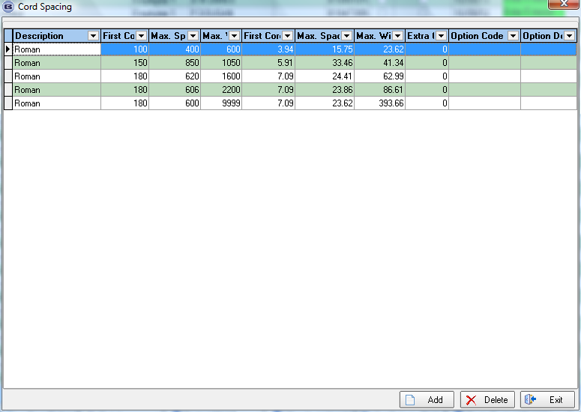

Standard/Cascade folding

We need to know if the Roman blind has Cascade or Standard folding. Cascade means that the folds get increasingly larger. Standard means the same. If Cascade then only the information in 3 will print out. If Standard then only 4 will print.

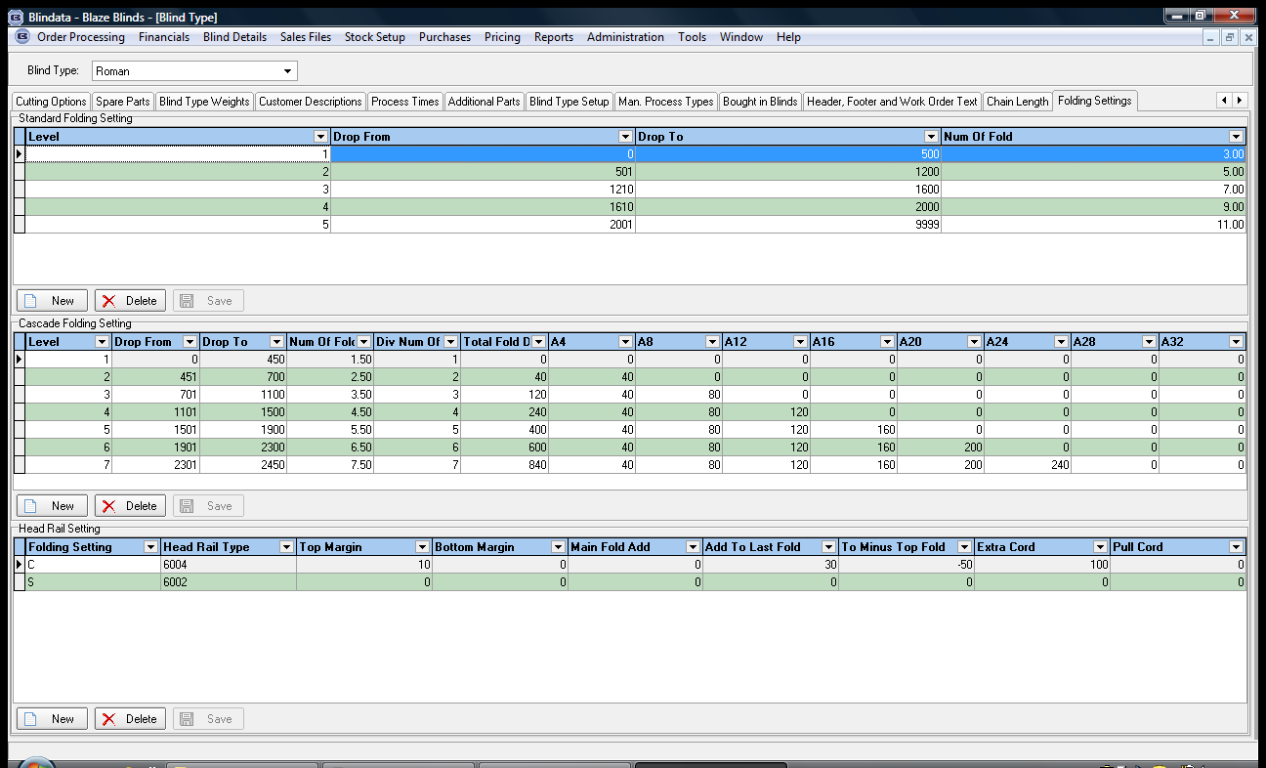

3. Cascade folding

There is a new field in the ‘Cascade Folding Section’ called ‘Add Amount’.
To do the calculation, first of all calculate X.
X = Drop + Top Margin + To Minus Top Fold (these fields are in Headrail Settings in Folding Settings, so we need to check the headrail selected).

Then look up cascade folding table and divide X by relevant divider (Div Num of A) to give Y.
Y + Add Amount (new field) = Z

Z is the last fold (LF)

We then apply this formula: X – Z = A + (A+40) + (A+80) + (A+120) (we get A+ etc from the Cascade Folding Setting depending on the drop).

We then need to work out A.

Then first fold (FF) = A + 20

A4 (on works order) = FF + A4 (in Cascade Folding Setting)
A8 (on works order) = FF + A8 (in Cascade Folding Setting)
Etc

Example

Drop is 1435
1435 + 10 - 50 = 1395 (X)
Y = X / 9 (div num of A?) = 155
155 + 30 (from new field called ‘Add Amount’ in ‘Cascade Folding Setting’) = Z = 185
Z is the last fold (LF)
A + (A+40) + (A+80) + (A+120) = X – Z
1395 – 185 = 1210
A + (A+40) + (A+80) + (A+120) = 1210
4A = 970, A = 242.5
Add 20 to A to get first fold(FF) = 262.5
A4 = 262.5 + 40
A8 = 262.5 + 80
A12 = 262.5 + 120

4. Standard folding

This is headrail dependent.

For standard balance fold: drop of the blind plus Top Margin, then minus 25mm, then minus 80mm, then divide by the ‘Num Of Fold’ in ‘Standard Folding Setting’.

The result of this is Y (Balance fold).

Main fold (meaning first fold in the blind) is (Y+80)

Example:

Blind is 1800 drop
1800 + 10 – 25 – 80 = 1705
1705 / 9 = 189.5 (balance)
189.5 + 80 = 269.5 (main)

2811. Bill Of Materials

The square metreage calculator now takes into account the dimension code add/deductions for calculator = Square Metres.

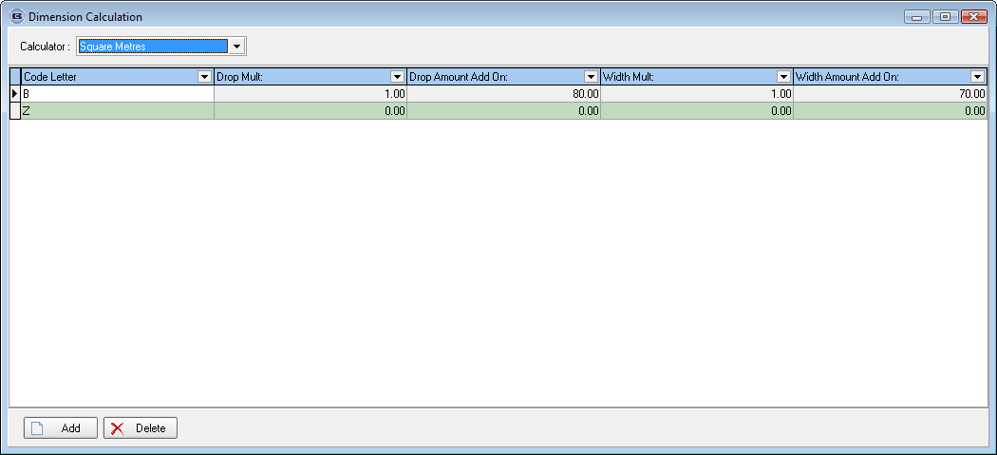

2813. Production List > Fabric Cut List

This report prints out by looking at the ‘Cutting Settings’ in Blind Types and making deductions/additions.

2814. Production List > Curtain Fabric Cut

This report prints out by looking at the ‘Cutting Settings’ in Blind Types and making deductions/additions.

2815. Production List > Lining Cut List

This again is very similar to the fabric cut list except the report is grouped by lining, then by blind type, and then by order. There is an extra field called ‘Go With Fabric’. This is the fabric code.

2816. Job Overview Report

This report should go in the Production List form. Please see Blaze Access database.

The columns with STG0003 and 6002 are option columns for lining and headrail.

2817. Quality Control List

This report is also in the Production List form.

Folding Style is an option. All the fields with tick boxes beside them are the fabric and then options. This report is used to check that each blind is ok before it leaves the factory.

2818. Sewing Job Overview Report

This report is also in the Production List form.

2826. Invoice – Bespoke 20

This invoice has been amended so that a new logo (which goes across the entire page) fits onto it.

