Blindata Release Note 6.0.8 

21 September 2012

Bug Fixes and Enhancements

3957. Production Documentation > Works Order – Bespoke 43 / Label Print – Bespoke 43

After the works order has been printed, the label print is now printed. Previously this only works if you choose ‘Reprint’.

3961. Works Order – Label 7

The fabric description was missing on this label. Fixed.

3962. Order Enquiry

If ‘Use Employee Scan’ is switched off, in ‘WIP Blind Scan’, ‘WIP Order Scan’, ‘Blind Made Scan’ and ‘Order Made Scan’, the process lookup was appearing. It no longer appears.

Also, the scan field is now in line vertically with the employee field

3963. Works Order – Bespoke 42

Previously, ‘Recess’ was hardcoded into the top section – it now shows the ‘Measure To’ entry in the detail line instead.

3965. Administration > Maintenance > Recalculate On Sales Order

The ‘On Sales Order’ figure was being wrongly calculated.

3966. Order Processing > Orders

If ‘Carriage Type’ is set up, then an extra carriage charge may be added, the validation message is now more meaningful.

3967. Order Processing > Orders

The issue date is now being displayed properly in the stock transaction record. It displays the date, not ‘00’.

New Work and Customer Requests

2789. Scheduling By Blind Type

Previously all the criteria for scheduling were held in Parameters, but now this data is also held against the blind type record.

There is a new flag in the blind type record called ‘Use Blind Type Scheduling’ which defaults to false.
When the scheduling date is being calculated (and ‘Use Blind Type Scheduling’ = true, the program looks at the new fields in the blind type record.

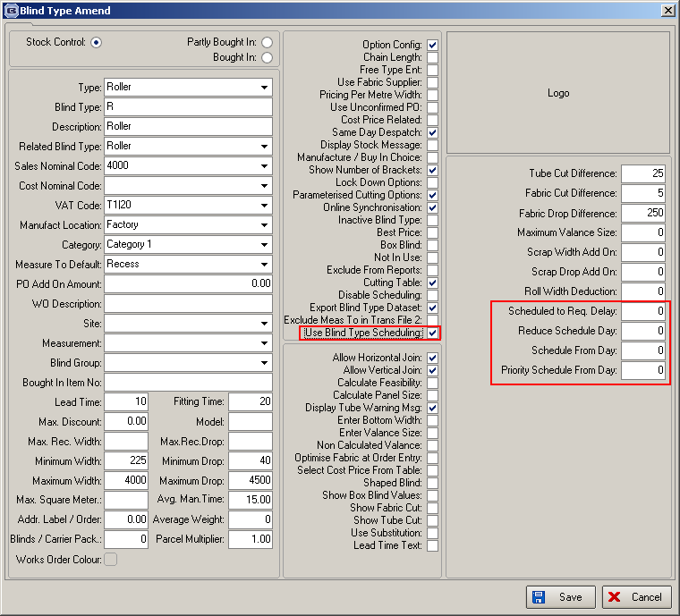

2792. Invoice Export CSV

We have created a new invoice export file in a CSV format for transferring between two of our customers.

2819. Fold Make Up List

This report can be printed from ‘Order Processing > Production List’.

Bar is the width of the bar in the Roman fabric

We also show the fabric on this list because it relates to the headrail colour.

2820. Curtain Make Up List

This report can be printed from ‘Order Processing > Production List’.

2821. Cord Make Up List

This report is now printed from ‘Order Processing > Production List’.

Cord amount is dependent on the width of the blind (see position calculation), and the add on for the pull up part and the deduction of the bottom amount from bottom rod to foot of blind. Each cord is a separate amount.

2823. Delivery Docket – Bespoke 43

This now looks like the individual invoice print for ‘Invoice – Bespoke 43.

2827. Sales Lead Estimate Sheet

The following changes have been made.

Removed ‘Mobile No’
Made ‘Width’ and ‘Drop’ columns a bit wider
Make ‘Recess Blind Size’ column a bit narrower
‘Payment Type’ has replaced ‘Discount’, ‘Sub Total’, ‘VAT’. This will then be filled in manually.
‘Notes’ has been added in bottom left – will be entered manually (handwritten).
‘Fitting Date’ has been added – will be entered manually (handwritten).

2830. Solar Solve Ltd Blind Packing List

The column heading ‘Blinds Packed’ has been changed to ‘Blinds Packed In Box’.

W170. Order Entry

If a customer had multiple delivery addresses set up, when the user selected ‘Set’ to change a delivery address, it was not saving it. Fixed.

