Blindata Release Note 6.0.6 

7 September 2012

Bug Fixes and Enhancements

3949. Label Print – Bespoke 43

This label print now prints for label size 88mm x 88mm. There are different labels for each order.

3950. Works Order – Bespoke 43

This is now printing the ‘Chain Opt’ or ‘Left / Right’.
We have Code field in option names Control Option 1 and Control Option 2 set up to tie to the relevant option names. Would this help if we used these?

3953. Purchase Order Enquiry

If regular purchase orders were being delivered for items with a ‘Unit Of Sale’ set up, it was not updating the ‘On Purchase Order’ properly and not filling the correct quantity in the PO transaction that was held against the stock item. This is now correct.

3954. Purchase Order Enquiry > Regular PO

The column choices are now in alphabetical order and the default choices have been changed to this.

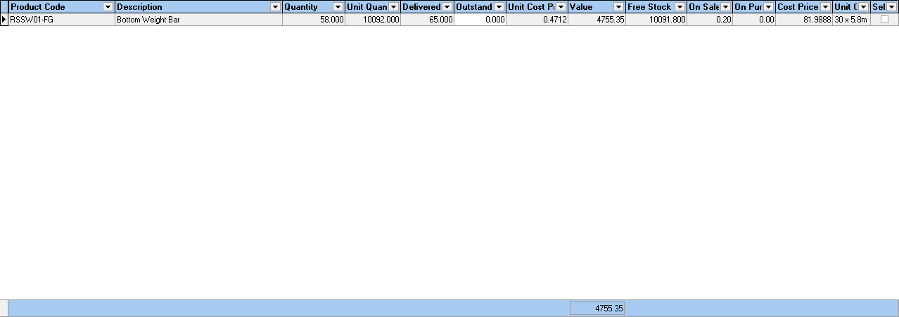

New Work and Customer Requests

2757. Shipping

There is a new parameter in the system called ‘Enable Shipping Packages’. This is held in Administration > Parameters.

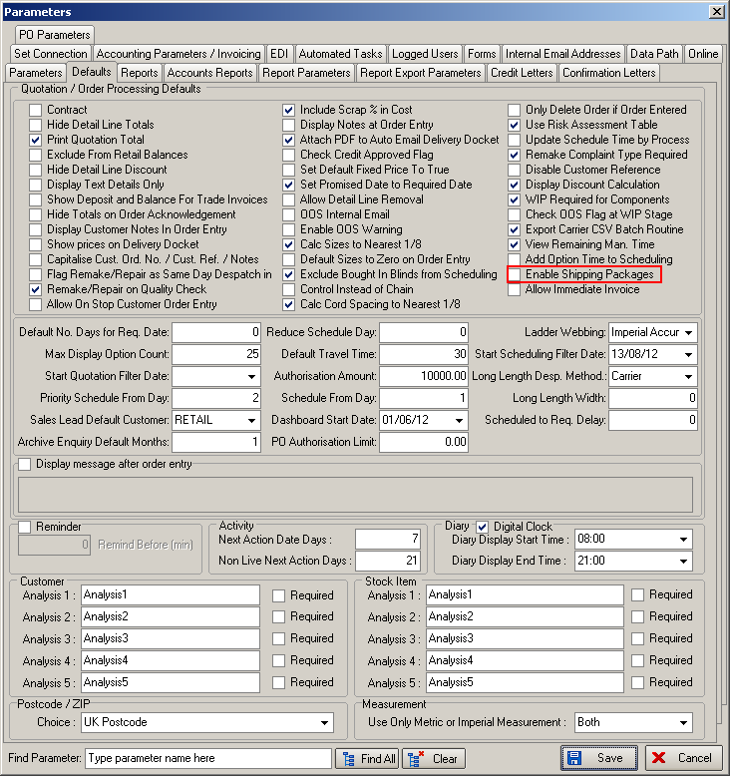

If this is set to true, then the ‘Delivery Docket Batch Print’ displays a different form called ‘Shipping’. This will display package records with fields for package number, customer, date, number of orders and number of blinds. There should be options for add, amend and delete.

If ‘Add’ is selected, the user can then select a customer and then add records to the package from a lookup, which will show orders for that customer that have a status of ‘Order Manufactured’. In here it is also possible to add carton number, weight and dimensions to the package record.

There is also a button for ‘Despatch’ in this form. This will change all orders in the package to order status = ‘Despatched’.

In ‘Create Invoices’, if ‘Enable Shipping Packages’ = true, an invoice number is created only by package number ie there is a one to one mapping between package number and invoice number.

2798. Stock Items > Unit Of Sale

The entry of these fields now works the same way for unit of sale as it does in ‘Unit Costs’ tab. After you enter an amount in the unit description (that is not ‘Unit’), the other fields get recalculated.

2799. Pattern Repeat Formula

A new calculator has bee created for stock items. It is called ‘Pattern Repeat’ and will be used mainly for curtains.

For the calculation to work, we need to know the following information:

Roll width – this is the width of the roll of fabric (‘Roll Width’ in ‘Stock items’)
Pattern Repeat – this is how often the pattern repeats itself (‘Pattern Repeat’ in ‘Stock items’)
Fixed amount – this is a fixed amount to add on (there is a new field in the blind type record if blind indicator = Curtain, called ‘Fabric Add On’).

First of all the system must work out the ‘widths’ of fabric required. Here is an example of how it is done:

Curtain fabric is 1335mm roll width, so if curtain has width of 2000mm, 2 widths of fabric would be required. If the width was 2700mm, 3 widths would be required etc.

The calculation for working out the fabric usage is as follows:

Widths required = (Width/Roll Width) rounded up to next whole number

Length required = (((Curtain drop + fixed amount) / pattern repeat) rounded up to next whole number) * pattern repeat.

Quantity = Widths required * Length required.

Example:

Curtain is 1500 width x 2000 drop. Roll width is 1335mm, pattern repeat is 660mm, fixed amount (Fabric Add On) is 500mm.

1500/1335 = 1.1235 rounded up to 2
((2000 + 500)/660) = 3.7878 rounds up to 4, then * by 660 = 2640mm.

Length of fabric is therefore 2.64m * 2 = 5.28m.

This is calculated for the bill of materials and can also appear on the works orders.

2800. Packing Machine Report

This now prints in alphabetical order by customer then order number.

2801. Order Processing > Orders > Despatch

If there is only one employee set up as ‘Despatch’, then that employee becomes the default when ‘Despatch’ is done.

2802. Order Processing > Orders

When using ‘Despatch’ the system now picks up the delivery docket from the customer record if it is set up. Previously it only looked for the delivery docket in Parameters > Reports. It should then look in the customer record to see if one is set up there.

This has been done to bring it in line with the functionality in Order Enquiry > Despatch Order

2807. Immediate Invoice Parameter

Previously, when you entered an order, it was possible to change the entry type from ‘Order’ to ‘Invoice’. The following message was then displayed. If you chose ‘Yes’, it altered the order of the status fields.

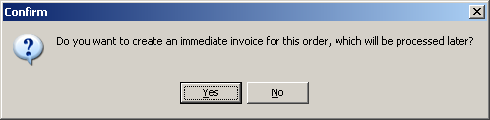

We have had a couple of cases where users have answered ‘Yes’ without fully understanding what was going to happen, so it is now possible to stop this.

Therefore there is now a new parameter in Administration > Parameters called ‘Allow Immediate Invoice’ which defaults to false. If it is set to true, then the above question will get asked, otherwise it will just behave like a normal invoice.

2808. Base Price & Square Metre Pricing

A request has been made for the selling price for a fabric in a blind to be a combination of the base price and the square metre price for the fabric. Previously we could only have one or the other.

There is a new flag in the stock record called ‘Sq Metre and Price Table’. If this is set to true then the base price for the blind will be the price that is found in the normal price table + the square metre price.

