Blindata Release Note 6.0.5 

31 August 2012

Bug Fixes and Enhancements

3938. EDI Import

When EDI records come in from a particular customer, the email address is now picked up properly from the customer record.

3939. Invoice – Bespoke 31

The ‘Cust ord No’ field has been made larger on this invoice.

3940. Order Processing > Orders

For component detail entry, previously when you tried to enter a product code starting eg with BK, it looked up B, then looked at codes that started with K, but if you click on the arrow to do the lookup, it finds BK. This has been changed so it will find BK…

3941. Sales Analysis

Unless you selected customer etc last, the filter choice that was made disappears. This has been fixed so it does not matter if you select one of these fields first – it will remember it.

New Work and Customer Requests

2784. Delivery Schedule

It is now possible to export a delivery schedule to a spreadsheet. This can be done in Order Processing > Delivery Docket Batch Print. There is a new button called ‘Delivery Schedule Export’.

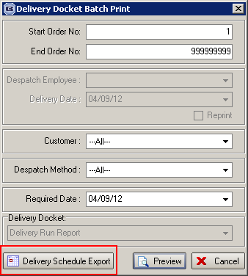

2787. Sage 50 2013 Integration

Blindata now integrates to version 2013 (v18) of Sage 50.

2794. Administration > Import From Excel > Customer Fabric Descriptions

There is now an import routine to import records to the customer description table for fabrics. The import spreadsheet has fields for stock code, customer account code and fabric description.

