Blindata Release Note 6.0.3 

17 August 2012

Bug Fixes and Enhancements

3894. Order Processing

Email address and phone number fields are held in both delivery address and invoice address tabs on the customer card. We now also hold first and last name, and these fields are pulled into the order.

3895. Administration > Import From Excel > Customer Delivery Addresses

The sub account import spreadsheet (Customer Delivery Addresses) now includes the email address for the sub account, and also the account name, so it can be imported.

3896. Acknowledgement – Schedule Date

This order acknowledgment now prints the sub account code underneath the company name as highlighted below. This is only for customers that have ‘Sub Account’ = true.

3897. Order Processing > Order Enquiry > Order Despatch Scan

There was an Access Violation error message appearing here. Fixed.

3901. Order Processing > Order Enquiry > Blind Process Scan

If ‘Use Employee Scan’ was not set to true, this function did not work. Fixed.

3903. Works Order – Bespoke 42

In the middle section the ‘Blind Width’ and ‘Blind Drop’ sizes now show manufacturing sizes ie blind size. Also, if the blind identifier = Miscellaneous, then the sizes do not print at all.

If the blind is for a ‘Remake’ or ‘Repair’ or ‘Redespatch’, the letters NCR now print at the top right of the page in large bold red capitals.

3904. Works Order – Bespoke 7

- The options have been moved left a bit because they are being overwritten by the cutting sizes.
- The process names have been moved up slightly.

3905. Emailing

This only happened if ‘Select Email Address’ is switched on in Administration > Parameters. If you click cancel at this point

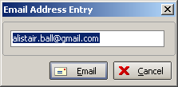

Then the following message appeared. Fixed.

3906. Financials > Invoice Batch Print > Invoice – Bespoke 20

The page numbering had got mixed up on this report. Fixed.

3907. Gross Profit By Order By Blind Type

This report was showing incorrect figures for ‘sales (ex Vat). It is now showing the total per blind type in here, not the total for the order.

3913. EDI Auto Acknowledgements

Standard email order acknowledgements will send correctly to the sub accounts email address, but auto EDI acknowledgements generated by the EDI import were still send to the customers mail acknowledgement email address. Fixed.

3914. Order Enquiry > Order Despatch Scan

There was a bug preventing orders from despatching. Firstly the ‘No of Packages’ box did not appear when the scan window first loads. It appeared after an order was first scanned. Secondly, if a ‘No of Packages’ was entered, when the order was then scanned, the ‘No of Packages’ reset to 0 and the user got an error preventing them from despatching.

3915. Scheduling

If ‘View Remaining Man Time’ is switched on and the (current date + ‘Schedule From Day’) is less than scheduled date, when the blind is manufactured the normal scheduled time stays the same, but the normal remaining time is now reduced.

If ‘View Remaining Man Time’ is switched on and the (current date + ‘Schedule From Day’) is greater than or equal to the scheduled date, when the blind is manufactured the normal scheduled time and the normal remaining time are reduced.

3916. Order Enquiry > Blind Process Scan

If ‘Use Employee Scan’ was switched off, there was a problem with the ‘Blind Process Scan’. When an order is scanned, a success message now appears in the window and the process transaction is registered against the blind. The problem was that when an order was scanned, a message saying ‘Blind Selected’ appeared, but nothing else happened and the scan wasn’t recorded.

3917. Scheduling Change for Required Date (dev 2770)

Decora have tested the ‘Scheduled to Req. Delay’ functionality and have found the following issues:

The required date was not set correctly for customers with specific delivery days. If they had a delivery day equal to the day the blind was scheduled for, the required date was set to that day and the ‘Scheduled to Req. Delay’ days were ignored. The system now sets the required date equal to the customers next delivery day after the scheduled date plus the required date delay.

The scheduled date should be calculated as usual.
If the add on day is 1, then one day should be added to the scheduled date to get a result for the required date.
The rules for delivery days etc should then be applied and the required date altered if necessary. So for example, if the scheduled date was 13/08/12, the required date would be calculated as 14/08/12. If the delivery day for the customer was only Monday, then the required date would become 20/08/12.

3918. Bought In Order Tracking

When using the Manufactured button or the Confirm diagram button, the detail lines were changed to WIP or Manufactured, but then didn’t check if it should then update the order header status. Fixed.

The PO is now created when the sales order is saved, and not when it is checked. This means that as soon as there is a sales order in the system with detail lines that are for bought in blinds, the PO will also be created. So in fact this has been changed back to the way it was.

3919. Total Of Orders Outstanding > Export to Excel

The figures that go into the ‘Production’ spreadsheets were still incorrect. This was actually caused by missing category codes in order detail lines. We noticed that the category code was not being saved if a detail line was copied, so this has now been fixed.

3920. Works Order – Bespoke 42

For miscellaneous orders, we have made the following changes.

- There is now more room for the description.
- Width and drop is not printed.

3921. Sales Lead Estimate Sheet

This report is now 11 inches long, and not A4.

3922. Label 5161 – Bespoke 35

If ‘Show Cord Spacing’ is switched off in Blind Details > Blind Types, the cord spacing does not print and ‘Location’ prints on the left hand side of that line.

New Work and Customer Requests

2778. Sales Files > Customers

There is now an option to copy all product discounts to another customer. There is a new button here called ‘Copy Discounts’. When clicked, it will then ask the user for the account code or customer company name to copy the product discounts to.

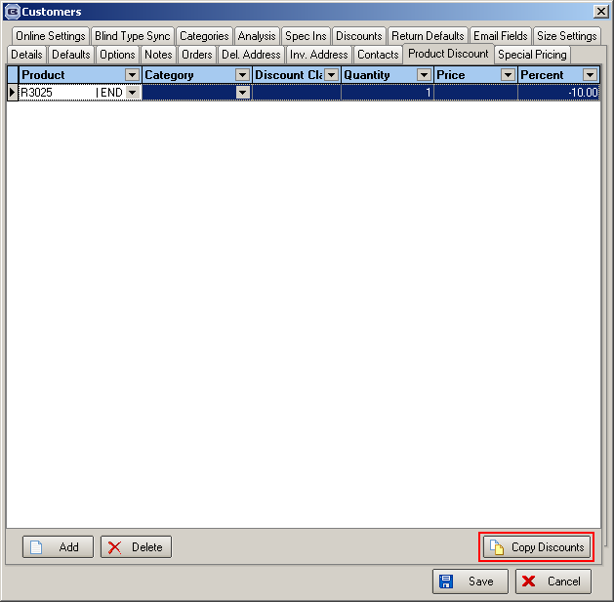

2781. Bought In Order Tracking > History

There is now a history option in the right click context menu in the bought in order tracking form.

