Blindata Release Note 6.0.1 

7 August 2012

Bug Fixes and Enhancements

3894. Order Processing

Email address and phone number fields are held in both delivery address and invoice address tabs on the customer card. We now also hold first and last name, and these fields are pulled into the order.

3895. Administration > Import From Excel > Customer Delivery Addresses

The sub account import spreadsheet (Customer Delivery Addresses) now includes the email address for the sub account, and also the account name, so it can be imported.

3896. Acknowledgement – Schedule Date

This order acknowledgment now prints the sub account code underneath the company name as highlighted below. This is only for customers that have ‘Sub Account’ = true.

3897. Order Processing > Order Enquiry > Order Despatch Scan

There was an Access Violation error message appearing here. Fixed.

3901. Order Processing > Order Enquiry > Blind Process Scan

If ‘Use Employee Scan’ was not set to true, this function did not work. Fixed.

3903. Works Order – Bespoke 42

In the middle section the ‘Blind Width’ and ‘Blind Drop’ sizes now show manufacturing sizes ie blind size. Also, if the blind identifier = Miscellaneous, then the sizes do not print at all.

If the blind is for a ‘Remake’ or ‘Repair’ or ‘Redespatch’, the letters NCR now print at the top right of the page in large bold red capitals.

3904. Works Order – Bespoke 7

- The options have been moved left a bit because they are being overwritten by the cutting sizes.
- The process names have been moved up slightly.

3905. Emailing

This only happened if ‘Select Email Address’ is switched on in Administration > Parameters. If you click cancel at this point

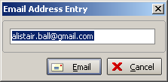

Then the following message appeared. Fixed.

3906. Financials > Invoice Batch Print > Invoice – Bespoke 20

The page numbering had got mixed up on this report. Fixed.

3907. Gross Profit By Order By Blind Type

This report was showing incorrect figures for ‘sales (ex Vat). It is now showing the total per blind type in here, not the total for the order.

New Work and Customer Requests

2747. Emailing

There is a new parameter in Administration > Parameters > Internal Email Addresses called ‘Select Email Address’. If this is set to true, then whenever a document is emailed to a customer, or a supplier, the user will be prompted for the email address, which will default to the relevant email address that has been set up.

The only place where this does not apply is in Financials > Invoice Batch Print.

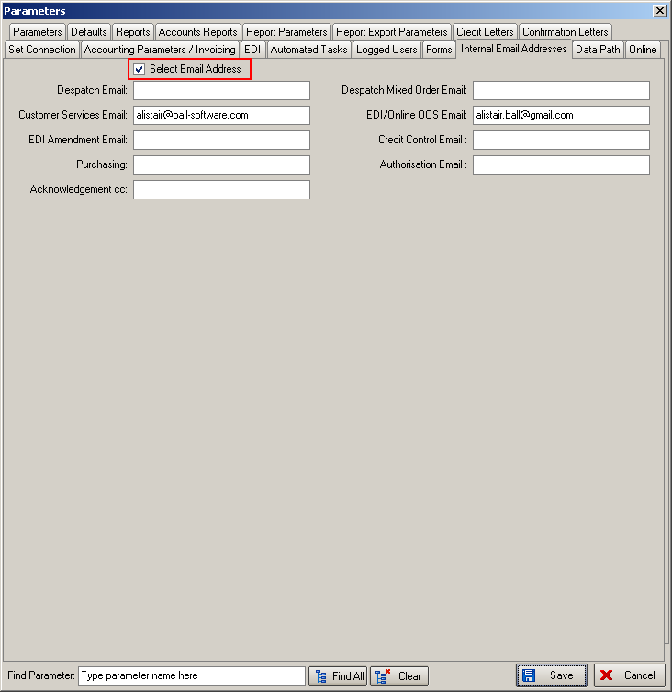

2761. Archive Enquiry > Email Addresses

The email address field is now a column choice in the Archive Enquiry form.

2762. Fitters Sheet/ Sales Lead > Sales Lead Entry

There is now an option where the Email address field can be made mandatory on the Sales lead screen.

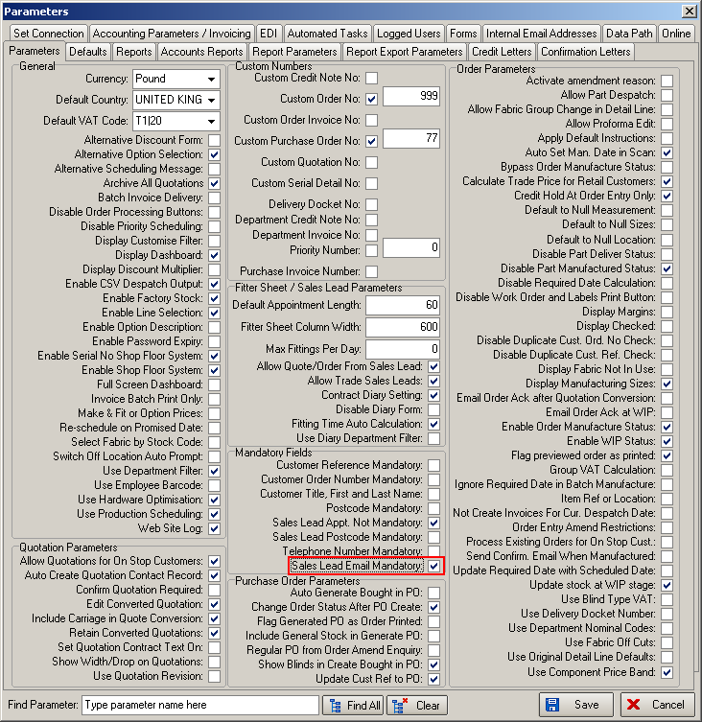

We have also changed the number of stored characters foe email addresses to 50 characters.

2763. Invoice – Laser Print 11 Detail Lines

If there is settlement discount on an invoice, then it now appear on this invoice. The same rules apply here as do in ‘Invoice – Bespoke 34’.

2764. Posting Invoices - QuickBooks

The date that is used for posting the invoice to QuickBooks is now the invoice date and not the current date.

2765. Production Lists > Production List by Component

This is a new report and is based on ‘Production List By Blind Type’, but with the following changes.

The ‘Detail no’, ‘Required Date’, ‘desp’, ‘Width’, ‘Drop’ and ‘Slats/Vanes’ columns have been removed.

We have made more space for the fabric column, and the fabric column has been renamed ‘Stock Description’. We do not group by blind type as only records with blind type = Miscellaneous will be printed.

2766. Invoice – Laser Print (Letterhead Logo) 8.5 x 11 (print and pdf)

Invoices that go to Canadian customers for certain wood products must have specific text printed on them.

We have used the ‘Order Text’ field in the Totals tab in the order for this. The text can be set up in Administration > System Tables > Order Text.

This text will then appear at the bottom of the invoice.

2767. Customer Fabric Default Options

A change has been made to the Option Restrictions system table functionality so that records can be set to apply to the desktop system, the online system or both.

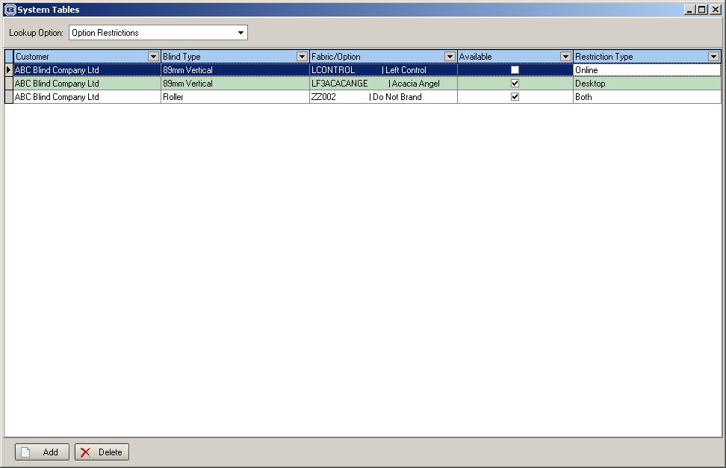

2768. Bought In Purchase Order Modifications

The following further changes that they want made to the purchase order functionality.

If ‘Display Checked’ is set to true in Parameters, it is not possible to create a bought in PO until the sales order has been ‘checked’.

If ‘Disable Scheduling’ is switched on in the blind type record, the message ‘Scheduled manufacture Date not Specified’ no longer appears when the order is saved (or checked).

Bought In Tracking Form

It is now possible to double click records on the Bought In Order Tracking form and bring up the sales order amend form.

There are now options for ‘View Details’ and ‘View Serial Details’ in the context menu (right click on the relevant record).

The label on the ‘Confirm Diagram’ button now says ‘Confirm PO/Diagram’.

It is now possible to go into the sales order form from here, amend the supplier for the relevant detail lines using thev ‘Global’ button and save the record. This will update the bought in purchase order with the revised supplier.

The Confirm Diagram button now updates the bought in order/line status to WIP.

There is a new flag in the Supplier form called ‘Confirmation Required’. This is required because some suppliers will not require confirmation of purchase orders.
For their bought in POs the order status will update to WIP when the ‘Send PO’ button is clicked on the Bought In Order Tracking, rather than when Confirm Diagram is clicked.

The following fields have been added as column choices in the Bought In Order Tracking form, and are hidden by default.

On Credit Hold
On Customer Hold
On Stop

There are some new fields on the Bought in Order Tracking form that are there as columns, and there is now a button called ‘PO Fields’ which will allow a user to update them.

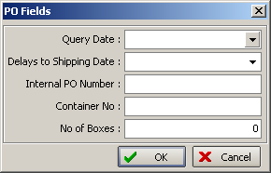

There is now an ‘Order Category’ column choice.

The Manufactured button on the Bought in Order Tracking form now updates the bought in order/line status to Manufactured.

The Manufactured button on the Bought in Order Tracking form also now updates the manufactured date of an order after it is first set.

Number of Items and number of panels on the Bought in Order Tracking form now sums correctly for blinds added after the order is first saved.

Amending Sales Order / Purchase order After PO Generated from Sales Order

There is a new parameter called ‘Auto Join Detail Lines to Bought In Po’ in Administration > Parameters > PO Parameters. If this is set to true, then when a detail line is added to a sales order for which there is already a bought in PO, the detail line will be added to the PO (provided it is for the same supplier).

Bought In Tracking Form > PO Receipt Validation

There is a new parameter called ‘Enable PO Receipt Date’. If this is switched on and the sales order has detail lines with bought in records, then if ‘PO Receipt Date’ is null, a message appears saying ‘The PO has not been received’.

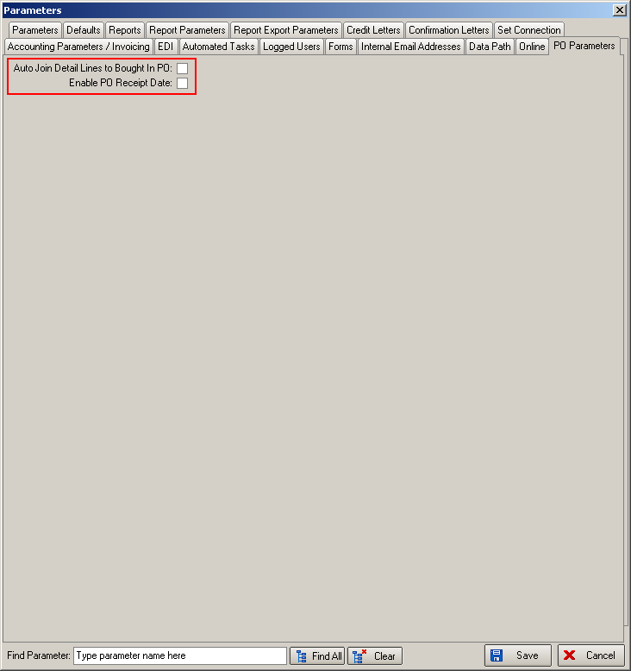

Administration > Parameters

There is a new field in the Parameters > Internal Email Address form called ‘Bought In Email Archive’. If this field has an email address in it, when a bought in PO is emailed to the supplier, it will be ‘cc’ed to this internal email address as well.

2770. Order Processing > Required Date

There is currently a flag in Parameters to update the Required Date with the order Scheduled Date. It is now also possible to set this flag but also determine that the required date should be a set number of days after the scheduled date. This is a new field in Administration > Parameters called ‘Scheduled to Req. Delay’.

If 1 is entered into this field this will result in one working day (considering weekends and holidays) being added to the schedule date, before customer delivery days are considered, and then the required date will be updated from that.

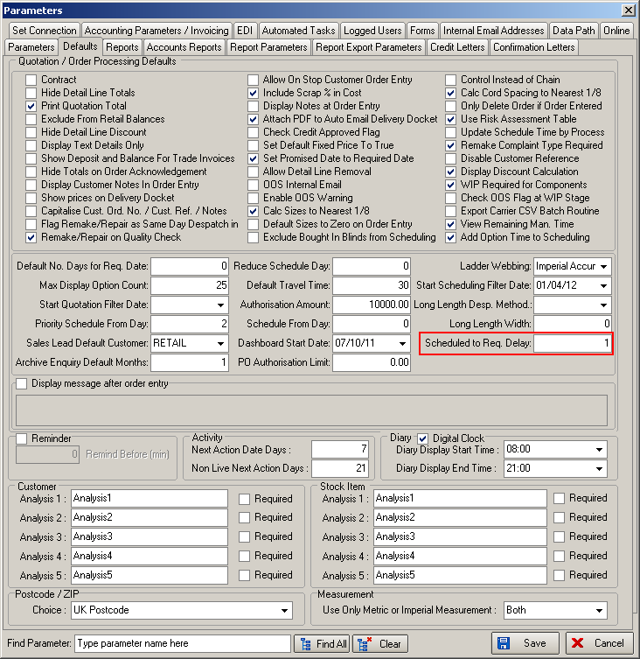

2772. Administration > System Tables > Departments

There is a new field in the Department form called ‘department Number. If this is filled in, then when the department is updated to Sage when invoices or receipts are posted, it will use this field.

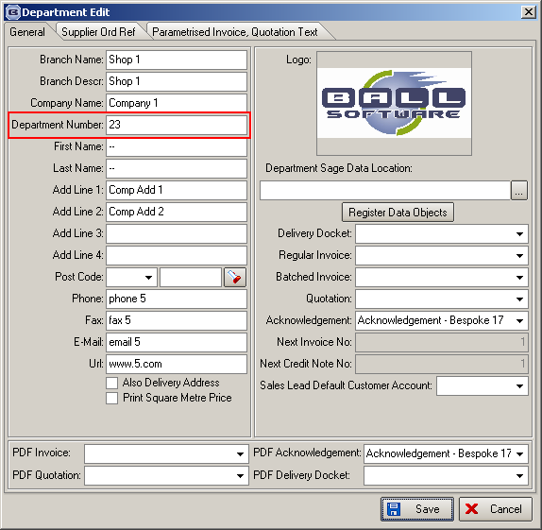

W166. Order Entry

Valance size validation now has the same rules as the desktop version for box size maximums.

There is now a pop warning to alert the user that they cannot enter a valance size longer than the box size of the blind in the detail line. A message like this will appear.

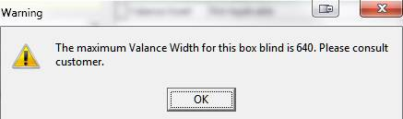

W167. Order Entry

Country is now ‘County’.

W168. Order Entry

The valance size validation online to act as the desktop version on box size maximums

If an order detail line is for panel blinds, there is no pop warning to alert the user to enter the number of panels. The user is now unable to continue until they have entered the number of panels.

