Blindata Release Note 7.9.9 

17 June 2016

Bug Fixes and Enhancements

The following issues were recorded in www.support.blindata.co.uk and have been resolved.

529. Quotations > Self bill
615. Support on Cutting Label Set-up
812. Set works order to print multiple duplicate works order forms each time
820. Option Cost Prices
821. Error "A blind of this size cannot be made" when editing an existing order when size is not changed and should be allowed.
824. Orders > Works Instruction
836. Administration > Archiving
840. Sage Integration - receipts not allocating to invoices
853. Wrong measurement displayed on a labels.
856. Export to ERP

New Work and Customer Requests
4795. Purchase Invoice Posting To Mertex

This is only applicable if Mertex accounting is switched on. The csv files that are exported for sales invoices, credit notes and purchase invoices have all been adjusted according to the specification.

4868. Reports > Purchase Analysis Reports

There is a new report here called ‘Purchase Invoice Analysis Report’.

This gives an analysis for each Invoice line.

4871. Works Order – Bespoke 52

Some layout changes have been made to this report. The BOM section has been removed and the option choices increased.

4874. Order Processing > Orders > Multi Blinds

Recently we created some new functionality for a Multi blind which involved entering the detail line like this. This actually works well as a detail line entry but has caused some other problems, in particular with the calculation of cutting sizes.

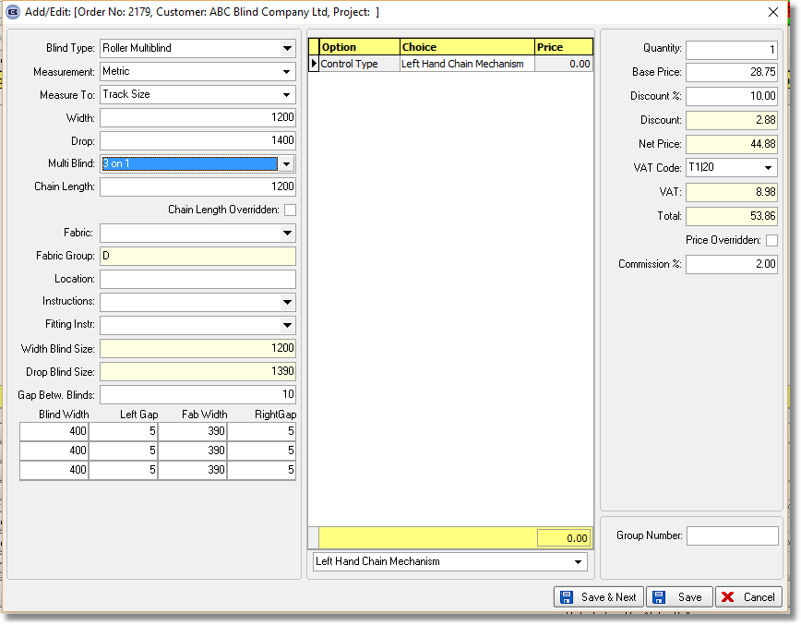

Wew still think the best way to handle multi blinds is to have a different detail line for each part of the blind, but users do not like this. Therefore we have thought of an alternative.

We still enter a detail line in the way we do for the above. The difference is that when the blind is saved, instead of one order detail line being created, 3 are created, one for each part of the blind. So in this case, we would create 3 detail lines, each with a width of 400mm and a drop of 1400mm. This will then make the cutting sizes a lot easier to calculate. It also means that if not all the option choices are the same, they can then be amended individually.

The first detail line would still contain all the main information (about each blind width etc) and if it was edited, the order detail lines would all be resaved.

There is a new parameter to do this in Administration > Parameters.

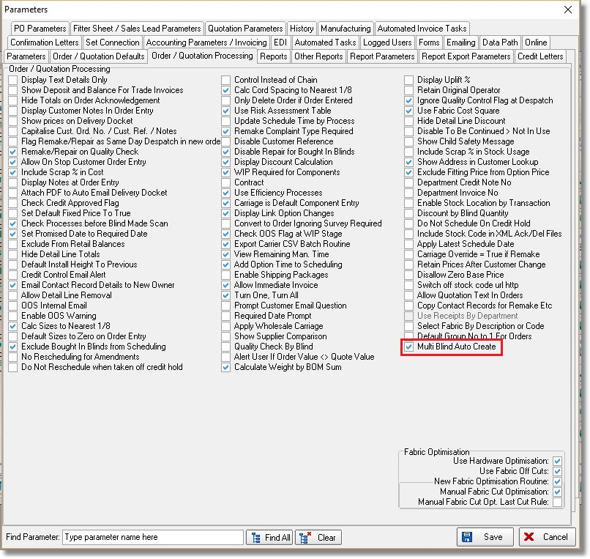

4875. Label Print – 4 x 5/8 Bespoke 35

A new label print report called ‘Label Print – 4 x 5/8 Bespoke 35’ that has similar fields to ‘Label Print – 5161 Bespoke 35’ but the main difference is that the label size is 4” wide and 5/8” deep.

4877. Label 5161- Bespoke 63

If the blind identifier = Pleated, then the number of pleats now prints on the label. It says ‘Number of Cells’ and print on the cuttinglabel (cutting label for ‘Ancho Tela’).

W263. Acknowledgement Print

For www.chile.blindata.co.uk, the Quantity, Unit Price, Disc % and Net Price were overlapping each other. The quantity has been moved to the left a bit.

