Blindata Release Note 7.9.5 

23 May 2016

Bug Fixes and Enhancements

The following bugs were recorded in www.support.blindata.co.uk and have been resolved.

627. Labels Not Printing Properly
658. Works Instruction 54
662. 10198
687. Nominal journal Normal

New Work and Customer Requests
4790. Purchase Order Enquiry > Update

There is a parameter called ‘Purchase Invoice Number’, which defaults to false. If this is set to true, when a purchase invoice gets created, the ‘Purchase Invoice Sequence Number’ appears on the screen and is saved against the purchase invoice.

There is a column choice for this field in ‘Purchase Order Enquiry’. If a purchase invoice file is posted to Mertex, the sequence number goes in the ‘Item Reference’ column.

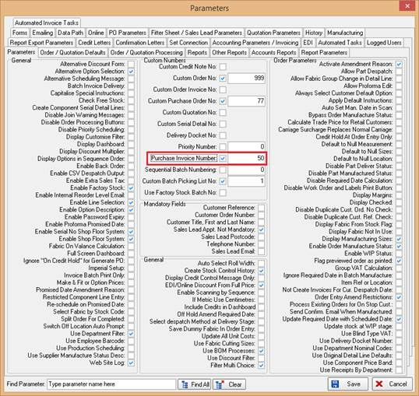

4791. Purchase Order Enquiry > Update

There is a new field in ‘Purchase Terms Code’ record called ‘Payment Due Days’. The ‘Invoice Due Date’ is calculated as (Purchase Invoice Date + Payment Due Days (from ‘Purchase Terms Code’ table)).

There is a new field in the ‘PurchaseInvoices’ table called ‘PaymentDueDate’ and the Due Date should be saved there.

When the purchase invoice is posted, this field is updated to the ‘PaymentDate’ field in the AuditTransaction record if ‘Blindata Accounting’ is switched on.

4792. Purchase Order Enquiry > Update

Once a purchase invoice has been created, it is now possible to edit a detail line and also to enter one. Therefore there are two new buttons called ‘Add’ and ‘Edit’ (both have button visibility choices). If ‘Add’ is selected, it is possible to add:

Description
Quantity
Amount (in supplier currency)
Nominal Code.

If ‘Edit’ is selected, it is possible to edit quantity, nominal code, net amount, VAT and total.

4793. Purchase Order Enquiry

Once a PO has had an invoice created against it, the Supplier Invoice Number is visible in the “Invoice Number” column of the PO Enquiry Screen. This happens if an invoice is created from a PO or Batch invoicing.

4794. Purchase Archive Enquiry

There is a new menu option in Purchases called ‘Purchase Archive Enquiry’. This goes beneath the new ‘Post Purchase Invoices’ menu option (see dev 4797).

The columns displayed are the same as in ‘Purchase Order Enquiry’. There are buttons to ‘Print PO’ and ‘View PO’.

Once a purchase order has been fully posted, it goes into the ‘Archive PO Enquiry’ form in the same way as a sales order goes to ‘Archive Enquiry’ once it has been posted.

Only purchase orders that have had invoices fully created and posted will appear in this form.

4802. Contact Management > File Attachments

It is now possible to attach files to contact management records in the same way as they are attached to sales orders. There is a new button on the ‘Contact Management’ form called ‘File Attachments’ which displays the ‘File Attachments’ form. When the attachment is saved, it indicates the sales order it is attached to (if it is attached to a sales record).

4844. Works Order – Bespoke 65

The works order for blind identifier = Vertical layout has been changed.

Also the option choices now print the description, not the stock code.

4845. Export To ERP

We made the following change in dev 4767.

If, in the customer record, ‘Export XML Account Code’ is not null, a separate XML file is exported to ERP. This file now contains the customer invoice address.

In fact the address now goes into the file that goes to ‘Export Folder’ and not into the file that goes into ‘Export Folder 2’.

4846. Purchase Order XML File (Bought In)

There is a new flag on the customer record called ‘Send Cust Ord No in PO XML’ which defaults to false. If it is set to true, then when the PO XML file is sent to the supplier, it contains the original cust ord no (from the sales order) and not ‘SO:9999, PO:1866).

It is also possible to import this new field in ‘Customer Update’.

