Blindata Release Note 7.9.3 

6 May 2016

Bug Fixes and Enhancements

The following bugs were recorded in www.support.blindata.co.uk and have been resolved.

283. Reports > Projects LOST Normal
545. Order Processing > Orders > Blind Entry Normal
573. Bought In Blind PO Amend Screen-The total for the order is Not Correct
575. Purchase Order Enquiry Screen-Date Format Incorrect for USA
594. Cutting labels are not printing properly
599. Fitters Sheet - Bespoke 54
603. Survey Request Sheet
606. Order Processing > Quotations
609. Fabric process

New Work and Customer Requests
4798. Contact Management > Add > Send Email

The hardcoded text for 'Further Details:', 'Action Required:' and 'Disclaimer Text:' has been removed from the body of the email.

4799. Sales Files > Reports > A4 Statement With Remittance

Click ‘Ok’ only has to be selected once at the start of the email statement process.

4800. Remake / Repair / Redespatch

A change was made recently where if an order was created using ‘Remake / Repair / Redespatch’, the contact records were copied over. Some customers do not want this, so there is now a new parameter called ‘Copy Contact Records for Remake Etc’ which defaults to false. The contact records are only copied from the existing order to the new order if this parameter is switched on.

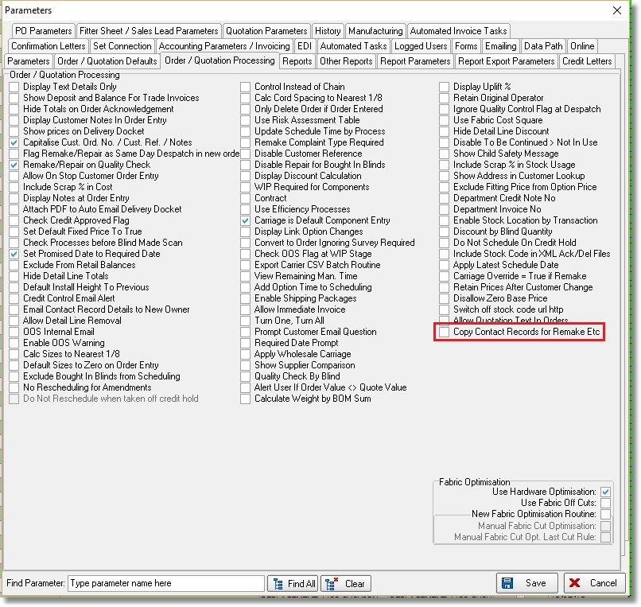

4801. Reports > System Reports > New Customer Sales Report

There is now a choice to select this report by ‘Rep’. The choice defaults to ‘All’.

4803. Order Processing > EDI Enquiry Receiving Data > Import Wizard

There is now a ‘Select All’ button on this form so all records can be selected at once.

4805. Carriage Charge For Different Delivery Address

If this flag is switched on in the customer record, the carriage amount for this is currently taken from the 'Postcode' table. There is a new field in 'Carriage By Area and Total' called 'Different Del Address Carriage'. If this is > 0, a carriage detail line is created when this is true. This works both for order entry auto carriage add, and at the 'Create Invoices' stage.

4806. Stock Control > Stock Transaction Entry

The 'Supplier Part No' and 'Supplier Barcode' fields have been moved below the 'Stock Description' field.
The stock description field in the lookup for 'Stock code' was being cut off by the width of the field. It now displays this beyond the end of the field.

4809. Order Processing > Orders > Blind Entry

There is now a ‘Keep Options After Fabric Change’ parameter held against the blind type record.

4810. Stock Control > Stock Items > History

If the cost price of a stock item has been changed in the purchase order ‘Update’, there is now a history record created in the stock item.

4811. Purchase Order Bought In (Blind Size)

The option names font is now the same size as the rest of the fields in the detail line.

4813. Stock Control > Reports > Stock Valuation (FIFO)

There is a new report in Stock Control > Reports called ‘Stock Valuation (FIFO). This calculates stock based on first in, first out.

Let’s use the following example of stock transactions that have been purchased for stock item X.

Date Qty Cost

31/01/16 20 5.00
28/02/16 10 5.60
31/03/16 15 5.60
30/04/16 20 5.25

There are currently 37 in stock in hand. Because first in, first out is being used, the oldest items should be used first. Therefore the quantity of 37 in stock is made up from these transactions:

28/02/16 2 5.60
31/03/16 15 5.60
30/04/16 20 5.25

The stock valuation for this item is therefore (2 * 5.60)+(15 * 56.60)+(20 * 5.25) = 200.2

4814. Works Order – Bespoke 54

The layout in the header of this report has been changed significantly.

4815. Projects > Survey Request Sheet

The contact name field has been removed from the customer address.

